June
S | M | T | W | T | F | S
 |  | 3
 |  | 10 | Deputy Chief Brain Fox – Danville Life Saving Crew Drones
 |  | 17 | Rosalinda Nuza – Filipino Educators in Danville
 |  | 24

July
S | M | T | W | T | F | S
 |  | 1
 |  | 8
 |  | 15
 |  | 22 | Institute for Advanced Learning & Research
 |  | 29

Check out our Club Website!
www.danvillevarotary.com

Don’t forget to wear
your Rotary pin! You will get to donate a $1.00 to the Club if you forget to wear it.

Of the Things We Think, Say, or Do,

Is it the Truth?

Is it Fair to All Concerned?

Will it Build Good Will and Better Friendships?

Will it be Beneficial to All Concerned?
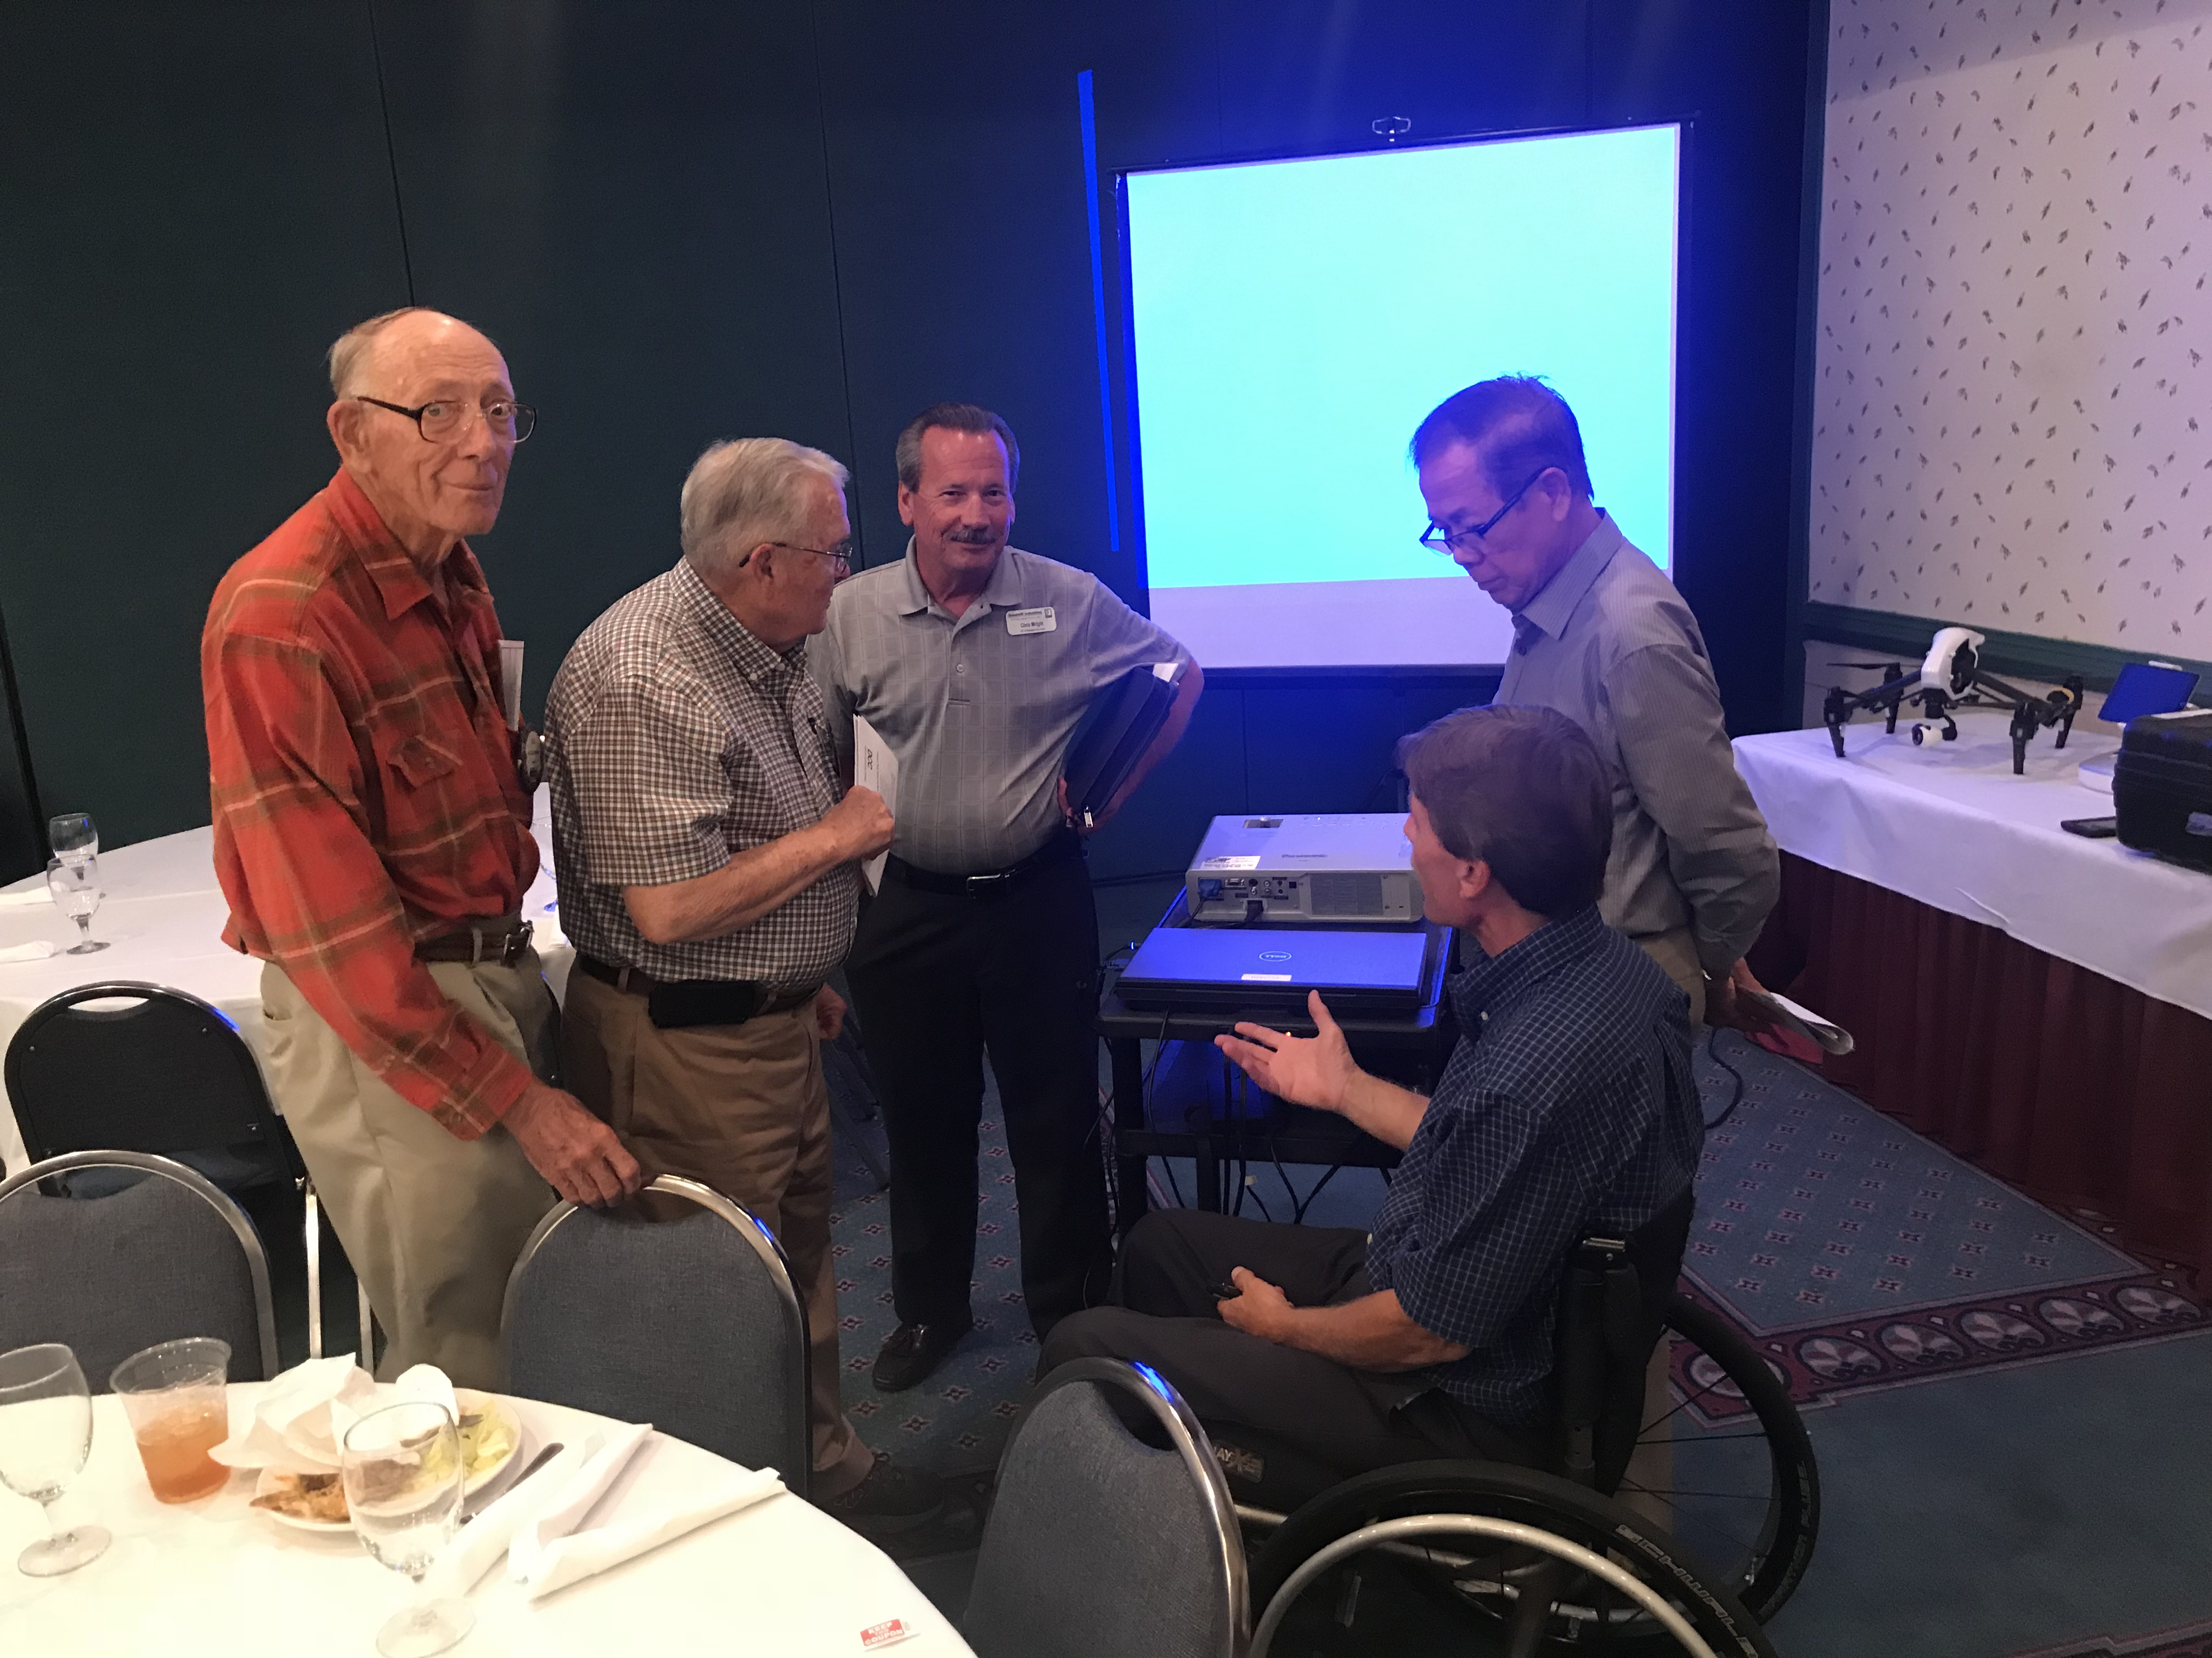

Want a picture in the Spoke!
Email it to c4@opbizz.com



This Day In History
June 3, 1965 – First American Astronaut Walks in Space
On June 3, 1965, 120 miles above the Earth, Major Edward H. White II opens the hatch of the Gemini 4 and steps out of the capsule, becoming the first American astronaut to walk in space. Attached to the craft by a 25-foot tether and controlling his movements with a hand-held oxygen jet-propulsion gun, White remained outside the capsule for just over 20 minutes. As a space walker, White had been preceded by Soviet cosmonaut Aleksei A. Leonov, who on March 18, 1965, was the first man ever to walk in space.
June 10th

Deputy Chief Brian Fox – Danville Life Saving Crew Drones

Tuesdays • 1:00 pm • Stratford Conference Center
2024-2025 OFFICERS

Dave Clark
President

Jennings McMann
President Elect

Chris Wright
Secretary

Jack Morning
Treasurer

Dan Angell
Assistant Treasurer

Cesar Guanzon
Eddie Cassada
Sergeant-At-Arms

Tom Gay
Past President
THIS WEEK’S PROGRAM
Tuesday, 6/3/2025

Printing compliments of
Agenda for our meeting today:
12:30 PM Lunch
12:50 PM Ring Bell - “My Country ‘Tis of Thee”,
Pledge & Invocation
Recite 4 Way Test
Introduction of Guest, Announcements, Happy Dollars,
Introduction of Speaker and Program
Drawing for 50 /50



Our Club Numbers

Active Current Members
29

Honorary Members
1

Paul Harris Fellows
38

Sustainers
29
Active Sustainers Percent
83.3%

Our goal is to have 100% Sustainers at $25.00 quarterly, $100.00 annually. Sustainer contributions support Rotary Programs in our District and the world. Did you know that 100% of your sustainer contributions are credited toward your Paul Harris Fellow level? You can also become a multiple-sustainer. Just let our Treasurer know.

