May
S | M | T | W | T | F | S
 |  | 6 | Cathy Gore – United Way
 |  | 13 | Adam Jones – The Brick
 |  | 20 | Renee Burton – Director of Planning and Zoning
 |  | 27

June
S | M | T | W | T | F | S
 |  | 3
 |  | 10
 |  | 17
 |  | 24

Check out our Club Website!
www.danvillevarotary.com

Don’t forget to wear
your Rotary pin! You will get to donate a $1.00 to the Club if you forget to wear it.

Of the Things We Think, Say, or Do,

Is it the Truth?

Is it Fair to All Concerned?

Will it Build Good Will and Better Friendships?

Will it be Beneficial to All Concerned?
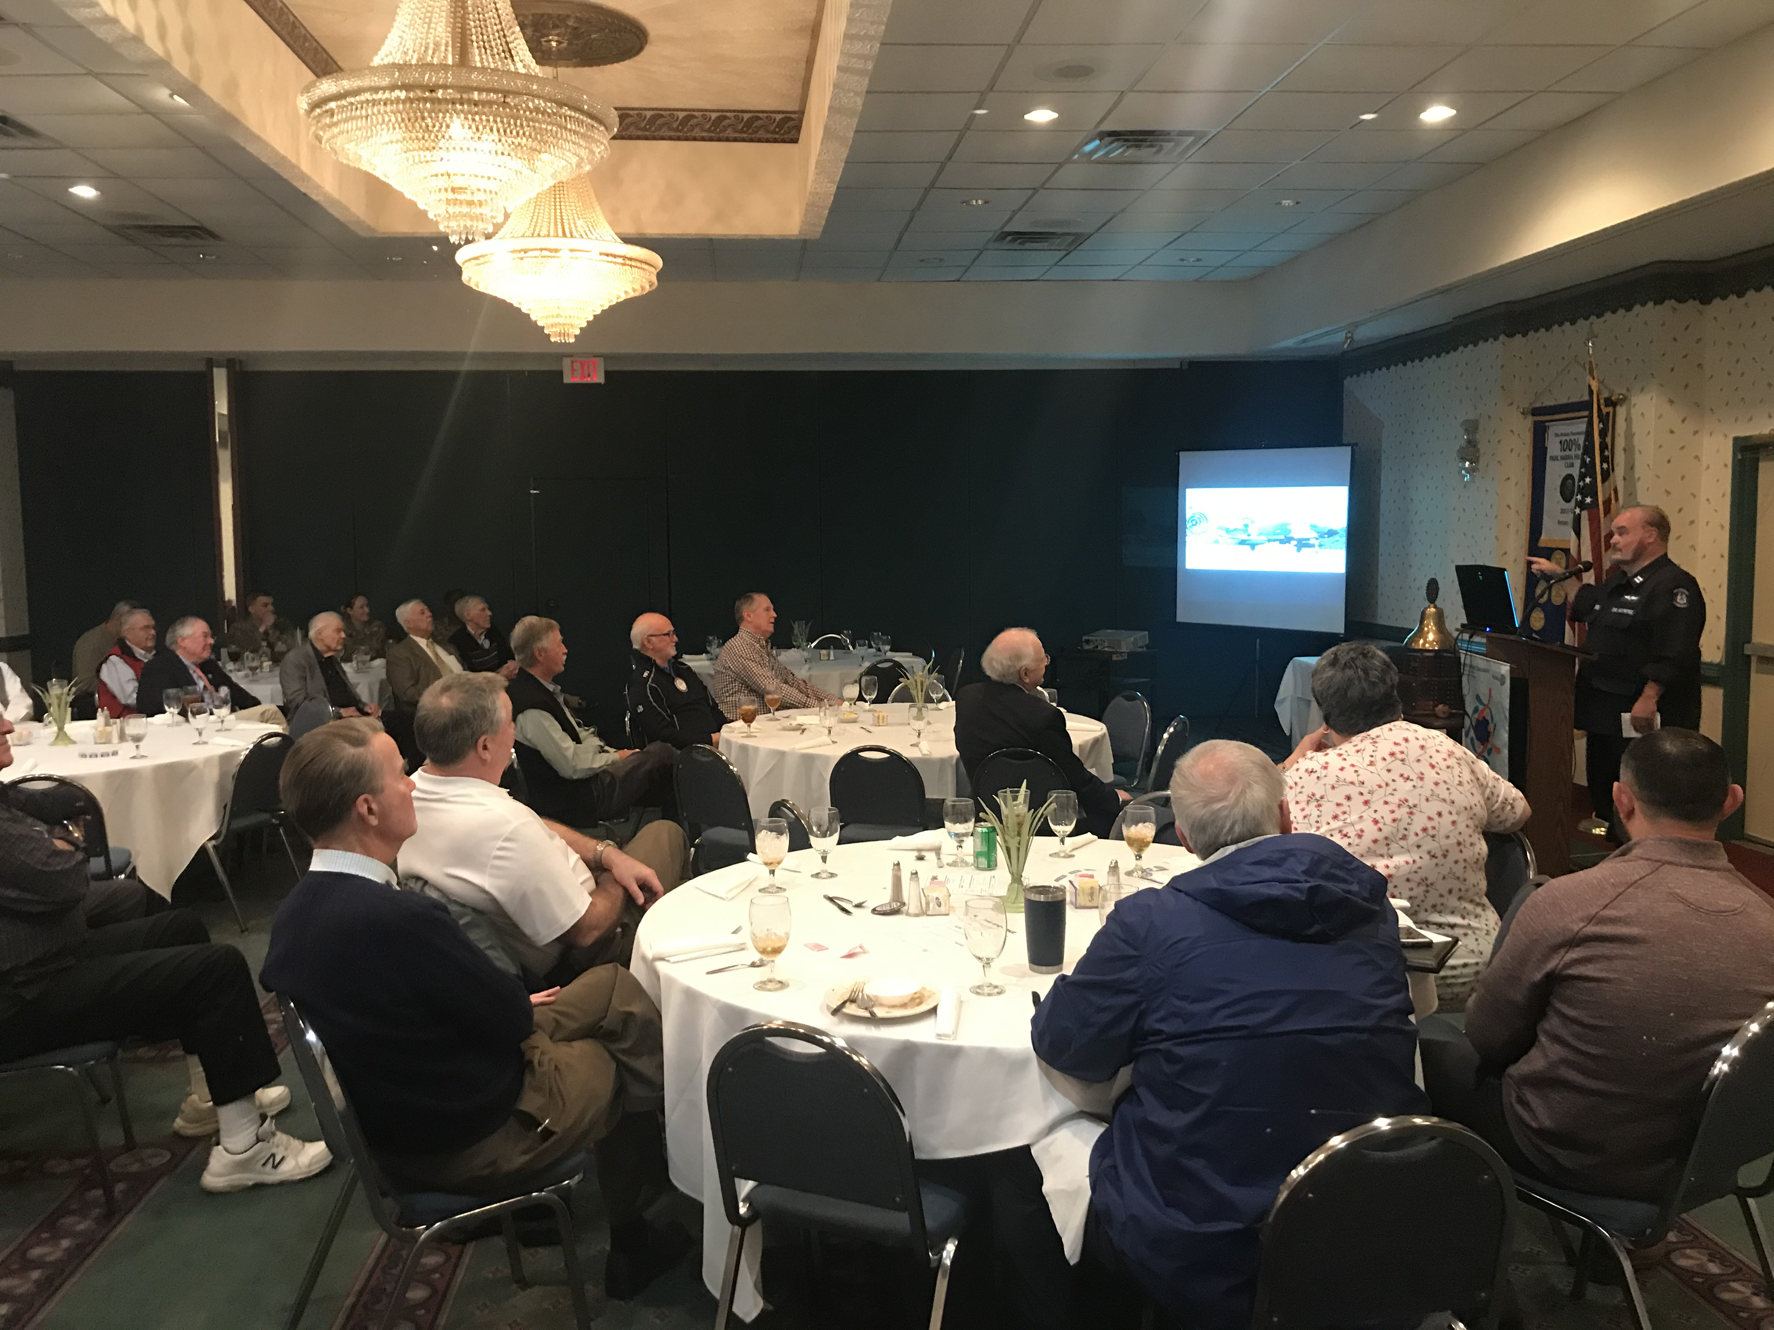

Want a picture in the Spoke!
Email it to c4@opbizz.com



This Day In History
May 20, 1498 – Vasco da Gama Reaches India
Portuguese explorer Vasco de Gama becomes the first European to reach India via the Atlantic Ocean when he arrives at Calicut on the Malabar Coast. Da Gama sailed from Lisbon, Portugal, in July 1497, rounded the Cape of Good Hope, and anchored at Malindi on the east coast of Africa. With the aid of an Indian merchant he met there, he then set off across the Indian Ocean. The Portuguese explorer was not greeted warmly by the Muslim merchants of Calicut, and in 1499 he had to fight his way out of the harbor on his return trip home. In 1502, he led a squadron of ships to Calicut to avenge the massacre of Portuguese explorers there and succeeded in subduing the inhabitants. In 1524, he was sent as viceroy to India, but he fell ill and died in Cochin.

May 27th

Tuesdays • 1:00 pm • Stratford Conference Center
2024-2025 OFFICERS

Dave Clark
President

Jennings McMann
President Elect

Chris Wright
Secretary

Jack Morning
Treasurer

Dan Angell
Assistant Treasurer

Cesar Guanzon
Eddie Cassada
Sergeant-At-Arms

Tom Gay
Past President
THIS WEEK’S PROGRAM
Tuesday, 5/20/2025

Renee Burton
Director of Planning and Zoning

Printing compliments of
Agenda for our meeting today:
12:30 PM Lunch
12:50 PM Ring Bell - “My Country ‘Tis of Thee”,
Pledge & Invocation
Recite 4 Way Test
Introduction of Guest, Announcements, Happy Dollars,
Introduction of Speaker and Program
Drawing for 50 /50



Our Club Numbers

Active Current Members
29

Honorary Members
1

Paul Harris Fellows
38

Sustainers
29
Active Sustainers Percent
83.3%

Our goal is to have 100% Sustainers at $25.00 quarterly, $100.00 annually. Sustainer contributions support Rotary Programs in our District and the world. Did you know that 100% of your sustainer contributions are credited toward your Paul Harris Fellow level? You can also become a multiple-sustainer. Just let our Treasurer know.

