May
S | M | T | W | T | F | S
 |  | 6 | Cathy Gore – United Way
 |  | 13 | Adam Jones – The Brick
 |  | 20 | Renee Burton – Director of Planning and Zoning
 |  | 27

June
S | M | T | W | T | F | S
 |  | 3
 |  | 10
 |  | 17
 |  | 24

Check out our Club Website!
www.danvillevarotary.com

Don’t forget to wear
your Rotary pin! You will get to donate a $1.00 to the Club if you forget to wear it.

Of the Things We Think, Say, or Do,

Is it the Truth?

Is it Fair to All Concerned?

Will it Build Good Will and Better Friendships?

Will it be Beneficial to All Concerned?
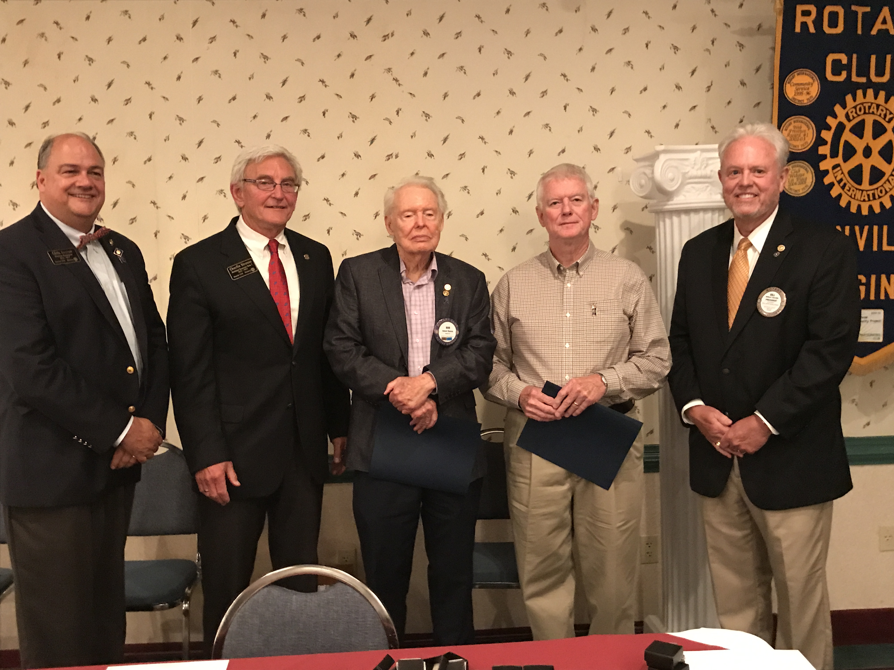

Want a picture in the Spoke!
Email it to c4@opbizz.com



This Day In History
May 13, 1920 – Socialists Party Nominates “Convict 2253” for President
On May 13, 1920, the Socialist Party nominates Eugene V. Debs as its candidate for president in the upcoming November election. There’s a slight complication, though: Debs is serving a 10-year sentence at a federal penitentiary in Atlanta and isn’t due to get out until 1928. As the New York Tribune observes, “his nomination marks the first instance in the history of the United States when the name of a person confined behind prison bars was presented to the people as a candidate for the chief magistracy of the nation.” It was the fifth nomination for the 64-year-old, Indiana-born labor leader, who began his career as a railroad worker and made his first bid for the presidency in 1900. Despite his inability to hit to campaign trail, Debs won more than 900,000 votes in the 1920 election, his best showing to date. The victor, Republican Warren G. Harding, commuted his sentence in December 1921, citing Debs’ age and physical condition. Though now a free man, Debs never ran for president again and died in 1926.

May 20th

Renee Burton – Director of Planning and Zoning

Tuesdays • 1:00 pm • Stratford Conference Center
2024-2025 OFFICERS

Dave Clark
President

Jennings McMann
President Elect

Chris Wright
Secretary

Jack Morning
Treasurer

Dan Angell
Assistant Treasurer

Cesar Guanzon
Eddie Cassada
Sergeant-At-Arms

Tom Gay
Past President
THIS WEEK’S PROGRAM
Tuesday, 5/13/2025

Adam Jones
The Brick

Printing compliments of
Agenda for our meeting today:
12:30 PM Lunch
12:50 PM Ring Bell - “My Country ‘Tis of Thee”,
Pledge & Invocation
Recite 4 Way Test
Introduction of Guest, Announcements, Happy Dollars,
Introduction of Speaker and Program
Drawing for 50 /50



Our Club Numbers

Active Current Members
29

Honorary Members
1

Paul Harris Fellows
38

Sustainers
29
Active Sustainers Percent
83.3%

Our goal is to have 100% Sustainers at $25.00 quarterly, $100.00 annually. Sustainer contributions support Rotary Programs in our District and the world. Did you know that 100% of your sustainer contributions are credited toward your Paul Harris Fellow level? You can also become a multiple-sustainer. Just let our Treasurer know.

