April
S | M | T | W | T | F | S
 |  | 1
 |  | 8
 |  | 15 | Sergeant Lane, VA State Police – Safe Driving Tips
 |  | 22
 |  | 29 | Joy Wood – Casino Funds Disbursement

May
S | M | T | W | T | F | S
 |  | 6
 |  | 13
 |  | 20
 |  | 27

Check out our Club Website!
www.danvillevarotary.com

Don’t forget to wear
your Rotary pin! You will get to donate a $1.00 to the Club if you forget to wear it.

Of the Things We Think, Say, or Do,

Is it the Truth?

Is it Fair to All Concerned?

Will it Build Good Will and Better Friendships?

Will it be Beneficial to All Concerned?

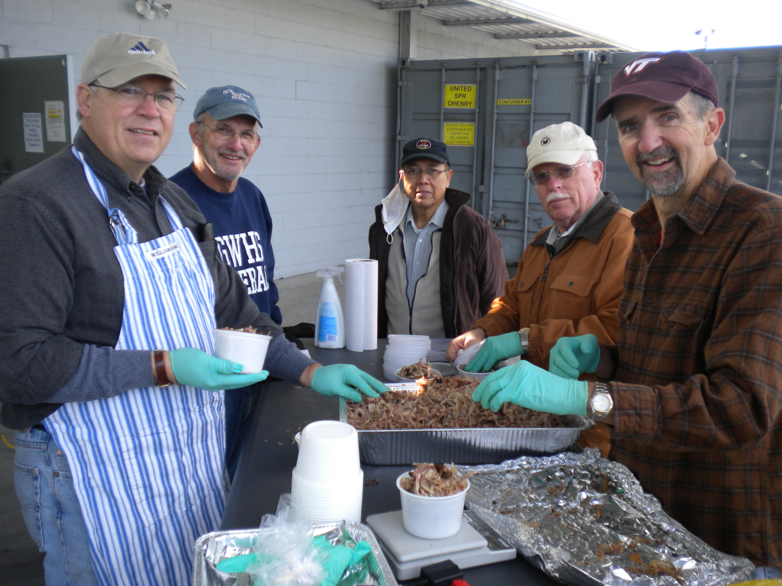

Want a picture in the Spoke!
Email it to c4@opbizz.com



This Day In History
April 1, 1789 – Hank Aaron Breaks Home Run Record
On April 8, 1974, Hank Aaron of the Atlanta Braves hits his 715th career home run, breaking Babe Ruth’s legendary record of 714 homers. A crowd of 53,775 people, the largest in the history of Atlanta-Fulton County Stadium, was with Aaron that night to cheer when he hit a 4th inning pitch off the Los Angeles Dodgers’ Al Downing. However, as Aaron was an African American who had received death threats and racist hate mail during his pursuit of one of baseball’s most distinguished records, the achievement was bittersweet. Aaron hung up his cleats in 1976 with 755 career home runs—a record that stood until 2007, when it was broken by controversial slugger Barry Bonds (Bonds admitted to using steroids in 2011).

April 15th

Sergeant Lane, VA State Police – Safe Driving

Tuesdays • 1:00 pm • Stratford Conference Center
2024-2025 OFFICERS

Dave Clark
President

Jennings McMann
President Elect

Chris Wright
Secretary

Jack Morning
Treasurer

Dan Angell
Assistant Treasurer

Cesar Guanzon
Eddie Cassada
Sergeant-At-Arms

Tom Gay
Past President
THIS WEEK’S PROGRAM
Tuesday, 4/8/2025

Printing compliments of
Agenda for our meeting today:
12:30 PM Lunch
12:50 PM Ring Bell - “My Country ‘Tis of Thee”,
Pledge & Invocation
Recite 4 Way Test
Introduction of Guest, Announcements, Happy Dollars,
Introduction of Speaker and Program
Drawing for 50 /50



Our Club Numbers

Active Current Members
29

Honorary Members
1

Paul Harris Fellows
38

Sustainers
29
Active Sustainers Percent
83.3%

Our goal is to have 100% Sustainers at $25.00 quarterly, $100.00 annually. Sustainer contributions support Rotary Programs in our District and the world. Did you know that 100% of your sustainer contributions are credited toward your Paul Harris Fellow level? You can also become a multiple-sustainer. Just let our Treasurer know.

