April
S | M | T | W | T | F | S
 |  | 1
 |  | 8 | Vic Ingram
 |  | 15 | Sergeant Lane, VA State Police – Safe Driving Tips
 |  | 22 | John Haynsworth
 |  | 29 | Joy Wood – Casino Funds Disbursement

May
S | M | T | W | T | F | S
 |  | 6
 |  | 13
 |  | 20 | Renee Burton – Director of Planning and Zoning
 |  | 27

Check out our Club Website!
www.danvillevarotary.com

Don’t forget to wear
your Rotary pin! You will get to donate a $1.00 to the Club if you forget to wear it.

Of the Things We Think, Say, or Do,

Is it the Truth?

Is it Fair to All Concerned?

Will it Build Good Will and Better Friendships?

Will it be Beneficial to All Concerned?

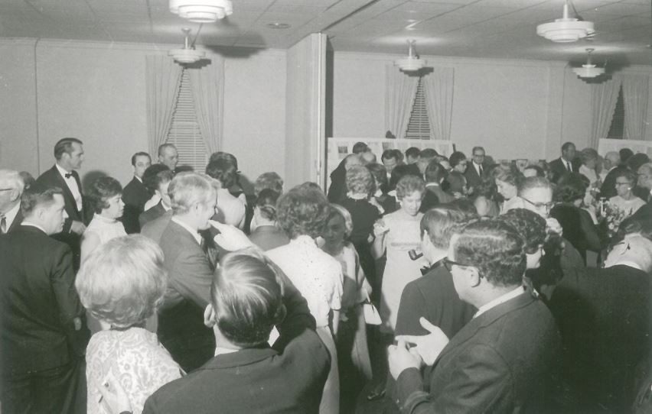

Want a picture in the Spoke!
Email it to c4@opbizz.com



This Day In History
April 29, 1947 – Nixon Announces Release of Watergate Tapes
On April 29, 1974, President Richard Nixon announces to the public that he will release transcripts of 46 taped White House conversations in response to a Watergate trial subpoena issued in July 1973. The House Judiciary committee accepted 1,200 pages of transcripts the next day, but insisted that the tapes themselves be turned over as well. On August 8, 1974, Nixon avoided a Senate impeachment trial by becoming the first American president to resign from office. He was later pardoned by his successor, President Gerald Ford, “for all offenses against the United States which he committed, or may have committed.”

May 6th

Tuesdays • 1:00 pm • Stratford Conference Center
2024-2025 OFFICERS

Dave Clark
President

Jennings McMann
President Elect

Chris Wright
Secretary

Jack Morning
Treasurer

Dan Angell
Assistant Treasurer

Cesar Guanzon
Eddie Cassada
Sergeant-At-Arms

Tom Gay
Past President
THIS WEEK’S PROGRAM
Tuesday, 4/29/2025

Joy Wood
Casino Funds Disbursement

Printing compliments of
Agenda for our meeting today:
12:30 PM Lunch
12:50 PM Ring Bell - “My Country ‘Tis of Thee”,
Pledge & Invocation
Recite 4 Way Test
Introduction of Guest, Announcements, Happy Dollars,
Introduction of Speaker and Program
Drawing for 50 /50



Our Club Numbers

Active Current Members
29

Honorary Members
1

Paul Harris Fellows
38

Sustainers
29
Active Sustainers Percent
83.3%

Our goal is to have 100% Sustainers at $25.00 quarterly, $100.00 annually. Sustainer contributions support Rotary Programs in our District and the world. Did you know that 100% of your sustainer contributions are credited toward your Paul Harris Fellow level? You can also become a multiple-sustainer. Just let our Treasurer know.

