April
S | M | T | W | T | F | S
 |  | 1
 |  | 8 | Vic Ingram
 |  | 15 | Sergeant Lane, VA State Police – Safe Driving Tips
 |  | 22
 |  | 29 | Joy Wood – Casino Funds Disbursement

May
S | M | T | W | T | F | S
 |  | 6
 |  | 13
 |  | 20
 |  | 27

Check out our Club Website!
www.danvillevarotary.com

Don’t forget to wear
your Rotary pin! You will get to donate a $1.00 to the Club if you forget to wear it.

Of the Things We Think, Say, or Do,

Is it the Truth?

Is it Fair to All Concerned?

Will it Build Good Will and Better Friendships?

Will it be Beneficial to All Concerned?

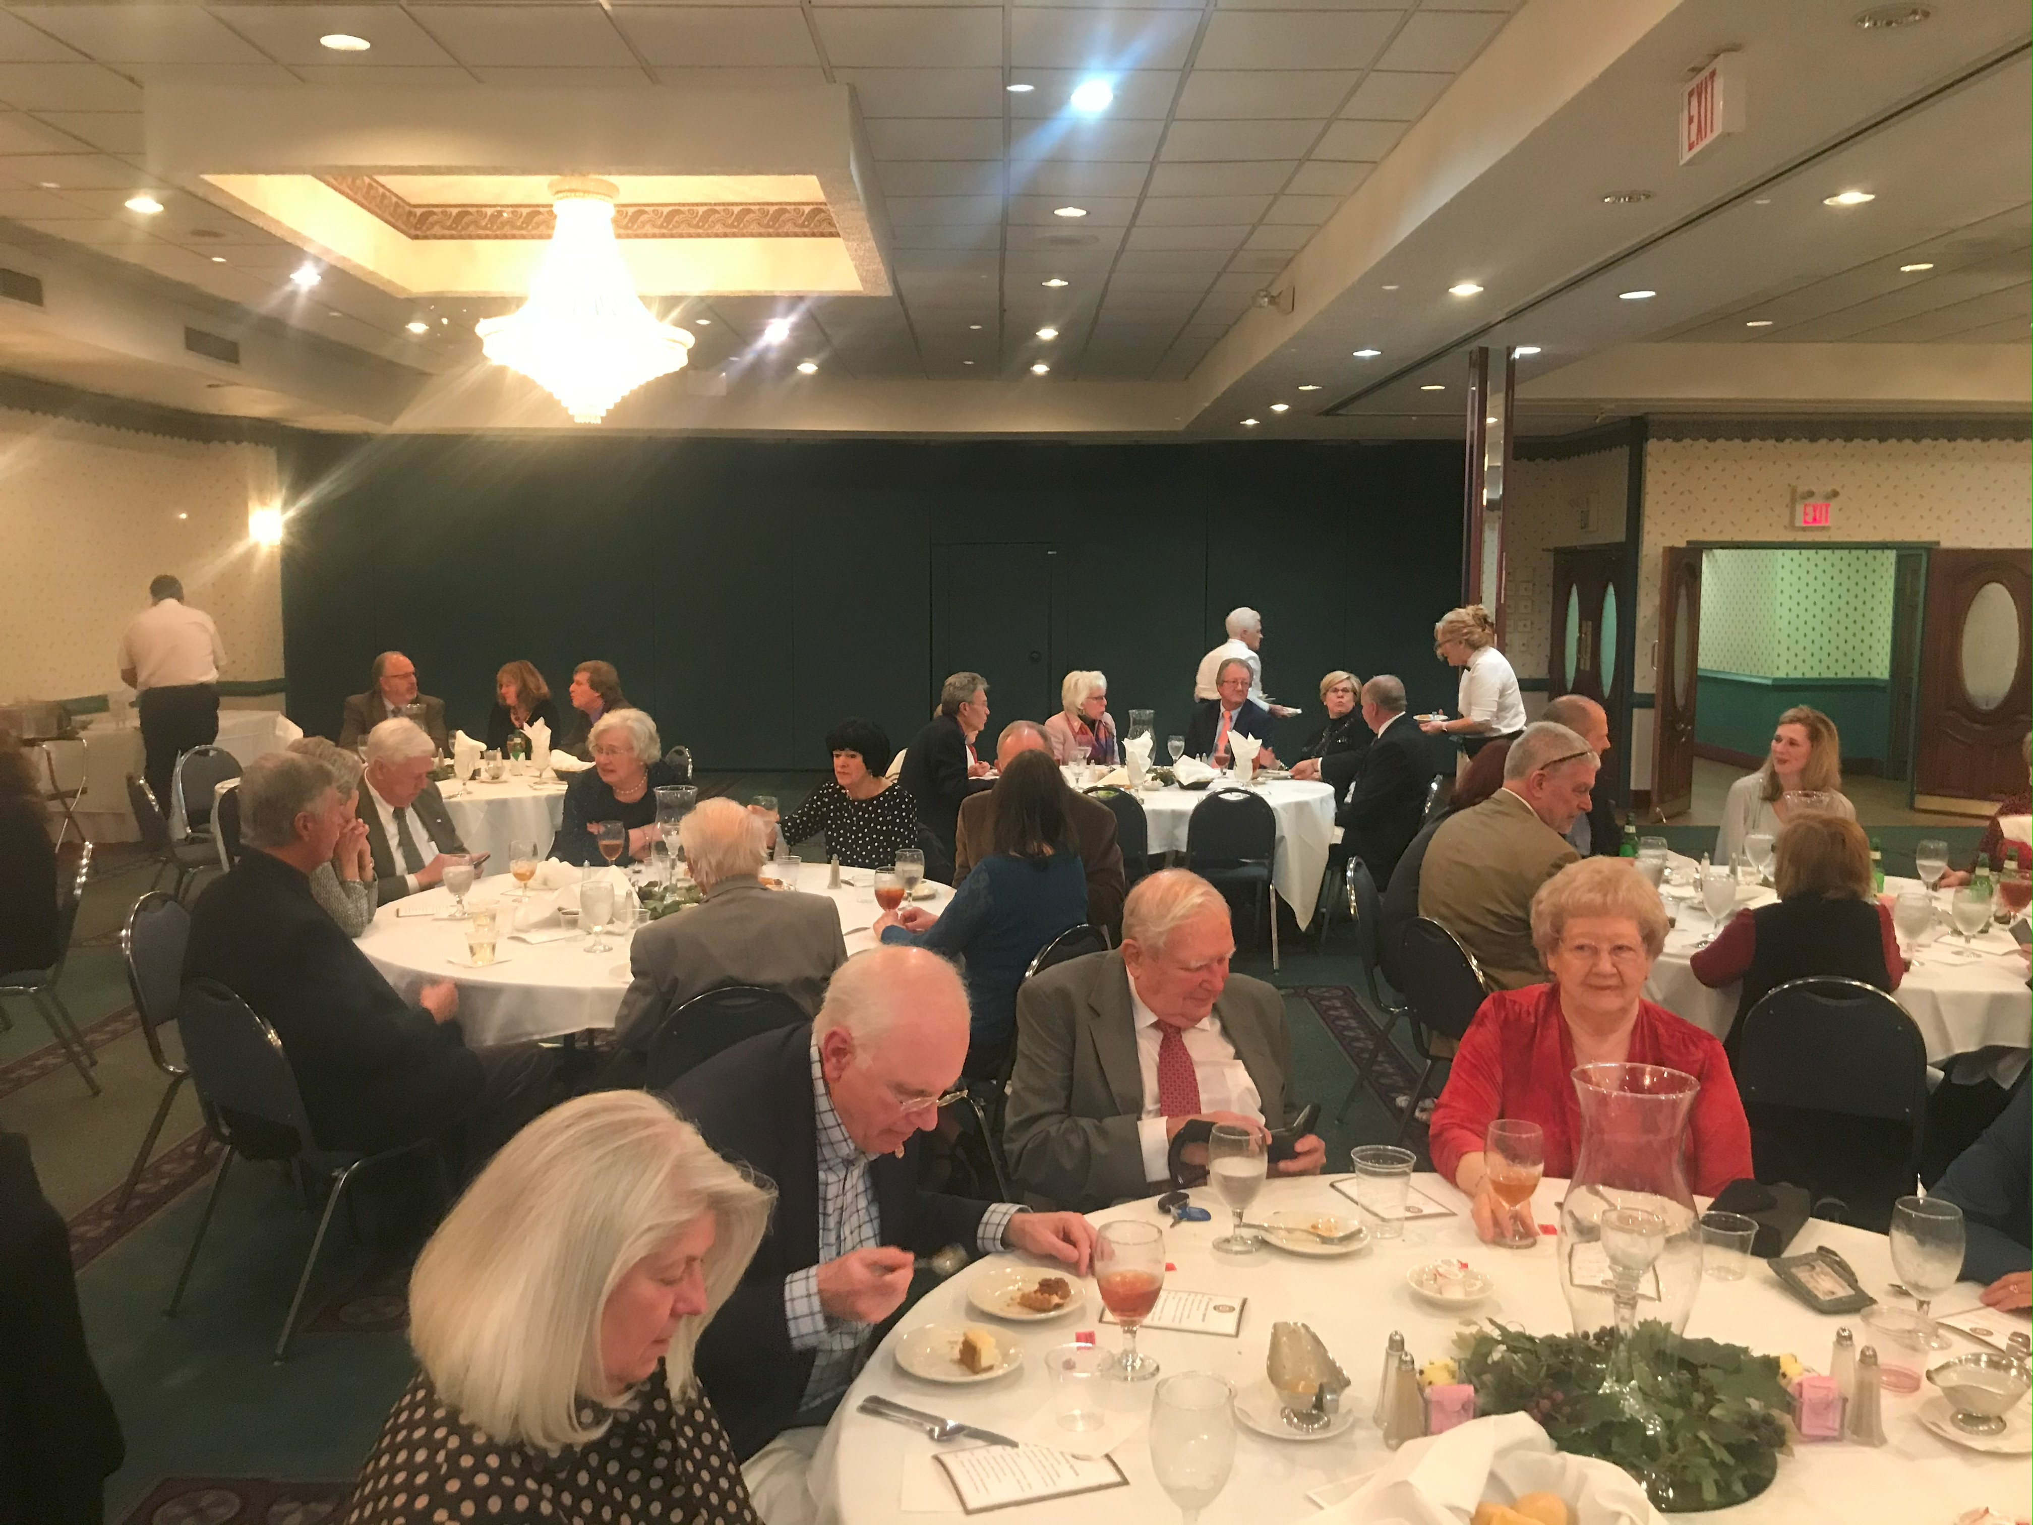

Want a picture in the Spoke!
Email it to c4@opbizz.com



This Day In History
April 15, 1947 – Jackie Robinson Steps on the Field
On April 15, 1947, Jackie Robinson, age 28, becomes the first African American player in Major League Baseball's modern era when he steps onto Ebbets Field in Brooklyn to compete for the Brooklyn Dodgers. Robinson broke the color barrier in a sport that had been segregated for more than 50 years. Exactly 50 years later, on April 15, 1997, Robinson’s groundbreaking career was honored and his uniform number, 42, was retired from Major League Baseball by Commissioner Bud Selig in a ceremony attended by over 50,000 fans at New York City’s Shea Stadium. Robinson’s was the first-ever number retired by all teams in the league.

April 22nd

Tuesdays • 1:00 pm • Stratford Conference Center
2024-2025 OFFICERS

Dave Clark
President

Jennings McMann
President Elect

Chris Wright
Secretary

Jack Morning
Treasurer

Dan Angell
Assistant Treasurer

Cesar Guanzon
Eddie Cassada
Sergeant-At-Arms

Tom Gay
Past President
THIS WEEK’S PROGRAM
Tuesday, 4/15/2025

Sergeant Lane – VA State Police Officer
Safe Driving Tips

Printing compliments of
Agenda for our meeting today:
12:30 PM Lunch
12:50 PM Ring Bell - “My Country ‘Tis of Thee”,
Pledge & Invocation
Recite 4 Way Test
Introduction of Guest, Announcements, Happy Dollars,
Introduction of Speaker and Program
Drawing for 50 /50



Our Club Numbers

Active Current Members
29

Honorary Members
1

Paul Harris Fellows
38

Sustainers
29
Active Sustainers Percent
83.3%

Our goal is to have 100% Sustainers at $25.00 quarterly, $100.00 annually. Sustainer contributions support Rotary Programs in our District and the world. Did you know that 100% of your sustainer contributions are credited toward your Paul Harris Fellow level? You can also become a multiple-sustainer. Just let our Treasurer know.

