April
S | M | T | W | T | F | S
 |  | 1
 |  | 8
 |  | 15
 |  | 22
 |  | 29

May
S | M | T | W | T | F | S
 |  | 6
 |  | 13
 |  | 20
 |  | 27

Check out our Club Website!
www.danvillevarotary.com

Don’t forget to wear
your Rotary pin! You will get to donate a $1.00 to the Club if you forget to wear it.

Of the Things We Think, Say, or Do,

Is it the Truth?

Is it Fair to All Concerned?

Will it Build Good Will and Better Friendships?

Will it be Beneficial to All Concerned?

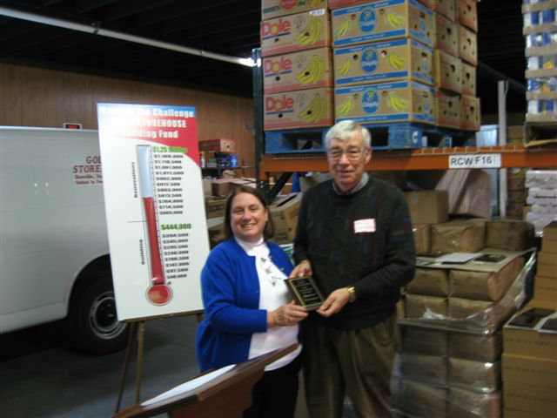

Want a picture in the Spoke!
Email it to c4@opbizz.com



This Day In History
April 1, 1789 – First U.S. House of Representatives Elects Speaker
On April 1, 1789, the first U.S. House of Representatives, meeting in New York City, reaches quorum and elects Pennsylvania Representative Frederick Augustus Conrad Muhlenberg as its first speaker.
Muhlenberg, a Lutheran minister and the former president of the Pennsylvania convention to ratify the U.S. Constitution, was the son of Henry Augustus Muhlenberg and grandson of Johann Conrad Weiser, two of the leading Germans in colonial Pennsylvania. His brother, Major General John Peter Gabriel Muhlenberg, also served in the first House of Representatives. For three years, he served as pastor to congregations in New Hanover, Oley and New Goshenhoppen before embarking on a political career.

April 8th

Tuesdays • 1:00 pm • Stratford Conference Center
2024-2025 OFFICERS

Dave Clark
President

Jennings McMann
President Elect

Chris Wright
Secretary

Jack Morning
Treasurer

Dan Angell
Assistant Treasurer

Cesar Guanzon
Eddie Cassada
Sergeant-At-Arms

Tom Gay
Past President
THIS WEEK’S PROGRAM
Tuesday, 4/1/2025

Printing compliments of
Agenda for our meeting today:
12:30 PM Lunch
12:50 PM Ring Bell - “My Country ‘Tis of Thee”,
Pledge & Invocation
Recite 4 Way Test
Introduction of Guest, Announcements, Happy Dollars,
Introduction of Speaker and Program
Drawing for 50 /50



Our Club Numbers

Active Current Members
29

Honorary Members
1

Paul Harris Fellows
38

Sustainers
29
Active Sustainers Percent
83.3%

Our goal is to have 100% Sustainers at $25.00 quarterly, $100.00 annually. Sustainer contributions support Rotary Programs in our District and the world. Did you know that 100% of your sustainer contributions are credited toward your Paul Harris Fellow level? You can also become a multiple-sustainer. Just let our Treasurer know.

