March
S | M | T | W | T | F | S
 |  | 4 | Ken Bowman – Pittsylvania County Board of Supervisors
 |  | 11
 |  | 18 | Ralph Hawkins – Averett University
 |  | 25

April
S | M | T | W | T | F | S
 |  | 1
 |  | 8
 |  | 15
 |  | 22
 |  | 29

Check out our Club Website!
www.danvillevarotary.com

Don’t forget to wear
your Rotary pin! You will get to donate a $1.00 to the Club if you forget to wear it.

Of the Things We Think, Say, or Do,

Is it the Truth?

Is it Fair to All Concerned?

Will it Build Good Will and Better Friendships?

Will it be Beneficial to All Concerned?

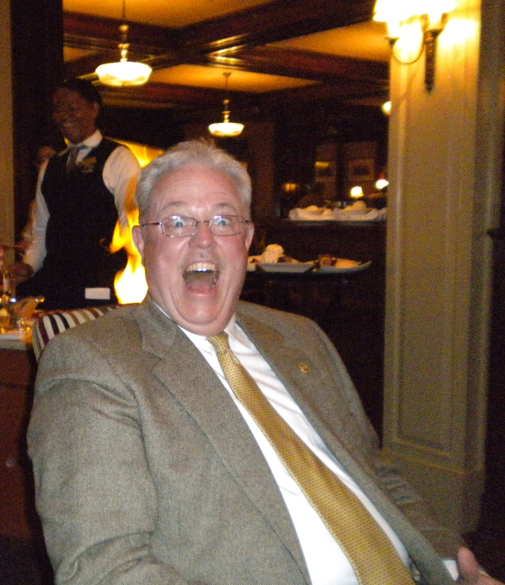

Want a picture in the Spoke!
Email it to c4@opbizz.com



This Day In History
March 18, 1852 – Wells & Fargo Start Their Company
On March 18, 1852, in New York City, Henry Wells and William G. Fargo join with several other investors to launch their namesake business, today one of the world's largest banks. The discovery of gold in California in 1849 prompted a huge spike in the demand for cross-country shipping. Wells and Fargo decided to take advantage of these great opportunities. In July 1852, their company shipped its first loads of freight from the East Coast to mining camps scattered around northern California. The company contracted with independent stagecoach companies to provide the fastest possible transportation and delivery of gold dust, important documents and other valuable freight. It also served as a bank—buying gold dust, selling paper bank drafts and providing loans to help fuel California’s growing economy.

March 25th

Tuesdays • 1:00 pm • Stratford Conference Center
2024-2025 OFFICERS

Dave Clark
President

Jennings McMann
President Elect

Chris Wright
Secretary

Jack Morning
Treasurer

Dan Angell
Assistant Treasurer

Cesar Guanzon
Eddie Cassada
Sergeant-At-Arms

Tom Gay
Past President
THIS WEEK’S PROGRAM
Tuesday, 3/18/2025

Ralph Hawkins – Averett University
“Resurrection in the Old Testament”

Printing compliments of
Agenda for our meeting today:
12:30 PM Lunch
12:50 PM Ring Bell - “My Country ‘Tis of Thee”,
Pledge & Invocation
Recite 4 Way Test
Introduction of Guest, Announcements, Happy Dollars,
Introduction of Speaker and Program
Drawing for 50 /50



Our Club Numbers

Active Current Members
29

Honorary Members
1

Paul Harris Fellows
38

Sustainers
29
Active Sustainers Percent
83.3%

Our goal is to have 100% Sustainers at $25.00 quarterly, $100.00 annually. Sustainer contributions support Rotary Programs in our District and the world. Did you know that 100% of your sustainer contributions are credited toward your Paul Harris Fellow level? You can also become a multiple-sustainer. Just let our Treasurer know.

