March
S | M | T | W | T | F | S
 |  | 4 | Ken Bowman – Pittsylvania County Board of Supervisors
 |  | 11
 |  | 18 | Ralph Hawkins – Averett University
 |  | 25

April
S | M | T | W | T | F | S
 |  | 1
 |  | 8
 |  | 15
 |  | 22
 |  | 29

Check out our Club Website!
www.danvillevarotary.com

Don’t forget to wear
your Rotary pin! You will get to donate a $1.00 to the Club if you forget to wear it.

Of the Things We Think, Say, or Do,

Is it the Truth?

Is it Fair to All Concerned?

Will it Build Good Will and Better Friendships?

Will it be Beneficial to All Concerned?

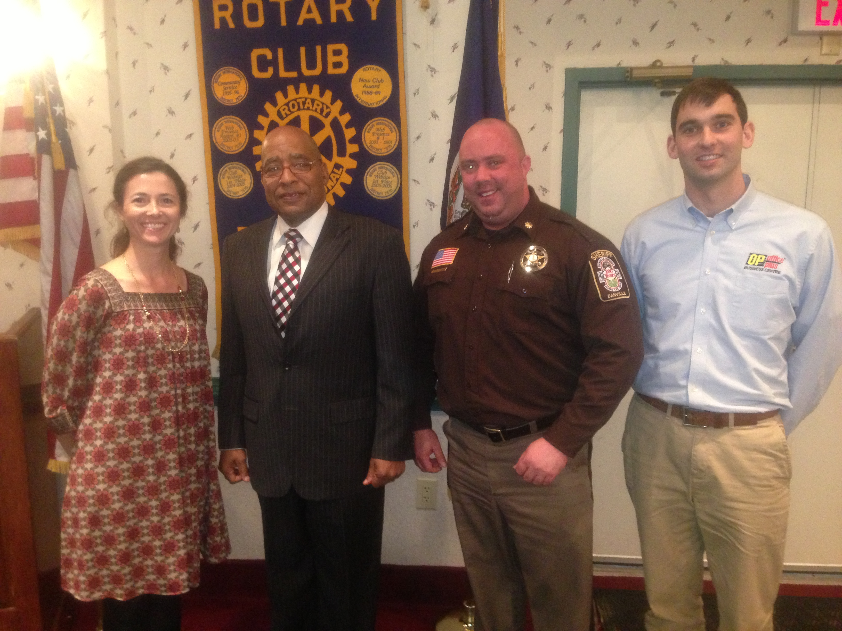

Want a picture in the Spoke!
Email it to c4@opbizz.com



This Day In History
March 11, 1989 – “COPS” Makes TV Debut
On March 11, 1989, "Cops," a documentary-style television series that follows police officers and sheriff’s deputies as they go about their jobs, debuts on Fox. In 1989, the debut episode of "Cops" featured the men and women of the Broward County Sheriff’s Department in Florida. The show aired over 1,000 episodes and filmed in 140 U.S. cities, as well as international locations including London and Hong Kong. With its widely recognized theme song, “Bad Boys” by the reggae group Inner Circle, "Cops" had spawned numerous imitators in addition to parody shows. "Cops" went on to become one of the longest-running shows in television history. It went off the air in 2020.

March 18th

Ralph Hawkins – Averett University

Tuesdays • 1:00 pm • Stratford Conference Center
2024-2025 OFFICERS

Dave Clark
President

Jennings McMann
President Elect

Chris Wright
Secretary

Jack Morning
Treasurer

Dan Angell
Assistant Treasurer

Cesar Guanzon
Eddie Cassada
Sergeant-At-Arms

Tom Gay
Past President
THIS WEEK’S PROGRAM
Tuesday, 3/11/2025

Printing compliments of
Agenda for our meeting today:
12:30 PM Lunch
12:50 PM Ring Bell - “My Country ‘Tis of Thee”,
Pledge & Invocation
Recite 4 Way Test
Introduction of Guest, Announcements, Happy Dollars,
Introduction of Speaker and Program
Drawing for 50 /50



Our Club Numbers

Active Current Members
29

Honorary Members
1

Paul Harris Fellows
38

Sustainers
29
Active Sustainers Percent
83.3%

Our goal is to have 100% Sustainers at $25.00 quarterly, $100.00 annually. Sustainer contributions support Rotary Programs in our District and the world. Did you know that 100% of your sustainer contributions are credited toward your Paul Harris Fellow level? You can also become a multiple-sustainer. Just let our Treasurer know.

