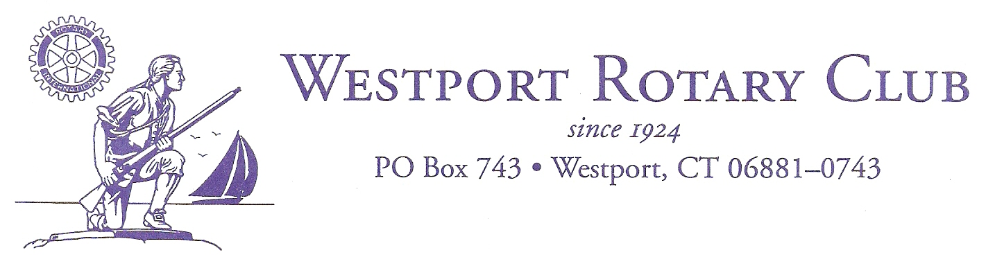
December 27, 2018
Dear Westport Rotary Community Partnership Grant Applicant,
The Westport Rotary is committed to supporting charitable causes on both an international and domestic basis. We believe that local community partnerships are an important part of our mission and we are proud to support organizations such as yours that help our friends and neighbors right here in Fairfield County.
At this time, we are beginning the application process for our 2019 Community Partnership Grants. Please find a copy of a new, revised application attached to this e-mail. Please do not use the old application form.
Applications and supporting documentation must be submitted via email to: ilebish@optonline.net.
The deadline for submission of applications is Friday, March 1, 2019
In making your request, please keep in mind that grants typically range from $500 to $4,500. Every year we receive more requests than we are able to fund. Please remember that grants are not guaranteed year to year. Community Partnership Grant recipients will be notified of our decision by e-mail around the middle of April and awards will be presented at the Westport Rotary Luncheon at Christ and Holy Trinity Church on Tuesday, May 14th, 2019.
Please feel free to contact us with any questions or concerns you may have. We look forward to reviewing your application.
Sincerely,
Irwin Lebish
Community Grants Chair, Westport Rotary Club
ilebish@optonline.net
cell: 203-451-4228
Home: 203-222-0626

