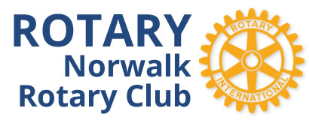

P.O. BOX 531

NORWALK, CONNECTICUT 06852

www.norwalkrotary.org

Welcome Prospective New Member,

Thank you for your interest in our club. We are a small but close knit group of members who live or work in the Norwalk area…. several for most of their lives. The Norwalk Rotary Club is committed to helping residents in our City and providing community service to individuals and organizations for the betterment of all. By participating in club service projects, members volunteer their time and talent where they are most needed in service, fund raising, and fun activities. Rotary is a “Service Above Self” organization.

The Rotary Club meets most Wednesdays for lunch at the Norwalk Inn, 99 East Avenue, Norwalk at 12:15 pm. We have some amazing speakers at our lunch meetings. Approximately once per month, we forego our lunch meeting and meet after work at a local restaurant for an informal gathering where friends, family, and co-workers are invited to join us for networking. The Club will be involved in 8-10 service project activities during the year. These activities are local and vary in the day and time, but usually last 1-4 hours. Recent service projects have included distributing dictionaries to 3rd Graders in the Norwalk Public Schools, assisting the Seaport Association food booth at the Oyster Festival, Salvation Army Bell Ringing, and the Citywide Spring Cleanup just to name a few.

The Club fund raisers are fun and exciting to plan. Our 4th Annual Cooking for Charity is coming up in November at Aitoro Appliance. There is also the 2nd Annual Put for Charity at the Norwalk Cove Marina in May to benefit the Norwalk Fire Department.

If you have any questions, please contact us at info@norwalkrotary.org.

Yours in Rotary Service,

Tony Lopez
President

