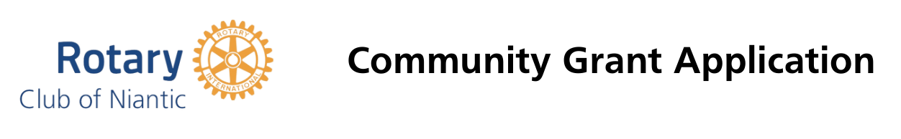
Please fill out all fields below and email to: nianticrotary@gmail.com OR mail to ATTN GRANTS, PO Box 339, Niantic, CT 06357.
DEADLINE to submit is DECEMBER 1, 2022
CLICK IN CELL AND TYPE
Date
Name of Organization
Address
City/State/Zip
Email Address
Cell Phone
Name of Applicant
Title of Applicant
Does the organization currently have a
501 (C) 3 designation?
Has your organization received a Niantic Rotary Community Grant before?
Are you requesting a specific amount? If so, how much?
Please provide details on how, if awarded, the grant monies will be used (Please feel free to provide an additional sheet if necessary):
`

