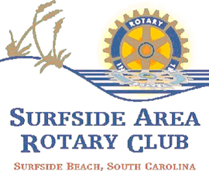

Rotarian Name

Where do you hail from and what is your alma mater? Tell us a little about your children/family.

When did you arrive in the Grand Strand? Since your arrival What awards have you won in the past that you would
here, what has been your favorite experience? like to share with us?

What do you believe is your greatest professional Please explain your career at this time. Was this the
accomplishment? career path you planned or have you had a surprise
along the way?

Tell us something about yourself that if no one ever asked you, What is your all-time favorite movie?
It would be a secret forever.

Besides the Surfside Rotary charity involvement, what is the local What is your favorite place that you have ever traveled
charity that you support most and why? or visited?

What is your favorite pastime, hobby, and sport? If you could interview any person, dead or alive, who would
It be and why?

Do you currently use the District database?

