Rotary District 7770 Youth Exchange Scholar
Long Term

Eastern, SC, USA
“It’s not a year in a life, but a life in a year.”

Long Term Exchange Overview: Takes place over an entire school year (approximately 10 months). Our district participates in exchanges with countries all over the world. An individual student will stay with up to 3 host families over this time. During the exchange the student will become fluent in a 2nd language and gain confidence and maturity. The exchange will also enhance the student’s college applications and job opportunities as well as familiarizing the student with a foreign culture.
How to Apply :
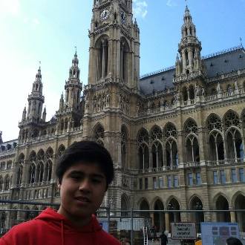
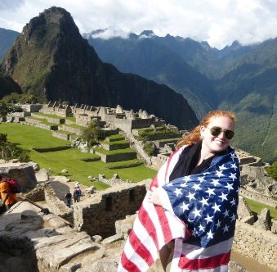
- Go to www.rotaryyouthexchange7770.org
- Click on the image for the long term application
(this is a preliminary application)
- Print and complete the Preliminary Application.
- Once preliminary application is completed send it:
to your local rotary club Youth Exchange officer or
email the form to LouMello9@gmail.com
Preliminary Application Deadline is Nov. 1st

Apply early, limited number of exchanges!
- Once preliminary applications are reviewed and interviews have taken place, accepted students will receive an email with login instructions on how to complete a Full Online Application and will be scheduled for more interviews and Rotary YE training.
- Full Online Application Deadline is November 30th

Helpful links: www.rotaryyouthexchange7770.org
https://www.rotary.org/en/youth-exchanges
- $500 Application Fee
- Health Insurance (2017-18) insurance cost was ~$1000 (expect annual increases).
- Parents responsible for passport, language camps, visas, travel expenses, language camp (if ne necessary) and pocket money.
- Rotary International does not profit. Any fees paid by sponsoring club or paid by
parents are to cover costs and insurance.
- Emergency fund $350-$450 cash reserve. Returned if student does not use.
- Student scholar is paid a stipend of (approximately $100/month by Host Rotary Club)

Student Scholar Costs:

Student Scholar Requirements:
- Must Have the Best Year of Your Life!
- Must attend High School in foreign country
- Participate in Rotary Functions
- Must be 15 to 18 ½ years old
- Academically strong
- Articulate, Outgoing
- Demonstrate Leadership
- Familiar with a foreign language
- Obtain a passport and visa
- Willing to meet new people
- Have multiple interviews with Rotarians
- Attend Rotary District 7770 Conference in March - Required
- Attend Outbound Training Weekend in June – Required

