**ROTARY CLUB CENTRAL GUIDE TO GOAL ENTRY**

**Foundation Giving**

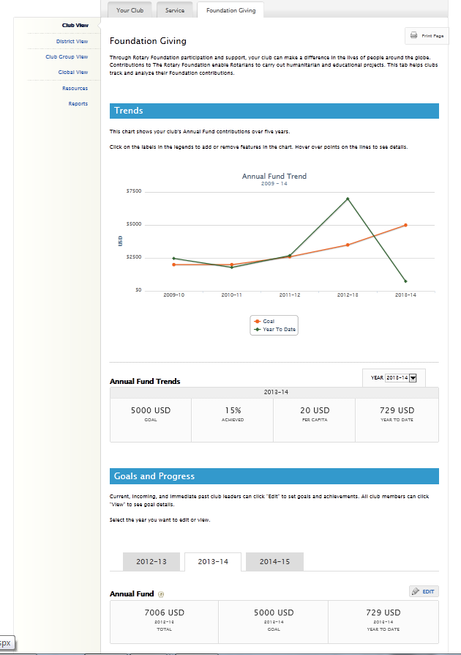

Select **Foundation Giving**.

Select the year of the goals you want to set. Default is current year.

Use the drop-down to see your club’s donations to the Annual Fund for the last five years.

Then click **EDIT** to update a goal.

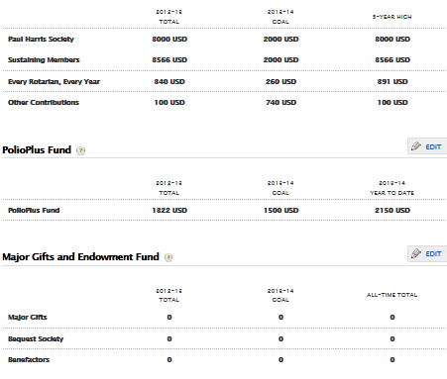

Click **EDIT** to update a goal.

Enter the number of donors you would like to have in each category. Please only enter an individual at their highest giving level.

Enter the average contribution amount for an individual.

Highest amount in any of the past 5 years. Data supplied by Rotary.

**Annual Fund**

Data is automatically calculated based on the goals entered.

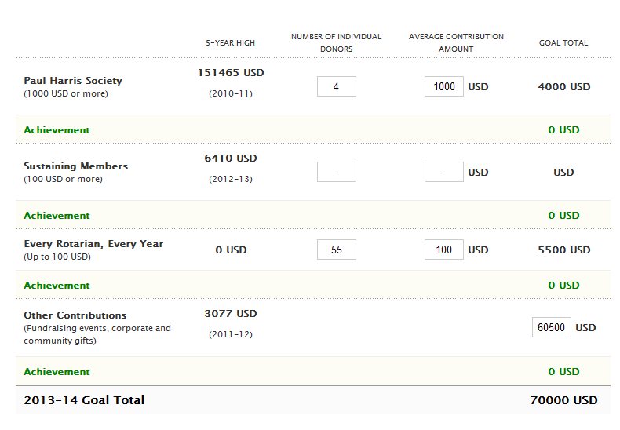

Data supplied by Rotary.

**C:\Users\lazare\AppData\Local\Microsoft\Windows\Temporary Internet Files\Content.IE5\YO635AEY\MC900290930[1].wmfIf unable to enter each area, please use “Other Contributions” to enter lump sum goal.**

**PolioPlus Fund**

Data supplied by Rotary.



Enter the amount your club would like to give.

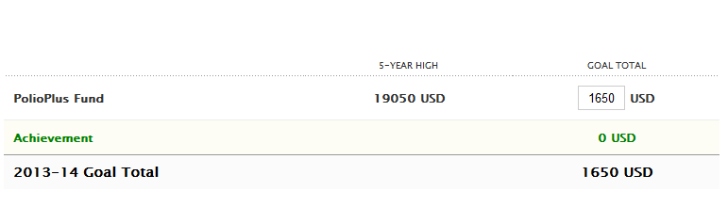

Data supplied by Rotary.

**Major Gifts and Endowment Fund**

The total number of members who have achieved each level during their time as a Rotarian. Data supplied by Rotary.

Enter the number of individuals who will commit to each giving level. The donation doesn’t have to be received during a club leader’s term, but the commitment must be.



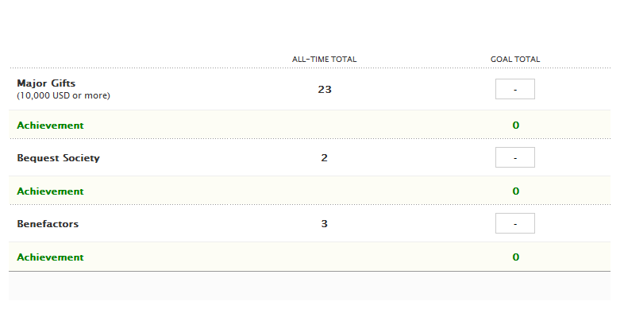

Data supplied by Rotary.

*Request a **Club Fundraising Analysis** from [contact.center@rotary.org](mailto:contact.center@rotary.org) to see a 5 Rotary year dashboard of Annual Fund goals, giving and recognition totals.