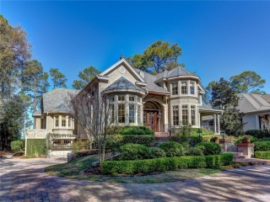
MILLION DOLLAR HOME TOUR
SATURDAY MARCH 25, 2017
$25 INCLUDES TRANSPORTATION AND LUNCH
12:00 P.M. LEAVING FROM THE HOTEL LOBBY
CONTACT: DENNIS NELSON TO REGISTER
dennishnelson@gmail.com

