District Governor Award

Go to the District Tab
Click on the 7730 Governor Award Icon

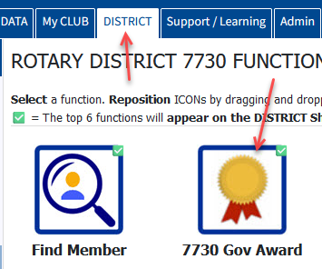

If you do not see the icon, click on the configuration wheel on the top right of the page. Drag the icon from icons available to icons displayed and click on set my configuration.

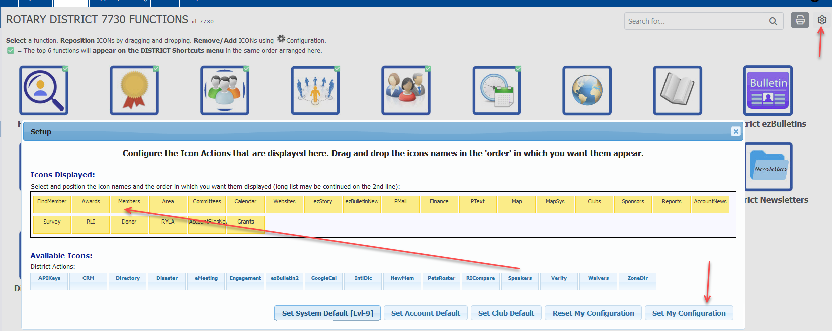

Now click on the Governor Award Icon

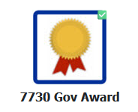
On the left side click on Activity Entry

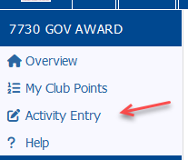

Just put a check mark in the boxes in front of the goals you achieved so far and then click on Add Activity

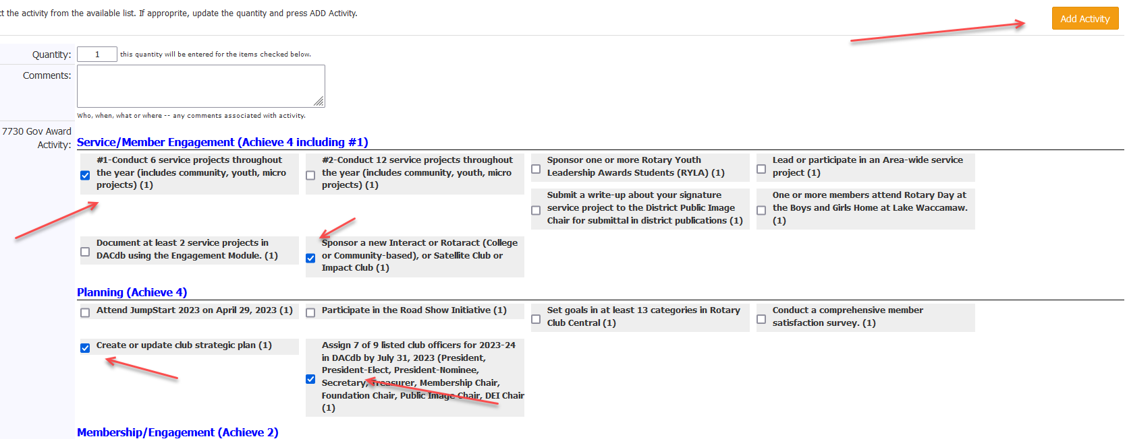

You can then click on My Club Points to confirm everything you entered. Items highlighted in yellow are goals you did not achieve.

