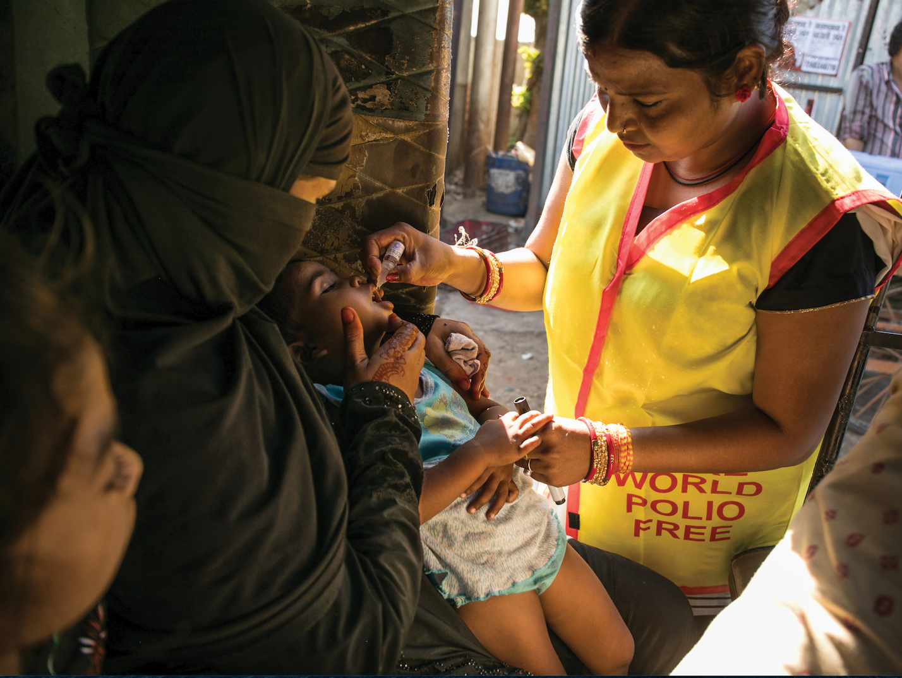
District 7720 Polio Plus Association

Members
Name | Club | Date
Kenneth R. Ritt | Goldsboro Three Eagles | 26Aug2020
Bryson Bateman | Goldsboro Three Eagles | 22Jul2020
William T Thompson Jr | Goldsboro Three Eagles | 19Aug2020
Dean Nelson | Goldsboro Three Eagles | 02Sep2020
Mary Ann Dudley | Goldsboro Three Eagles | 02Sep2020
Ray Burrell | Goldsboro Three Eagles | 21Oct2020
Darrell Horne | Goldsboro Three Eagles | 21Oct2020
Don Johnson | Hertford | 03Nov2020
Paul Platek | New Bern Breakfast | 04Nov2020
James W Finley | New Bern | 05Nov2020
William Clark Moore | Wilson | 06 Nov 2020
Walter Joseph Marm | Fremont | 04Dec2020
Shannon Painter | Kitty Hawk | 01Dec2020
Jack Boone | Hertford | 09Nov2021
Carl Joiner | Greenville Noon | 08Nov2021
Joe Easterwood | Hertford | 26Oct2021
Barry Lutz | New Bern Breakfast | 13Jan2022
Brant Bills | New Bern Breakfast | 13Jan2022
Barbara Belon | New Bern Breakfast | 13Jan2022
Tom Gingrich | New Bern Breakfast | 13Jan2022
Stephen Hoard | New Bern Breakfast | 13Jan2022
Bill Taylor | New Bern Breakfast | 13Jan2022
Deedra Durocher | New Bern Breakfast | 13Jan2022
Richard Peebles | New Bern Breakfast | 13Jan2022
George Orsega | New Bern Breakfast | 13Jan2022
James Karl | New Bern Breakfast | 13Jan2022
Robert Riggs | New Bern Breakfast | 13Jan2022
Andrew Garlick | New Bern Breakfast | 13Jan2022
Roberta Garlick | New Bern Breakfast | 13Jan2022
Joni Bass | New Bern Breakfast | 13Jan2022
Connie Jaklic | Hertford | 22Jan2022
Robert Dofner | New Bern Breakfast | 27Jan2022

