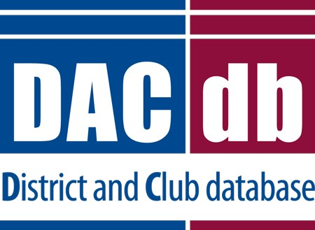

Contents
Quick Start Guide

My Club Tab Overview 1
Find a Member 2
Edit Club Information 2
Edit Club Positions 3
Add a New Member 6
Member Compare – Officer Compare 7
Edit, delete, or download a Member record 9
Edit User/Login Credentials 10
Compose, Save, and Send a PMail 11
Create, Edit, and PMail a Committee 13
Add a Meeting to the Calendar 16
Create an ezStory 18
Create a Newsletter/Bulletin 20

My Club Tab Overview

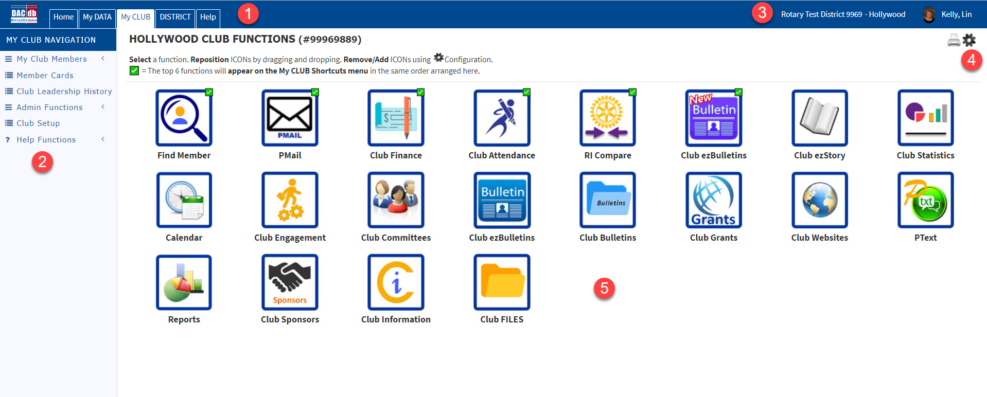
- Top Menu Bar
- Side menu
- District and Club – Will take you to website of each
- Configuration Wheel to remove or add menu icons
- Menu Icons – you can drag and drop in any position. Top six will appear as favorites on alternate pages

Common icons:

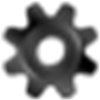
Settings Export to Excel

Export to Word

View .pdf Delete
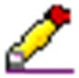 Edit Save

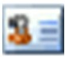
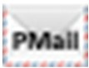
VCard Favorite

PMAIL

Tip: Don’t be afraid to explore! Try clicking the Settings wheel at the top of the page and select the member information fields you want visible on the “My Club” page.

1

Find a Member
Browse your membership by viewing the list provided on the My Club page. You can also scan “other” types of members and terminated members. Don’t have time to browse? Search.
To search for members outside your club:
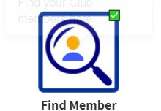
  - My Club tab --> Find A Member

  - 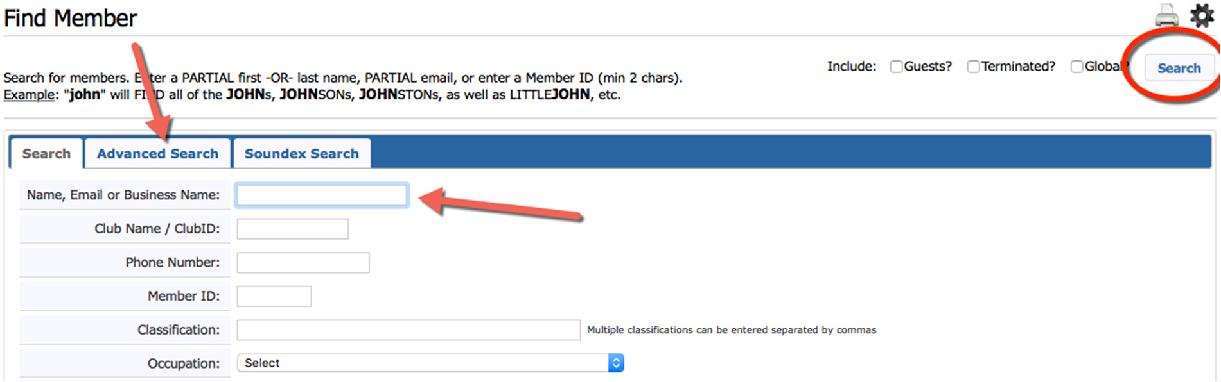For a general search use the Search tab. For a more granular search, use the Advanced Search tab. Enter search criteria and click the “Search” button. If they are not in your District, make sure you check “Global”

Tip: Try a Classification search to find members you could introduce to each other at your next meeting!

Edit Club Information
Edit club contact information, meeting location/time, and much more.
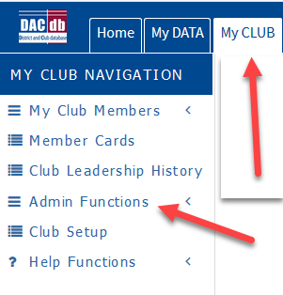
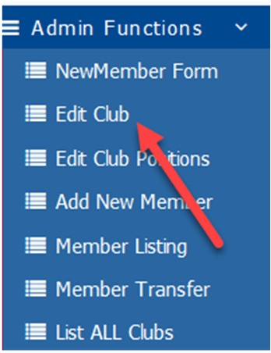
- My Club Tab--> Admin Functions--> Edit Club

- 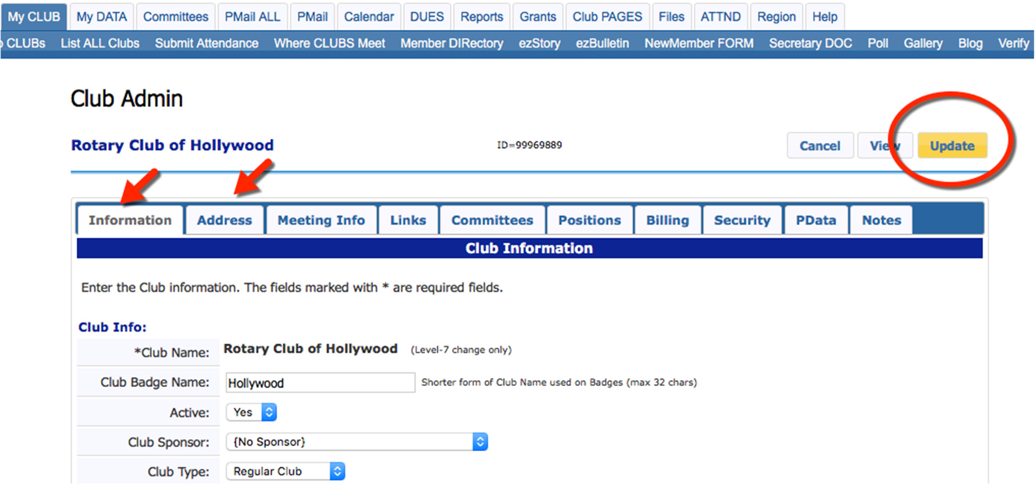Click through the tabs to edit club information.
- When finished, click the yellow “Update” button.

Tip: This information is important to your membership and district. Please keep it current!

Edit Club Positions
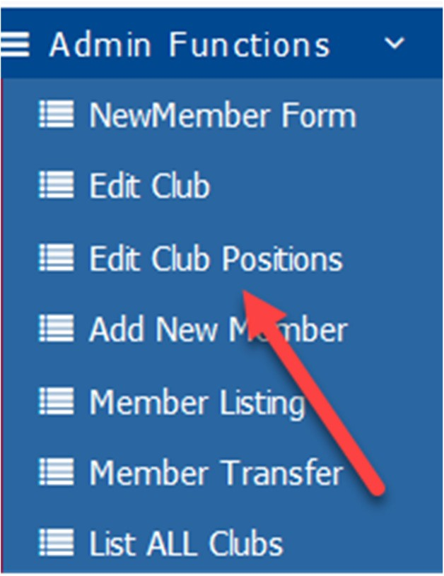
- My Club Tab--> Admin Functions--> Edit Club Positions

- Click the Pencil edit button next to the Member name.

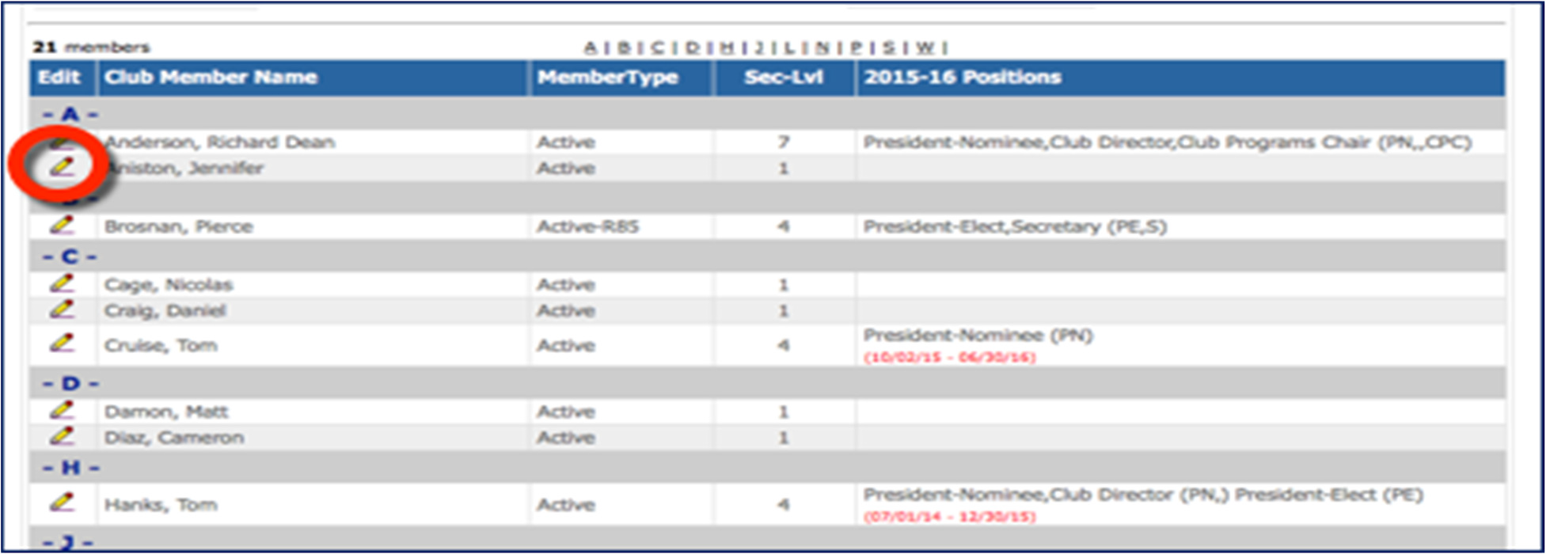
- Club Position Admin screen --> Edit
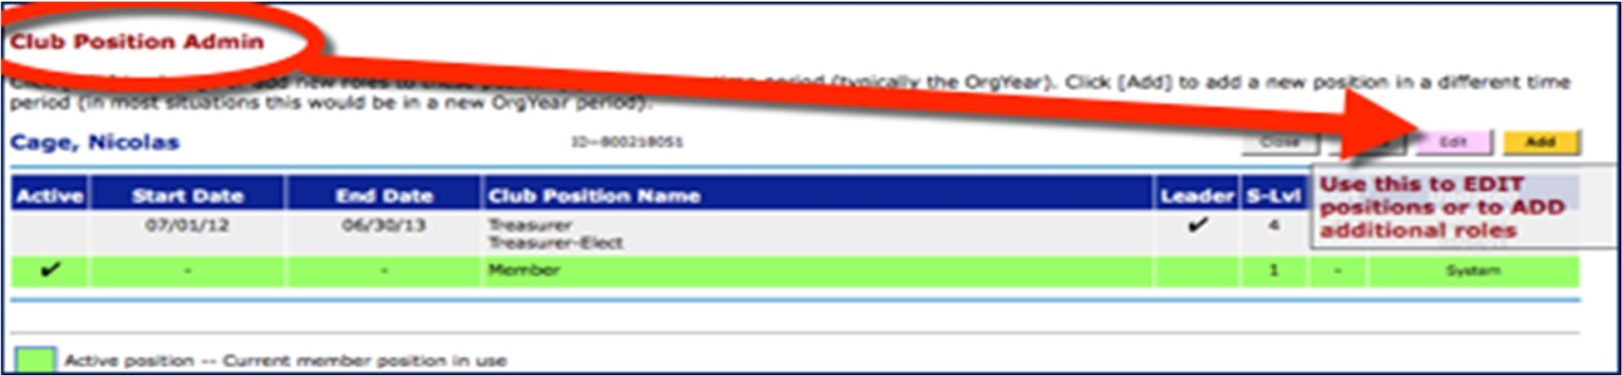
- Important to remember, you can only have one org year on a line but can have multiple positions within that org year.
- Enter start and end dates.
- 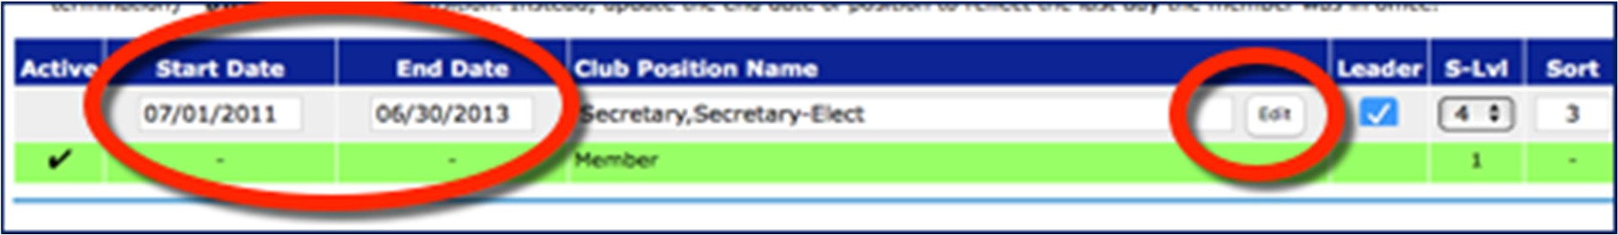Next to Position title, click ‘edit’ and a list of positions will appear.
- Check the box(es) next to the desired role(s) and click “Save”.

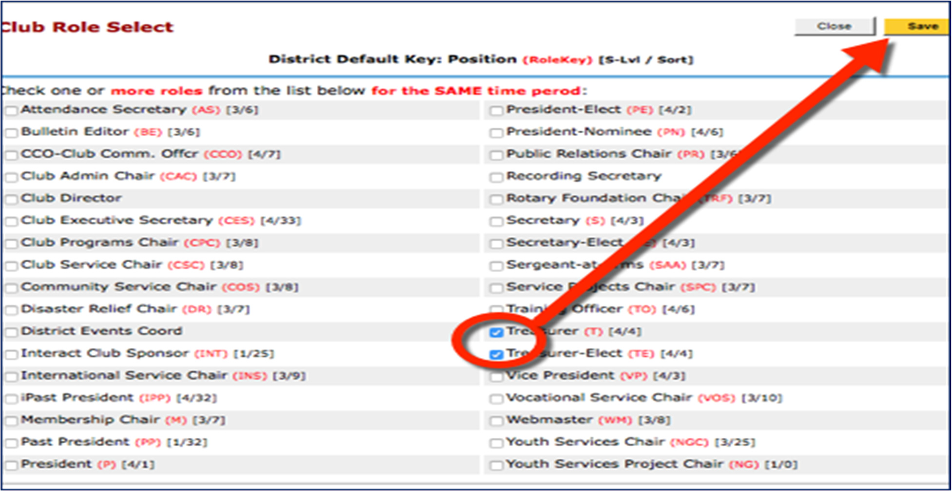

* If you add a position that has a known progression - such as a President-Nominee (PN) DACdb will automatically populate the rest of the progression for you in each subsequent Org Year! PN, PE, P, iPP, PP
- Check the “Leader” box to enable position visibility at the top of your club’s page.
- 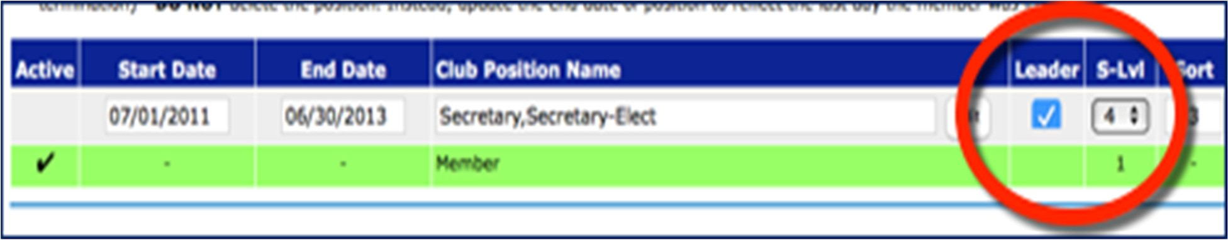You can assign leadership positions different security levels in DACdb. Level 4 is Club officer.
When finished, click “Update”.
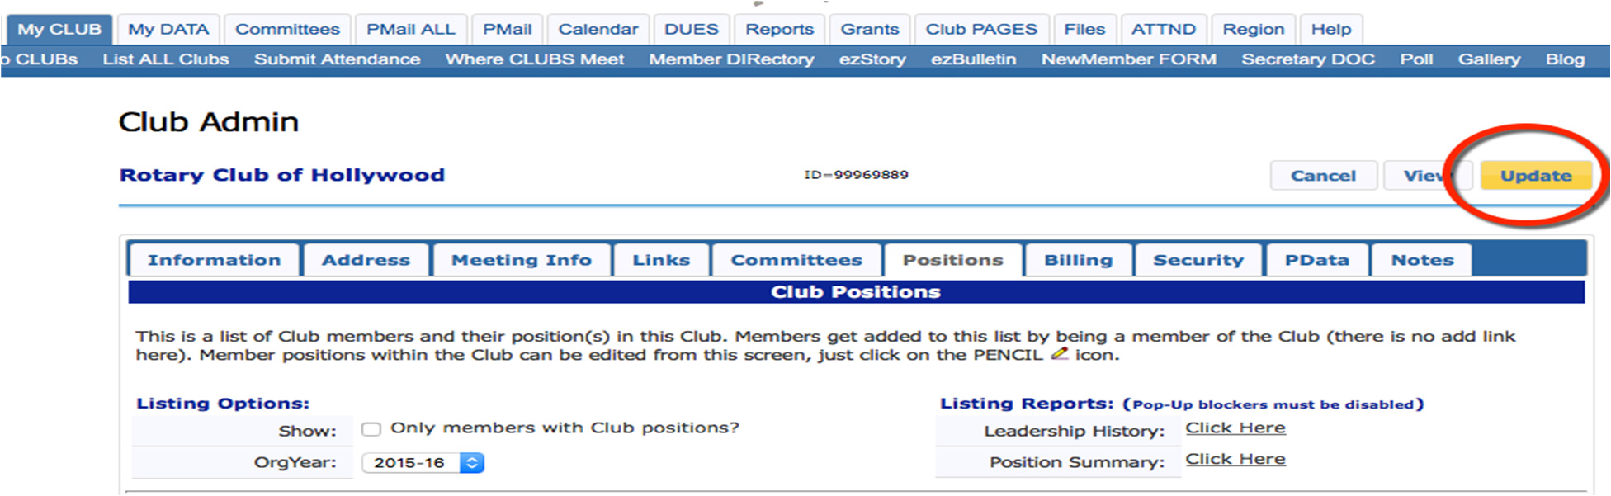

Tip: Encourage your members to provide profile photos so everyone can ‘see’ club leaders and fellow Rotarians.

Add a New Member
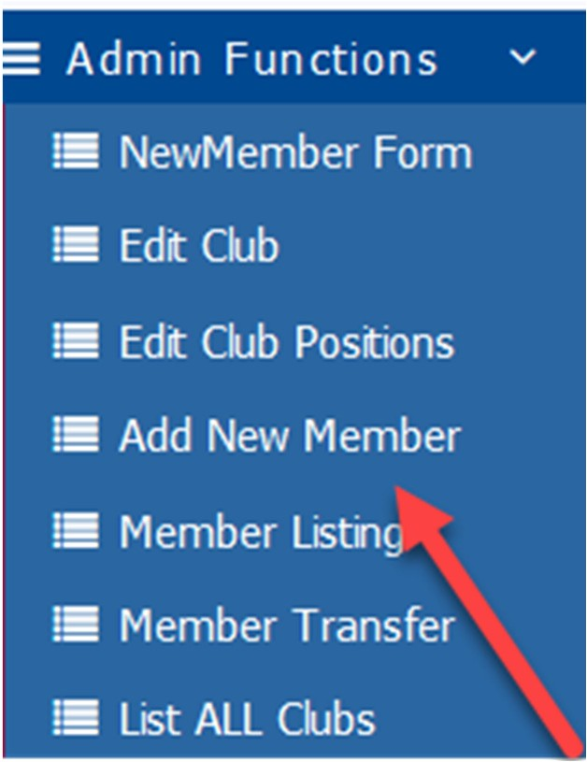
- My Club Tab --> Add New Member
- Fill in the member’s information. Note: * is required
- If you do not already have an RI member ID, leave this blank (0) for now.
- 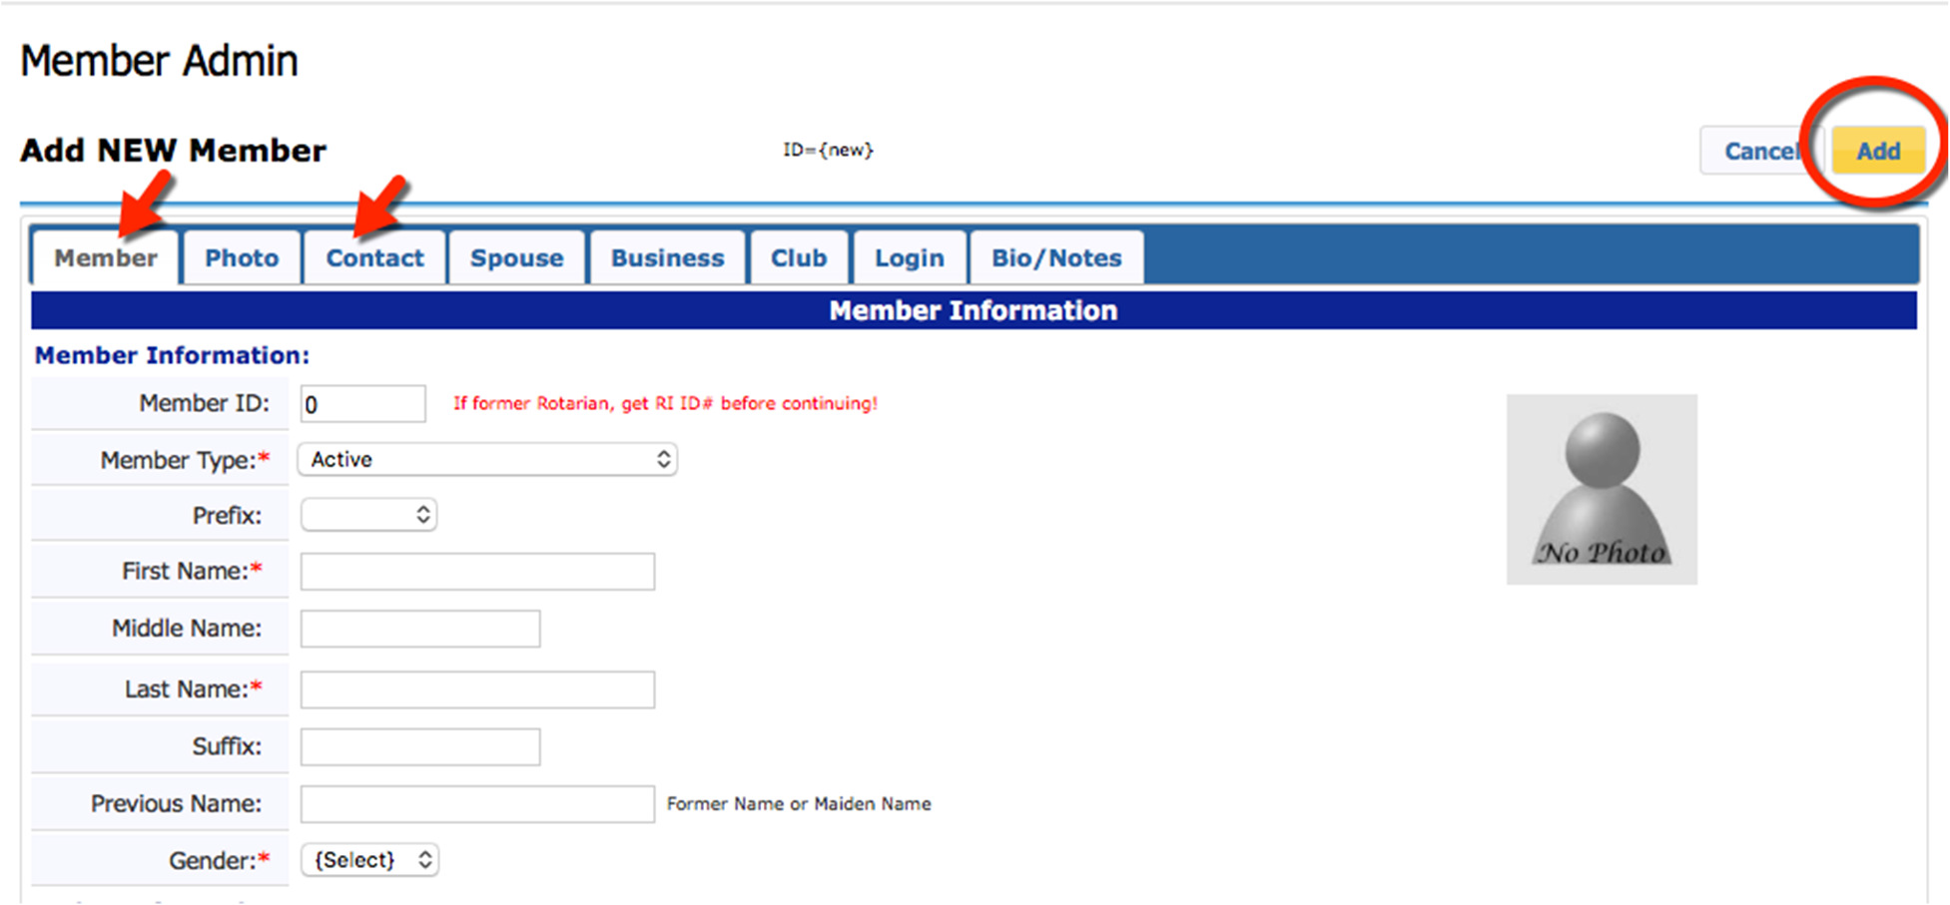When finished, click the yellow “Add” button.
- If you have RI Integration turned on RI will assign a number within a short period of time. Be sure to check Member Compare (which is discussed below) to make sure the member rolled up correctly.

Tip: A word of caution: Avoid changing the new member record until the RI ID number is in the DACdb system.

Member Compare – Officer Compare
- My Club Tab --> RI Compare Icon

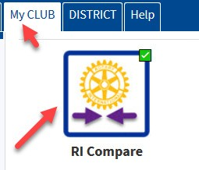

- Turning on RI Integration saves you time and keeps your District up to date with your club information and more importantly – keeps RI Current. The only thing that is not tracked here is foundation giving.
- Once you click on the RI Compare Icon, the Member Compare will automatically open. Give it a few seconds.
- Once it opens you will see two columns, the left-side column contains the information that is in RI and the right-side column contains information that is in DACdb. The goal is for these two columns to have the same information.

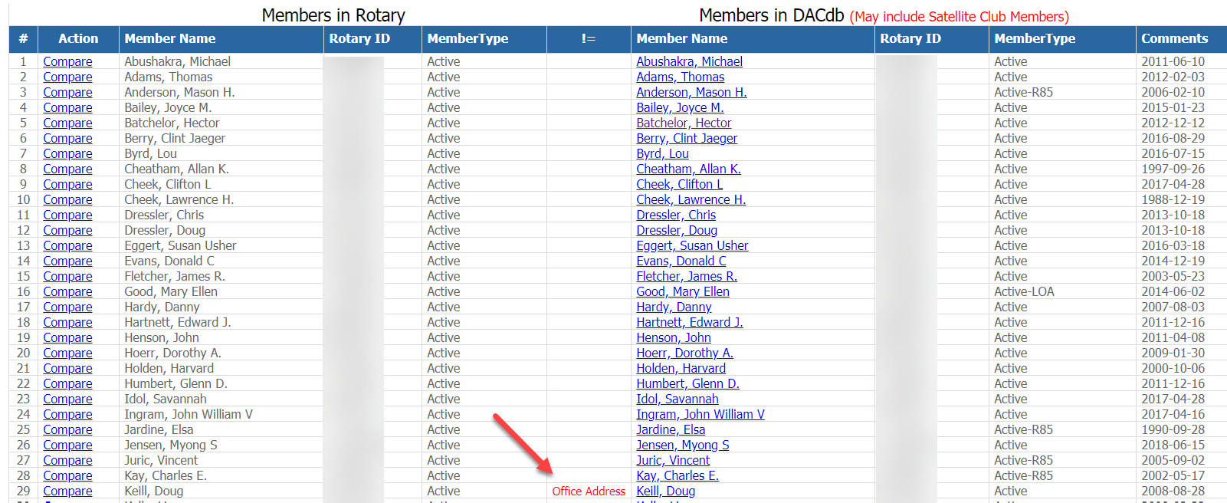

- If something appears in red, it means there is something that differs between the RI record and the DACdb record. Click on the “Compare” next to the member that has red next to their name and you can compare the information side by side. If you have members on the top right and nothing on the left it usually means the member did not roll up to RI. Usually the member record had an error in it when it was first entered. The other thing that might occur is there could be someone in the left column that is not in the right column. This usually occurs when someone enters a new member or terminates a member in Rotary International and does not do it in DACdb. In this case there will be a button to either add to DACdb or Terminate in RI. Keep in mind the information flows up to RI from DACdb. Make your changes in DACdb first. Information does not flow down from RI. More detailed information can be found under the Help Tab in DACdb under RI Integration.
- Club Officer Compare – Like Member Compare, this will show you the six officers that are in RI and those that are in DACdb and the goal is to have them match. The six officers RI looks for are President, Treasurer, Secretary, Club Executive Secretary, Foundation Chair, Membership Chair. In most cases the District also looks for these individuals because they have automated committees set up by role key to communicate throughout the year with these positions.
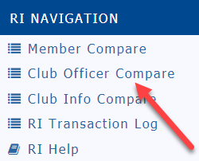
- Click on the RI Compare Button but instead of waiting until member compare opens up, click on the Club Officer Compare on the left

- It should look like this:

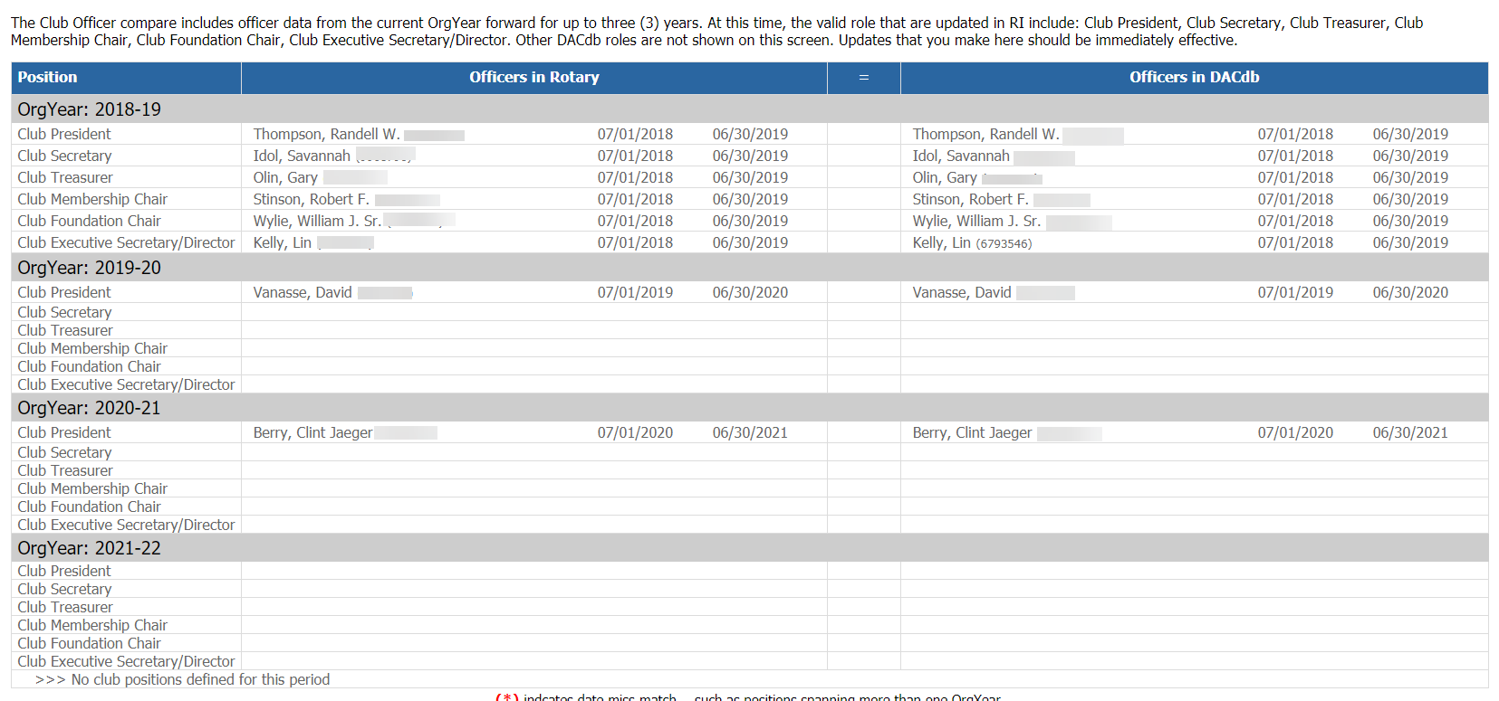

- You cannot appoint an officer who does not have an RI number. Keep in mind updating Club Positions was described earlier in this documentation.

Edit, delete, or download a Member record
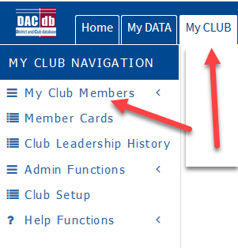
- My Club Tab --> My Club Members
- In the Action column of your current member list, you will see the pencil ‘edit’ button, a red “X” for terminate, and a shortcut to download the member into your Outlook address book.

Edit:
- 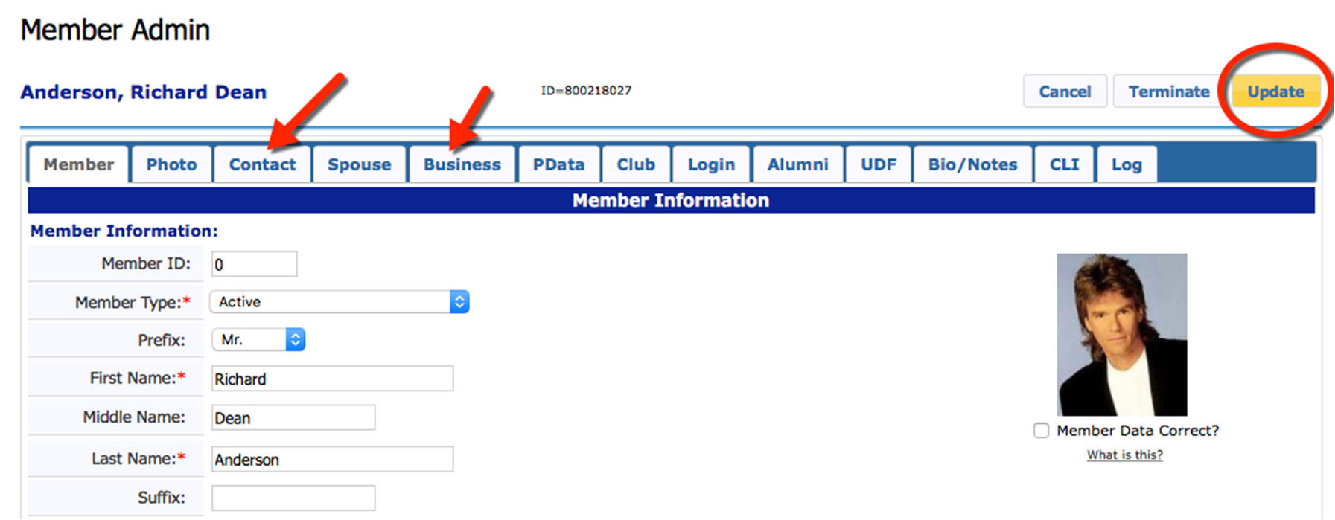Click the pencil in the Action column to open the Member Admin screen and edit a member’s record.
- Click through the tabs and correct the member’s information.
- When finished, click the yellow “Update” button.

Download member contact information to your address book:
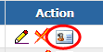
1. Click the contact card in the Action column, and follow the prompts on your computer.

Tip: For a quick look at member contact data and photo, hover your mouse over the member name. Click the name to view the member’s details.

Edit User/Login Credentials
Assist a member by reviewing and updating their login credentials.
- Find the member in DACdb and click to edit the record.
- In the Member Admin screen, click the “Login” tab.
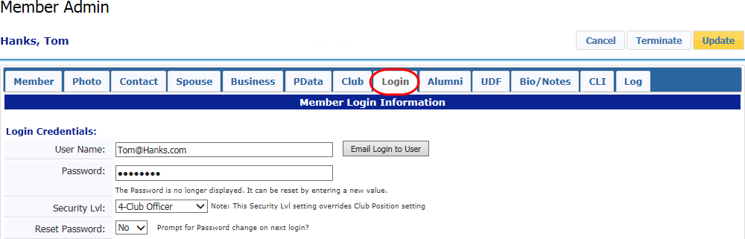
- Verify the Username (email address) and edit if necessary. Click the yellow “Update” button.
Note: changing a contact email address (on the “Contact” tab) does not by default change a login email address. Remember to change them both.
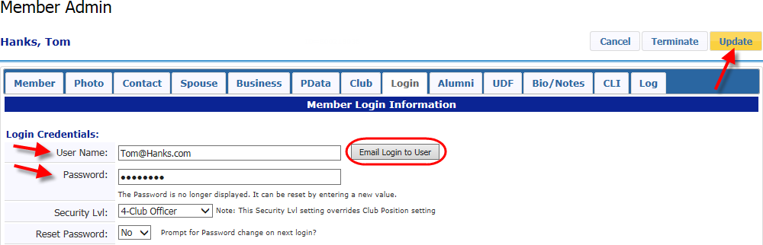
- Send the member an email with both username and password details by clicking “Email Login to User”. Verify the member’s email address in the “Contact” tab before sending. If you make changes to either the User Name or Password, save your changes before sending the email!
- Or, type in a new password for the member, click the yellow “Update” button, and direct them to the DACdb login screen.

Tip: Until it is replaced, the default password is the member’s 5 digit zipcode. Encourage members to edit their password details to something more ‘memorable’.

Compose, Save, and Send a PMail
The quickest and easiest way to communicate with your club is through our internal email system, called Personal Mail, or PMail. Check out the complete guide to PMail in the Help/Documentation section of DACdb.

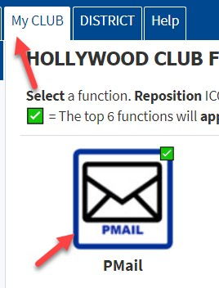
- My Club Tab --> Pmail Icon
- If you have the proper access you can click “Pmail all Active Members in My Club” which will be on the left side menu
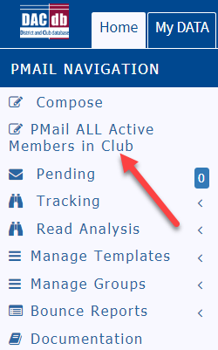
- Or you can select the “TO” on the pmail and click the Clubs icon and click the check mark next to your club name and check off the members you wish to pmail.

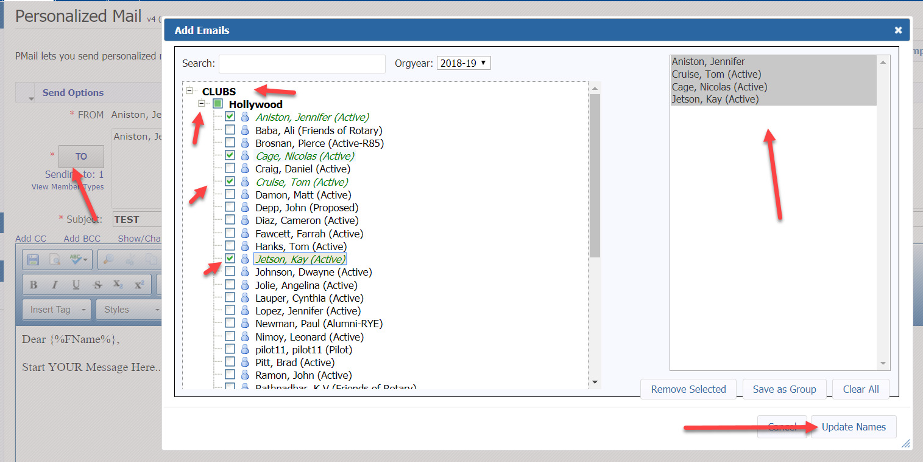

- Type your message in the box. The default email inserts the first name of the recipient.
- Format the colors, fonts, paragraph styles, etc. using the Editor toolbar.
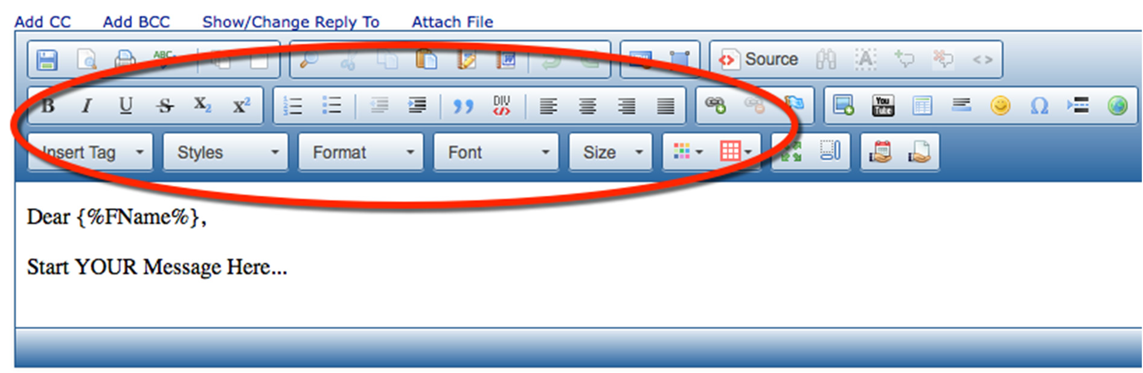
- To save your message, click the “disk” button in the upper right of the Editor. It is recommended to save your progress every few minutes as you compose the message.
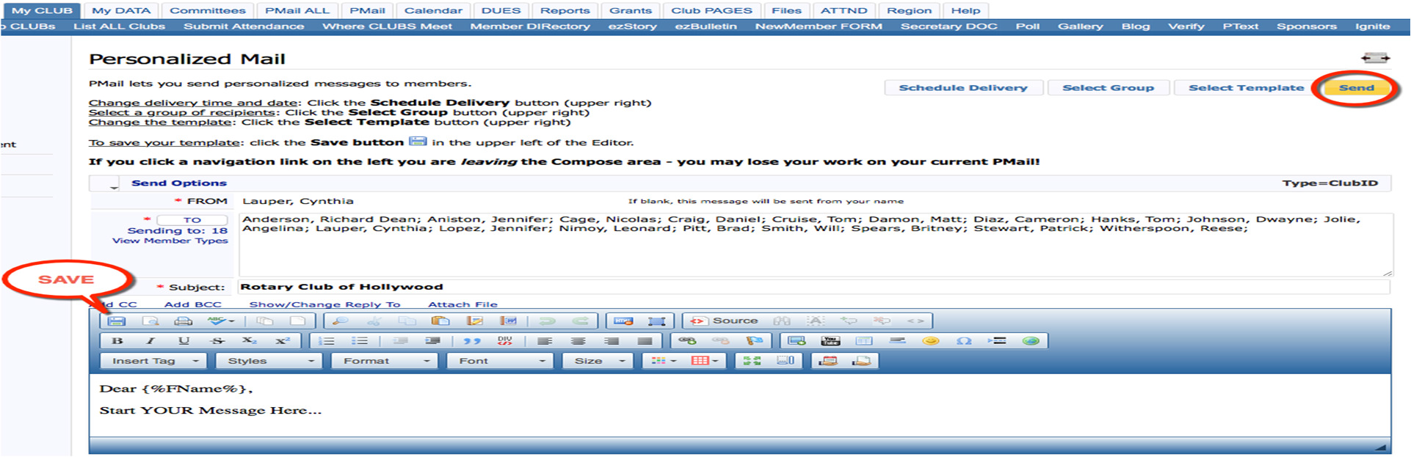
- The Save Template screen will appear. Choose to save your message in a Personal or Club folder (other officers may access). Give the message a name, and decide if this replaces a previous version. Click “Save” when finished.
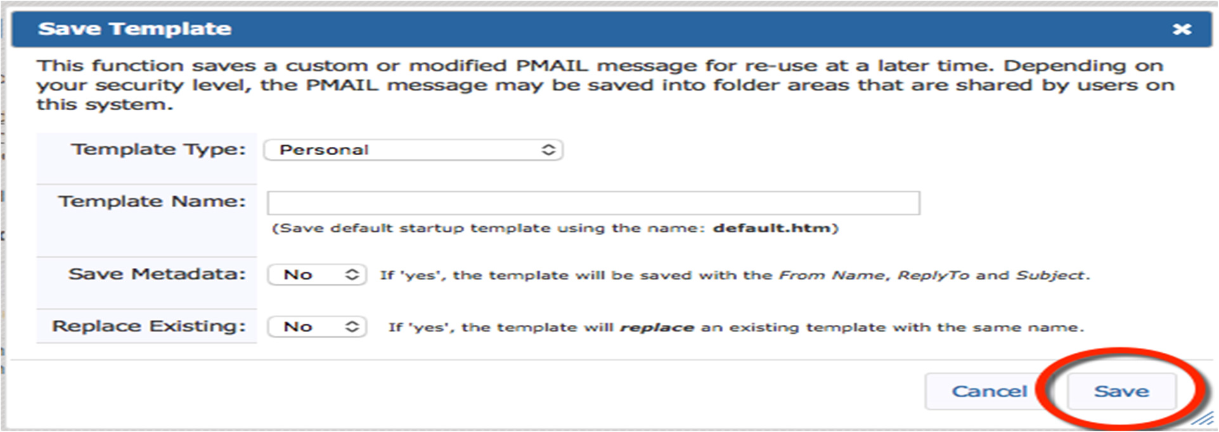

- After your message is composed and ready for delivery, click “Send”.
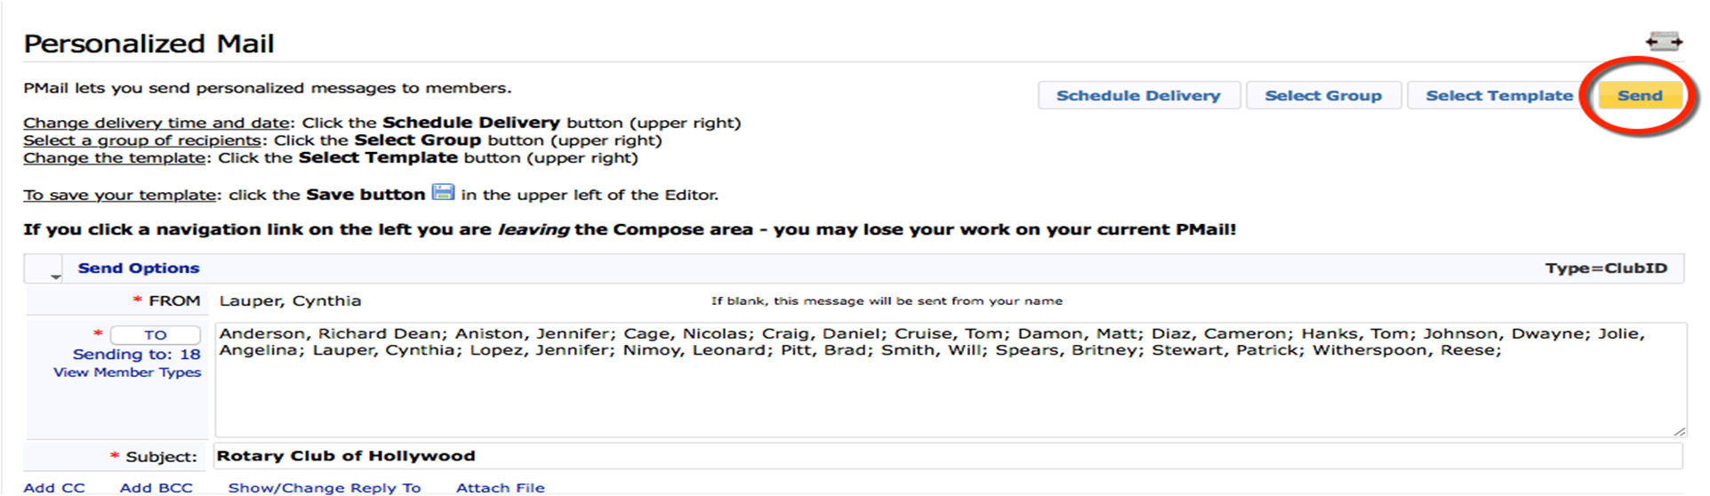

Tip: To PMail an individual, click the member’s name to open the member record and find the PMail button in the top right corner.

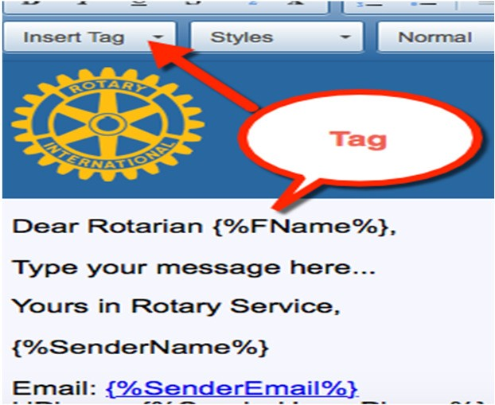Did you know… Tags are fields that auto-populate with information. To add ‘tags’ to your message, click the ‘insert tag’ button in the message editor. Even though your template looks funny at first, the final product will be a personalized email to each recipient.

Create, Edit, and PMail a Committee
Create a committee to communicate and share information with a select group of members.
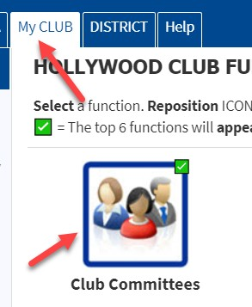
- My Club Tab --> Club Committees Icon

- 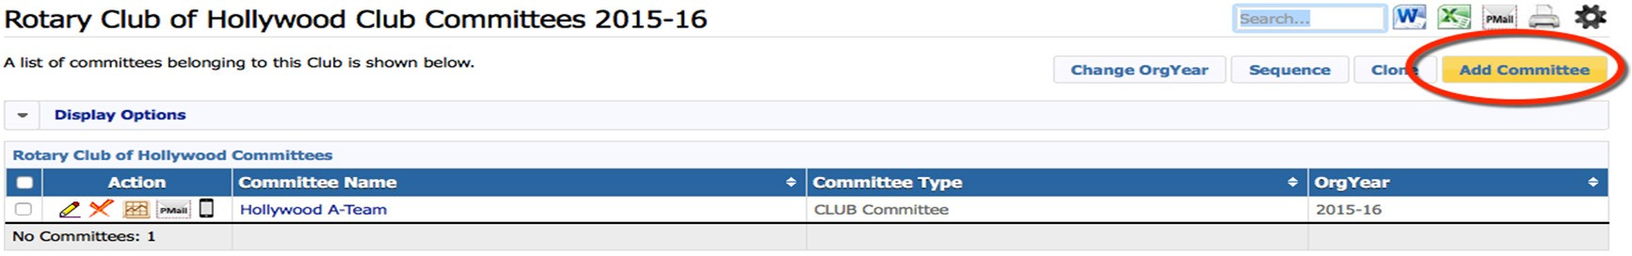The Committee page will open and display current committees. Click the yellow “Add Committee” button.
- Add committee name (1), Select Org Year (2), Enter a description for your committee
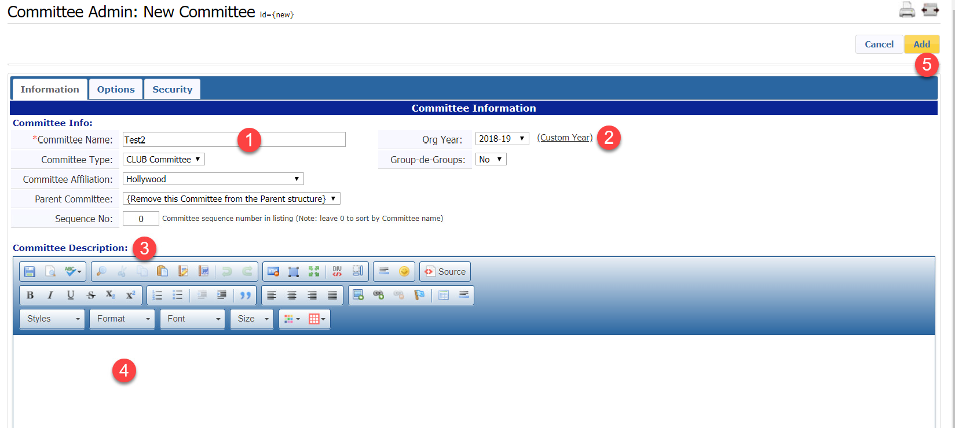
(4) and click on “Add” (5).
- After adding the committee, click on My Club Committees on the left-hand menu
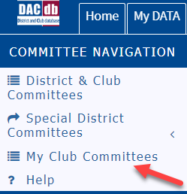
- Click on the pencil edit next to your new committee and “Members & Positions” tab will appear.
- Click on the Members and Positions tab --> “Add/Delete Committee Members”.
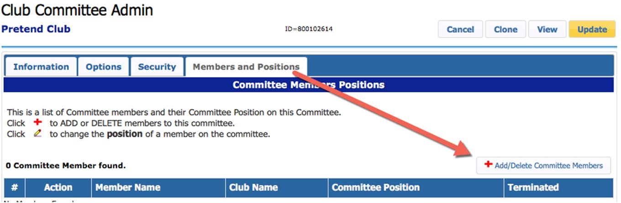

- 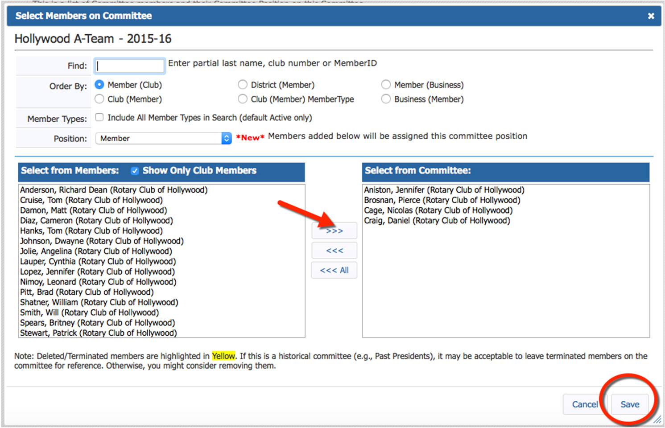Select members from the left column and use the right arrow button to add them to the committee. To remove members, select the name on the right, and use the left arrow.
- When finished, click “Save”.
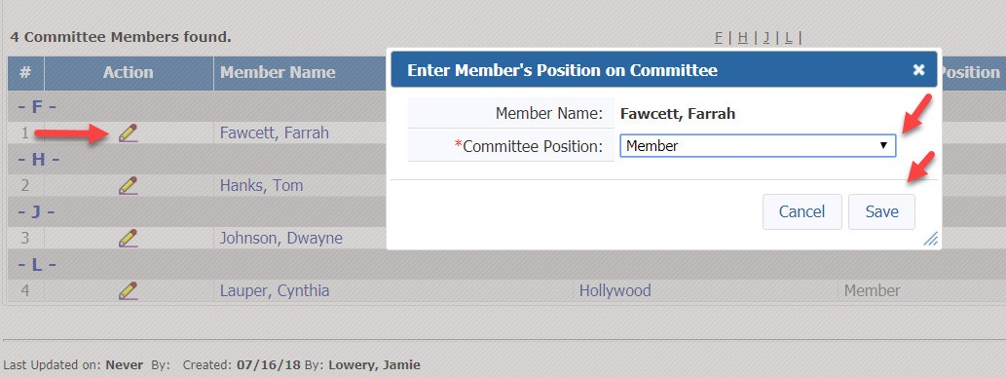
- To assign committee chair or other leadership roles, click the pencil edit button next to the member name, and enter the member’s position in the popup window.
- Using the icons in the Action column, easily delete, view reports, PMail or text the committee.
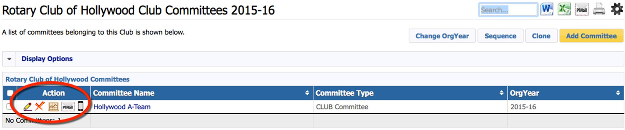

Add a Meeting to the Calendar
The DACdb calendar tool offers many options, ranging from recurring meetings to events that require registration. Start by simply adding weekly meeting information, then, as you become more comfortable, explore additional features.
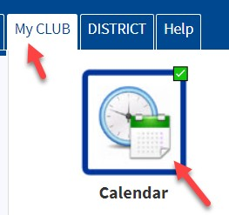
- My Club tab --> Calendar Icon

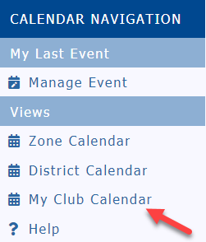
- Select My Club Calendar from left navigation.
- Click on the gold “Add Event” button on the top right.

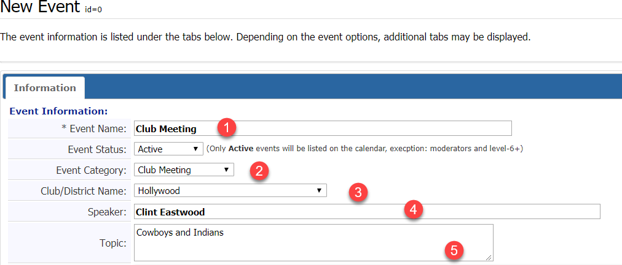

- Add the Event Name, i.e. Club Meeting (1)
- Add Event Category (2) Club Meeting, Club Fundraiser, Club Event

- Make sure the club/District Names indicates your club name. This is important as some clubs select District here which makes the event appear on everyone’s calendar in the district and other clubs will frown upon this. (3).
- If you have a speaker enter their name and the topic. If you do this, it can be used in your bulletin and website. (4 & 5)
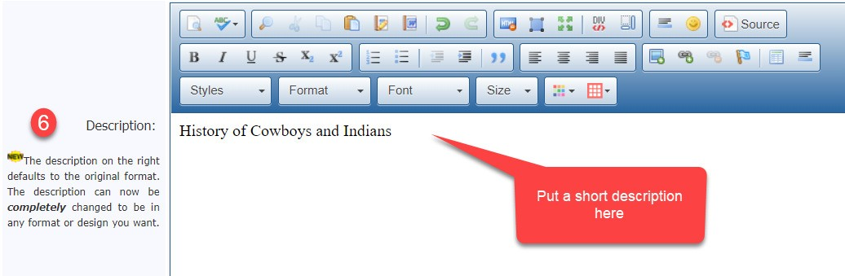
- Scroll down to the description box – type a “short” description (6)

- Scroll down to the location box – type in the location or a longer description here. Just use regular font size as this will pop up when someone scrolls across the event (7). Keeping this short is the key. Attach a pdf if you want them to have a flyer.
- Enter the start date (8), Enter the start time (9), End date is normally the same day unless it a two or three-day event. Please remember to make these days the same.
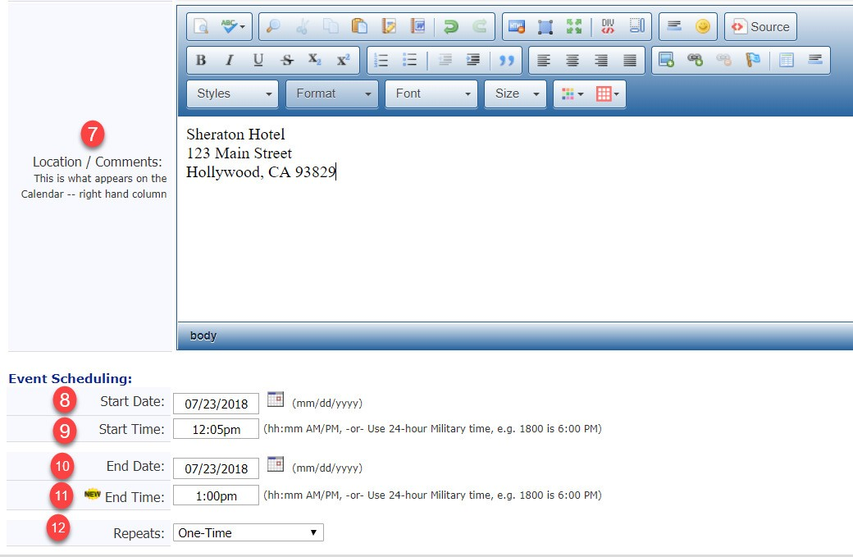
(10) End time (11) this must be after the start time. Finally Repeats. If you want to put your Club Meeting in for 4 weeks you can use repeat. Keep in mind the Start date and end date of the original event need to be the same. The recurring event will automatically adjust the dates for the recurring dates. Do not put an ending date of 4 weeks after the start date. (12)

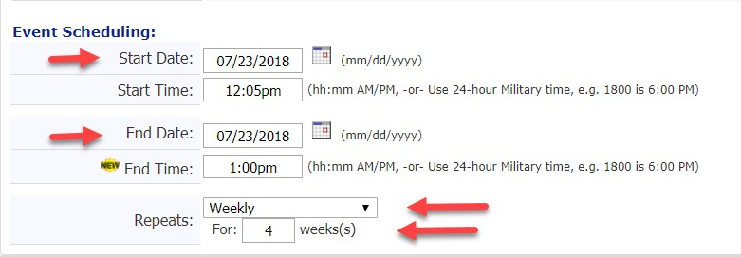
- Recurring event will look like this – Note the start and end date are the same

- When finished, click the gold “Add Event” button.
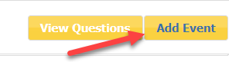

Create an ezStory
If you’re like most Rotary clubs, you write, print, mail, and email a newsletter to your membership. ezBulletin provides professional designs you can customize and save for future use.
Get started by creating an ezStory

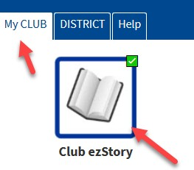
- My Club --> ezStory Icon
- Click on Add Story on top right
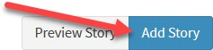

- Complete the information tab

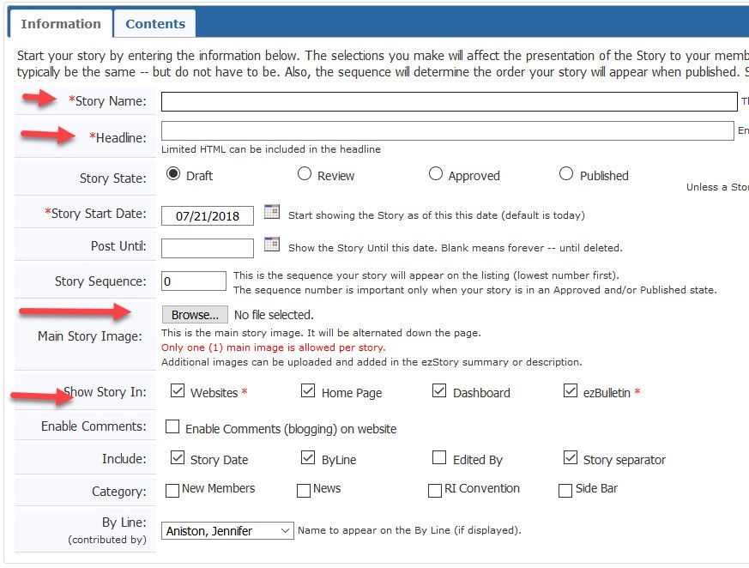

- Enter Story Name and Headline. Enter the main photo by clicking the Browse button and uploading from your computer. Check off where you want your story to appear. Then move to the Contents tab.
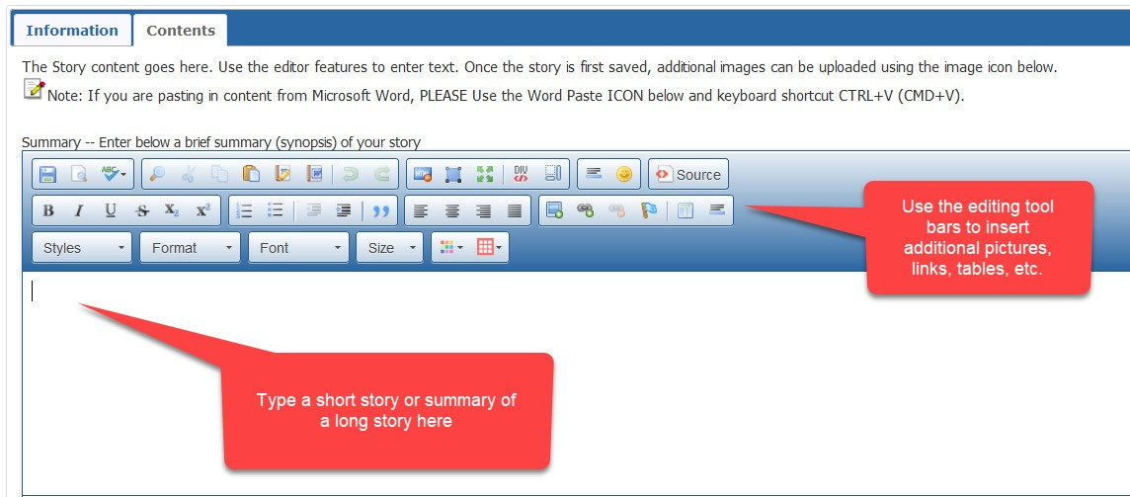
- Type a short story or the summary of a long story in the summary box. Don’t forget to use the editing tool bars
- If you have a very long story, continue the rest of the story in the box below the summary box and when you publish your bulletin readers will be able to click on “read more”.
- Don’t forget to Save as you work along so you don’t lose anything
- When you are finished go back to the information and click on the published button. Only published stories will show up in the bulletin, website, home page and club dashboard.
- Watch the video on creating an ezStory and sharing it with your District under the Help Tab in DACdb, Stories.

Create a Newsletter/Bulletin
You have created your stories, now it’s time to create a bulletin template.
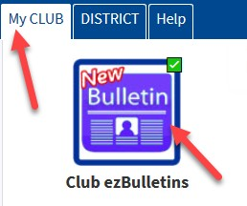
- My Club --> New ezBulletin Icon

- Click on the gold “New Bulletin” button on the right.
- You must now create your template. Once you create a template to create future bulletins you will go back to this template and use Advanced Build to build the next bulletin.
- Click on the blue “New Template” button on the right
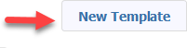
- Pick a format
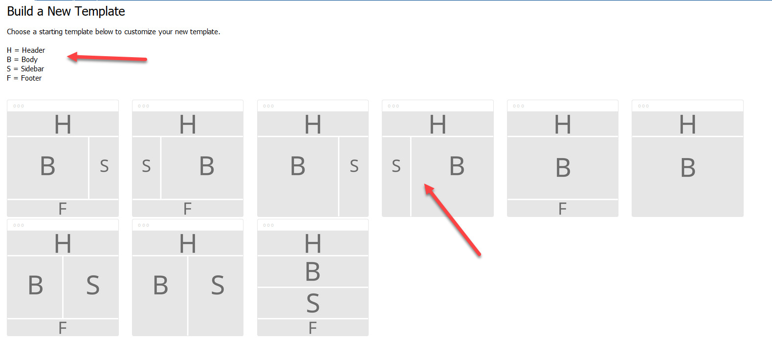

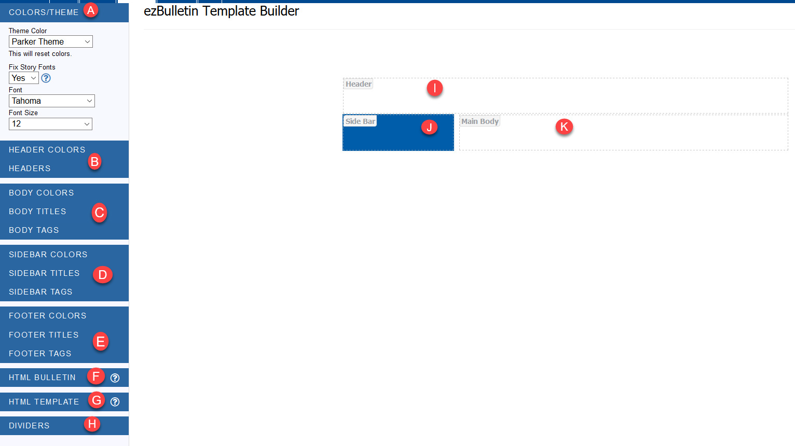
- The items on the sidebar are items you will be dragging into the template (I, J, K). Open each one and become familiar with the categories. Watch the video on creating a template.
- A template should look something like this after dragging the various tags over to the template area

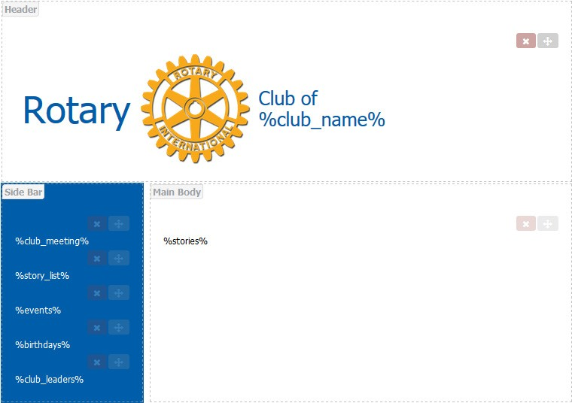

- Now click on the gold save button
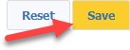
- Name your template, enter a description if you wish and click on submit

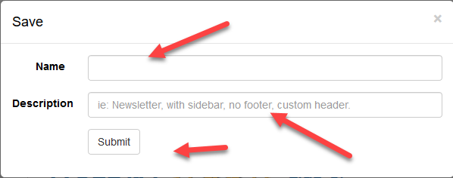
- You are ready to build your bulletin
- Hover over your template and click on Advanced Build

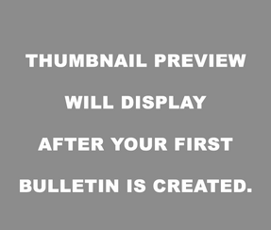
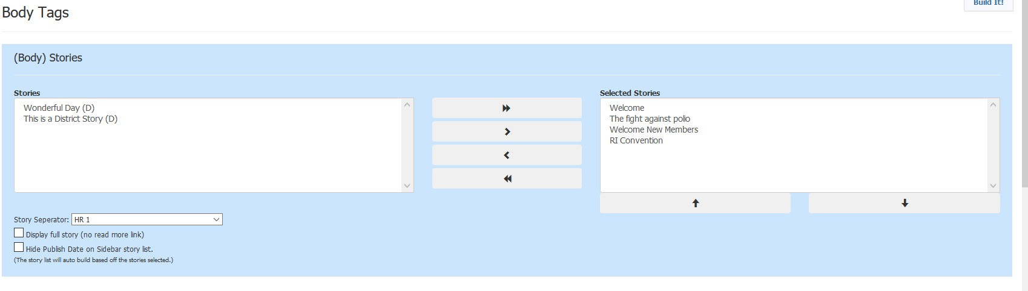
- Move your stories over
- Update your sidebar options
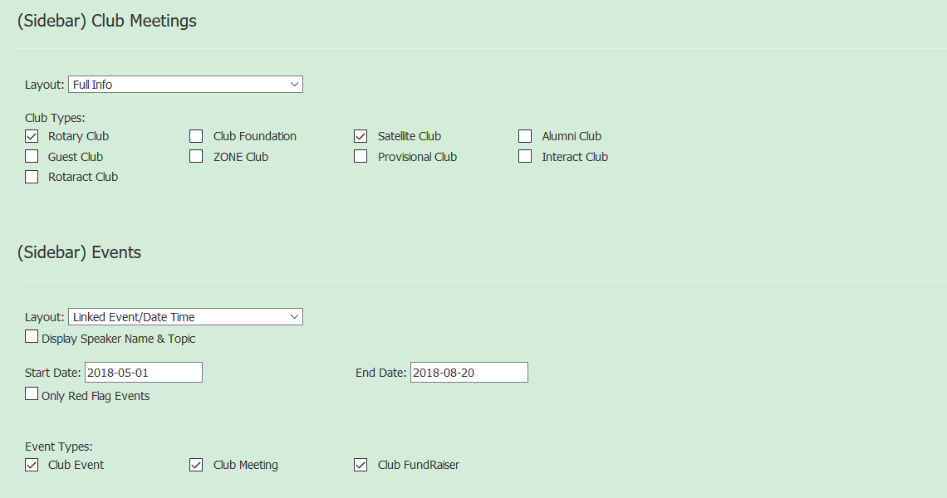
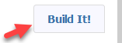
- Now click on build it on the top right
- You will see your bulletin and you have an option now of going back to advance build to change, preview it, preview it in pdf or save.

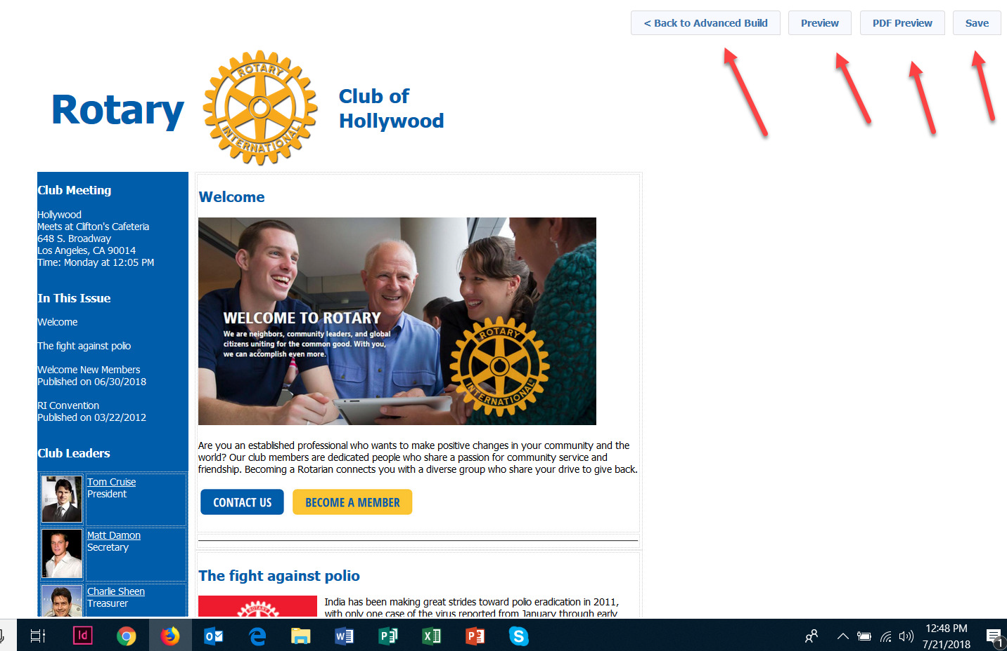

- To send your bulletin save your bulletin using the save on the top right.
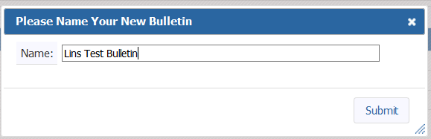
- Name your bulletin and submit.

- The bulletin will now appear in your drafts. Click the pencil edit button next to the bulletin
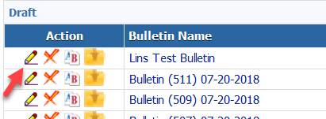

- Click on the Publish on top right

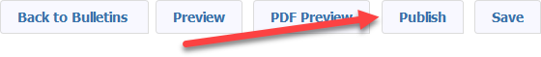

- The publish notification will appear. If you need to make changes you will have to unpublish first.
- Click on Back to Bulletins button

- You will now see a Pmail icon next to your published bulletin and it is ready to be sent out to your club. The bulletin will automatically be stored in your Club Bulletin File in pdf format and if you have a website and selected for bulletins to appear it will appear there. To delete any published bulletins, you also must delete them under the Club Bulletin files using the Club Bulletins Icon.

PLEASE NOTE THIS DOCUMENT ONLY HIGHLIGHTS SOME OF THE FUNCTIONS THAT USERS USE MOST OFTEN. REMEMBER TO VIEW THE HELP TAB IN DACDB OR FOR HELP CONTACT SUPPORT AT SUPPORT@DACDB.COM OR CALL 720-504-7300 EXT 1 FOR SUPPORT.

