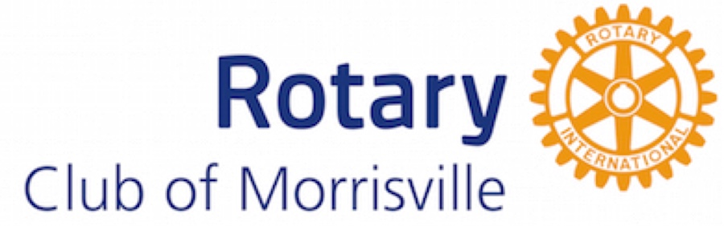
SPONSORSHIP PROPOSAL
COMPANY NAME: | d |  |  | PHONE NUMBER:
COMPANY ADDRESS: |  |  |  | CITY, POSTAL CODE:
CONTACT NAME: |  |  |  | TITLE:
Level of Sponsorship:  Dom Perignon $3k  Wine Partner $2k  Bourbon Partner $1k  Beer Partner $500 |  |  | Type of Sponsorship  Cash  In-Kind  Combination Cash and In Kind  Event Promotion  Other (describe below) |  |  |  | Estimated total value of Sponsorship  Cash:  In-Kind:  Other:  Total:

duties PERFORMED / responsibilities
Description of In-Kind, Event promotion or other types

SKILLS |  |  |  |  |  | EQUIPMENT USED
Additional Information or Special Requests
The Rotary Club of Morrisville is a 501(c)(3) nonprofit organization. Tax ID # 363245072.
Mail to: Rotary Club of Morrisville, P.O. Box 31, Cary, NC 27512

