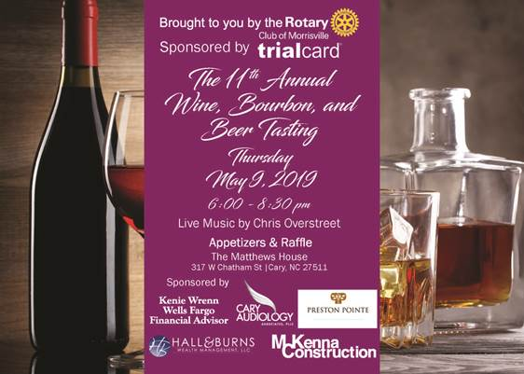

On behalf of the Rotary Club of Morrisville, thank you very much for supporting our 12th Annual “Wine, Bourbon, & Beer Tasting” event. With your generosity we can give back to so many wonderful charities!
This year’s event promises to be one of our best yet! The raffle portion promises to bring great items, with ticket costs of $5/each, you can win many fabulous items. Too, we will have an incredible spread of delicious food from our local neighborhood restaurants displaying their favorite dishes. Of course, great music by Chris Overstreet.
We look forward to seeing you at the event on Thursday, May 14th, 2020 from 6:00PM to 8:30PM at The Mattthews House located at 317 W Chatham Street, Cary, NC 27511.
Thanks for supporting our event!
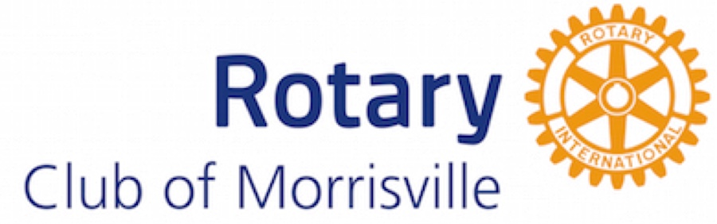
www.rotarywinebandb.com

