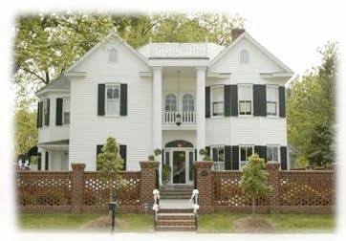
The Matthews House
Downtown Cary

Dear Supporters,

I am excited to announce our 12th Annual Wine, Bourbon & Beer Tasting is being held on Thursday, May 14th at The Matthews House in downtown Cary. Last year we had topped our headcount with 262 attendees; an incredible turnout! The proceeds from this fun charitable event enables us to give back to our local community and support projects abroad. The funds are used to support organizations like, The Carying Place for homeless families, Dorcas Ministries that provides crisis relief to area residents, Life Experiences creating jobs for adults with disabilities, the YMCA with hundreds of youth and adult programs and many more great causes. We could not do what we do without supporters like you.

Attached are the sponsorship levels for this year’s event. We hope you will consider sponsoring our event. If you need more information on our fundraiser, please feel free to contact me.

Yours in Rotary Service,

Rose Cornelious

Rose Cornelious
Event Chair
Wine, Bourbon & Beer Tasting
Rotary Club of Morrisville
(919) 656-0643

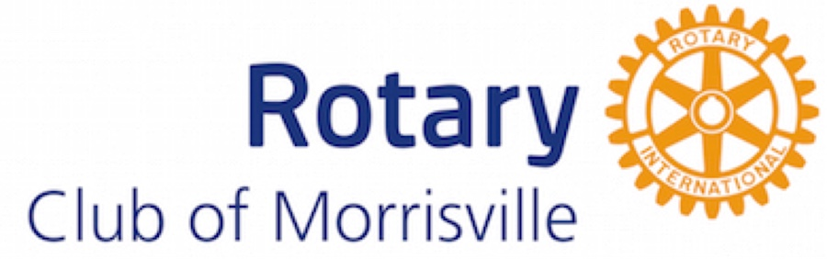
"Service Above Self"
http://www.morrisville.rotary-clubs.org
www.rotarywinebandb.com

