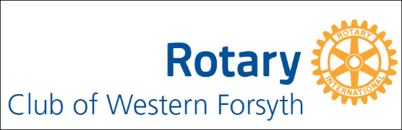

Minutes of Board Meeting August 2, 2022
Attendees: Area Governor Lloyd Barnhardt, Gene Blackwelder, Andrea Misel, Anant Venkataraman, Bill Hoyle, Tim Johnson, Mike Swain, Mike Baley, Ben Sessions

Membership Bill Hoyle – we have 31 members and have doubled our membership in the last three years. He encouraged us to reach out to people and invite them to our programs and events to introduce them to Rotary and our concept of Service Above Self.

Public Image Tim Johnson – we do weekly Facebook and Instagram posts to highlight our speaker and programs. We have free TV and radio ads promoting our Roast. There is an article in Forsyth Family magazine on Cameron and the Roast

Foundation Ben Sessions – the international Rotary Foundation is one of the highest rated charities in the world. It is responsible for providing clean water, educational opportunities, etc. for people around the world. It is also responsible for three Billion free polio vaccinations around the world.
Anyone who donates $1000 to the Rotary Foundation over their lifetime is designated as a Paul Harris Fellow (Paul Harris founded Rotary). Rotarian John Stewart helped start our club and is making an offer that he will donate his Rotary dollars in your name to the Rotary Foundation to make you a Paul Harris Fellow if you donate as much as $200 in the next few months.

Youth Services Mike Swain – we are donating food and books to Lewisville Elementary, food and tutoring to South Fork Elementary, and we celebrate a Student of the Month for Winston-Salem Prep. We also provide a $2000 scholarship to a senior at Winston-Salem Prep

Fellowship Socials – Gene reported for committee chair Dawn Vanorden that the committee will plan a social in August. We will vote between bowling, a DASH game, Sip and Draw (sip wine while drawing a picture) or SoftGolf.

Service projects –. We already pick up food at Panera Bread on Thursday nights and deliver to Neighborhood Hands, and we also organize a free Easter Festival for the community. Mike Baley suggested several projects to consider adding. They were Habitat for Humanity, Suicide
Prevention Awareness, a holiday project with the Fostering Faith Foundation and donating pet food to people who can’t afford to feed their pets. Habitat for Humanity got the most votes. We will revisit the other projects later.

Roast – Gene reported that sales were going great. We need some volunteers for greeters, check in and to help with the auction.

Treasurer Anant Venkataraman reported that we have $24,000 plus in our account after paying our International and District dues.
Submitted by Secretary Andrea Misel.

