We give thanks and special recognition to our two
CHARTER MEMBERS
Tom Posey and Pat Stewart

THE ROTARY CLUB OF HAYWOOD COUNTY MEMBERS:

Savannah Anders Marleen Marshall
Kris Boyd Ellis Morris
David Burrell Patsy Posey
John Chicoine Tom Posey
Angie Franklin Trevor Putnam
John Hawkins Rhonda Schandevel
John Highsmith Scotty Setser
Ryan Jacobson Blake Stanbery
Jonathan Key Lee Starnes
Ron Mackert Pat Stewart
Sally Mackert Bill Upton
George Marshall Natalie Walker

Club President: Celesa Willett
Honorary Member: Linda Beck
Corporate members: Town of Canton, Wells Funeral Home, Haywood County Schools and Mountain Projects

SERVICE ABOVE SELF

Welcome to

THE ROTARY CLUB
OF HAYWOOD COUNTY

Haywood County, NC
District 7670 – Club 6018
PO Box 495
Canton, NC 28716

Chartered in 1979, our club is a voluntary organization of diverse business, government and professional leaders united to provide humanitarian service in our community, our country and around the world.

Some of Our Activities

- Provided Financial Literacy Classes and incentives to 10 community members.
- Supported Rotary International’s Polio Plus campaign to help eradicate polio world-wide.
- Stained a deck and ramp for United Way of Haywood County Day of Caring.
- Donated and delivered Christmas Baskets to needy families.
- Participated as bell ringers for The Salvation Army.
- Read and donated books to kindergarten students in honor of
Dr. Seuss’ birthday.
- Provided seven Haywood County Schools Foundation Scholarships.
- Provided a scholarship to Haywood Community College.
- Participated in CART - Coins for Alzheimer’s Research Trust.
- Supported St. Andrews Episcopal Food Backpack program.
- Provided a $3,000 grant for Haywood Co. flood recovery.
- Enjoyed interesting and informative weekly meetings and had a great time together!

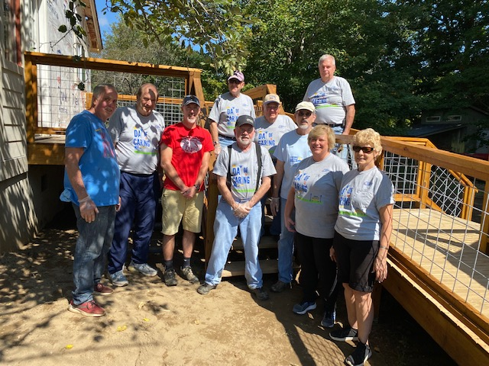
Day of Caring 2022
WHEN AND WHERE

The club meets every Thursday from 12:30 – 1:30 PM at the Haywood Regional Medical Fitness Center, 2nd floor.

FINANCIAL COMMITMENTS

- Rotary Dues: $240.00 per year
- Rotary Foundation Contribution $100.00 per year
- Purchase or sell at least two (2) Benefit Drawing Tickets
- Contributions to Christmas Baskets, etc. *optional

