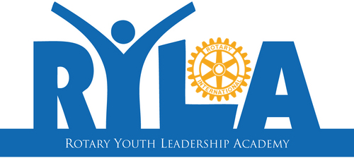
Do you have what it takes to become a dynamic leader and change not only yourself but the world?
Rotary Youth Leadership Academy (RYLA) is an intensive leadership experience organized by Rotary where you develop your skills as a leader while having fun and making connections.
What are the benefits?
Connect with leaders in your community and around the world to:
- Build communication and problem-solving skills
- Discover strategies for becoming a dynamic leader
- Learn from community leaders, inspirational speakers, and peer mentors
- Unlock your potential to turn motivation into action
- Join about 100 like-minded students from Western North Carolina to have fun and form lasting friendships.
What’s involved?
Rotary District 7670’s RYLA is organized locally for participants who are Freshmen, Sophomores, Juniors and Seniors in high school. Our next RYLA is 26-29 March 2020 at the YMCA Blue Ridge Assembly in Black Mountain, NC.
Young leaders will arrive at the site after school on Thursday, 26 March between 3-6:00 PM and depart RYLA on Sunday (29 March) early afternoon. You will stay in dormitories. Typically, the event will include presentations, outdoor activities and workshops covering a variety of leadership-related topics.
There is no cost to the young leaders attending RYLA. Students are selected and sponsored by local Rotary clubs.
Check out this video
https://youtu.be/sByLgYJzUlo
How can you get involved?
To find out more about RYLA in Western North Carolina including how to apply, please send your contact information and address (city and zip code is sufficient) to your local Rotary club or to RYLA Director Mike Stevenson msteven1@ccvn.com or 828-380-0580. He will contact your local club and someone from that club will contact you.

