Rotary High School Youth Exchange Program
For the adventure of your life 09 September 2023

The Rotary Youth Exchange program is a life changing opportunity to attend school and live with one or more host families in another country. It is one of the finest exchange programs available, carefully selecting and preparing students before departure and supporting them during their exchange.

There are two exchange programs: one for the entire academic year (long term), the other is a family to family summer exchange (short term). Students may apply (beginning in September) for either or both of these programs; they should be between 15 and 18.5 when they begin.
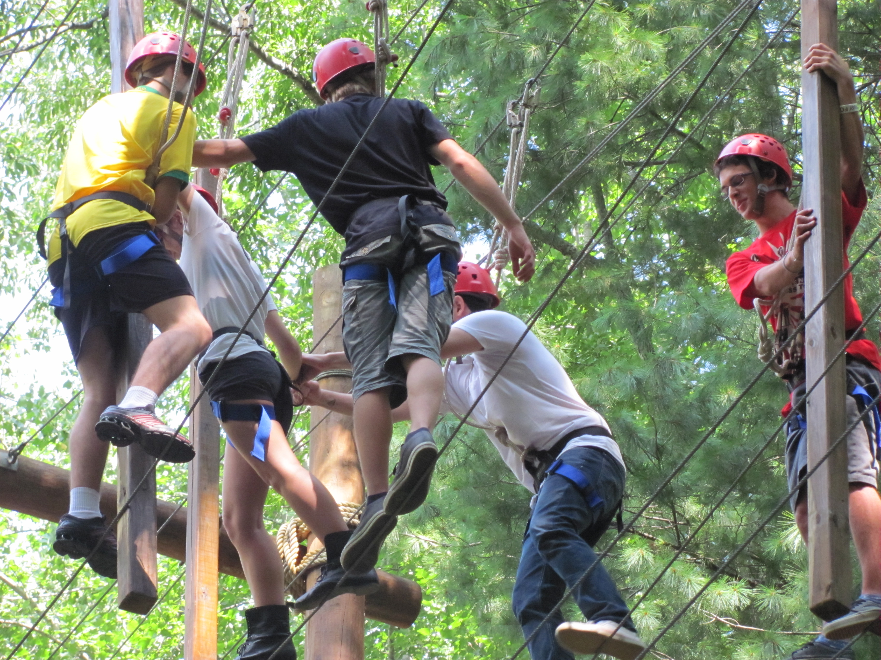
A third exciting opportunity is hosting a student. Rotary Clubs host a foreign student, and find three host families to cover the school year. We invite families to consider hosting – those with children of any age are a bonus. Our goal is three families, so each family would host for three or four months. This would be a great introduction to life as an exchange student.

These exchange programs are coordinated through the Ohio-Erie Youth Exchange Program, which supports the Rotary exchanges of several states. Once a student is selected by a local Rotary Club, Ohio-Erie handles the work of the actual placement. They have exchange agreements with Rotary districts in 30 or 40 countries. Students list their preferred countries for an exchange, but should be prepared to go anywhere.

There is much more information on our exchange programs on the Ohio-Erie Web site: www.ohioerie.org. There is also lots of info on the Rotary International web site: www.rotary.org.

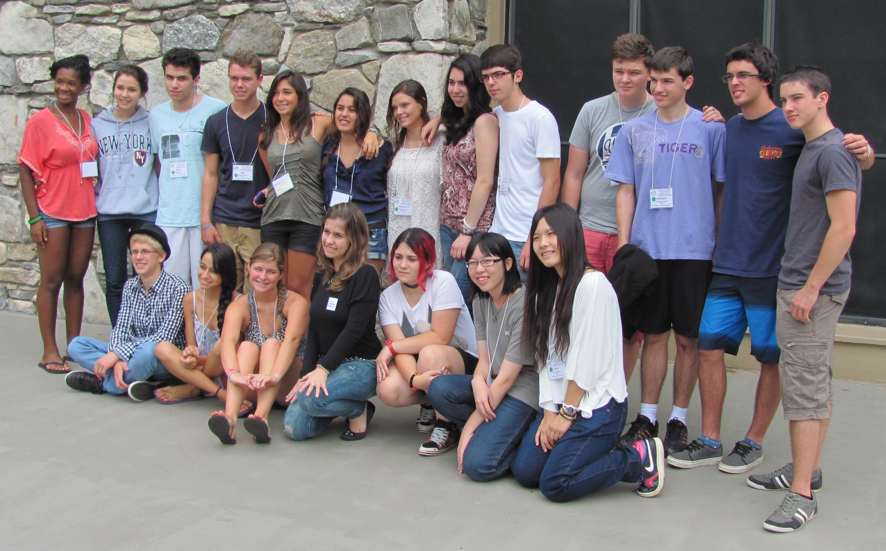
Our exchange students are our citizen ambassadors to the world, sharing with us our dreams of world peace and dedication to service above self.

Applications for these three youth exchange programs are coordinated by the Rotary District 7670 committee. Please contact our Youth Exchange Chairman, Fred Reidinger at fred_aia@comporium.net or text (828) 553-7346.

