ASHEVILLE-BUNCOMBE TECHNICAL COMMUNITY COLLEGE
ASHEVILLE CAMPUS POLICIES & REGULATIONS AGREEMENT

In conjunction with the Regulations on the Facility Usage Agreement, the following Policies & Regulations apply when renting a conference room, or classroom, at A-B Tech:

- Food and Drinks are not to be consumed in any classrooms, or the auditorium.
- Attaching anything to walls is prohibited. The renting party will be charged for any resulting damage to walls. Please note: This includes flipchart Post-It paper.
- No glitter of any kind (including decorative paper with glitter.) Please Note: There will be an additional $100 cleaning charge for any glitter, or confetti decorations, used in the building.
- Food is not to be placed on the upholstered furniture.
- Writing on sidewalks with chalk is prohibited.
- Art pedestals & acrylic tops in Conference Center Lobby should not be moved or touched (this includes: nothing placed on top, no tape attached, etc.)
- Any rented equipment brought in by renting party must make arrangements for same day pickup.
- All deliveries and pickups need to be scheduled with AB Tech’s Coordinator, Events & Facilities.
- No open flame in any buildings.
- Lobby furniture in the Conference Center may not be removed from the lobby.
- Conference Center red chairs must stay in the building.
- Fire Lanes & Loading Dock may be used for short term loading/unloading only. Vehicles cannot be parked in these areas for the duration of the event.
- Parking: Guest parking is permitted in the white lines only. (Yellow lines are Staff only.)
- Signs placed around Conference Center must be removed at the conclusion of the event.
- Signs are not permitted above the 1st floor of the parking garage. All signs must be removed at the conclusion of the event.
- Posted classroom maximum capacities are not to be exceeded.
- Classroom tables and chairs are not to be moved into the hallway or moved between classrooms.
- Any tables and chairs that are moved within the classroom must be put back to their original configuration at the conclusion of the event.
- Please arrange for off-site childcare if needed.
- Dogs, or animals of any kind, with the exception of service animals, are not permitted on campus or permitted to be left in vehicles.
- In the event of non-returned equipment, or damaged property relating to the room usage, costs will be invoiced to the renting person/organization.
- Please do not list A-B Tech as the contact for information, or registration, for your planned event.
- Please turn off all equipment when you have finished using it.
- Please bring your own class consumables such as flip chart paper, pens, markers, dry-erase markers, etc.
- Please bring adequate number of handouts & sign-in sheets for your event. AB Tech is unable to make copies.
- A-B Tech’s policy prohibits food and drink in the classrooms.
- Please remove everything that was brought in, at the conclusion of the event. All trash must be put in the proper receptacles. AB Tech will remove trash from the trash barrels.

Special Note: A-B Tech is a Tobacco Free & E-Cigarette Free Campus. Please advise your participants prior to your scheduled event that smoking is not allowed in any location on the campus.

The undersigned agrees to the above listed Polices & Regulations. Any questions regarding the above Policies & Regulations will be addressed prior to the scheduled event.

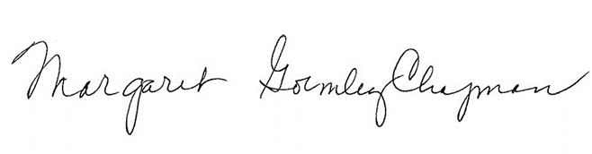
Margaret Gormley-Chapman_ Rotary International District 7670
Lessee Name: (print & sign name) Name of Organization Date10/11/18

__________________________ AB Tech_______________ __________

Ellen Ryan Name of Organization Date

Mailing Address: 340 Victoria Road ∙ Asheville, NC 28801 ∙ (828) 398-7901∙ Fax (828) 281-9876

