OPERTUNITY TO DO GOOD IN AFRICA

Your club is invited to join with other clubs to change lives in Nigeria through education and technology. We are asking a handful of clubs to join together and provide $1000 or $500 each for a Global Grant to promote education and training and computers and support to thousands of school children in Southern Nigeria.

In February a group of Rotarian (couples) will travel to Lagos on a Friendship Exchange and in May Nigerians will travel here. This Nigerian Friendship Exchange will be at our District Conference. In Toronto DG Isaac and I met with DG Kola Sodipo District 9110 to detail the Exchange. In Toronto we agreed to cement our relationship with a joint Global Grant Project.

Friendship Exchanges are exchanges between two International Rotary Districts BUT they are much more. FE’s are intended to develop extensive and lasting relationships including future exchanges, Professional Exchanges, Student Exchanges, and joint projects.

Having led a GSE team to northern Nigeria a few years ago and through other Rotary related trips to other countries in Africa, I can tell you that there is no other region in the world that could use our support and no other Country more needing our help.

Here are the details of this first Global Grant Project detailing your Club’s opportunity to get involved with the first project of many projects and exchanges as we build our relationship with Nigeria.

To participate or for further information.

Please contact: PDG Jim Efland

[jimefland@gmail.com](mailto:jimefland@gmail.com)

828 231-2299

The NUTS & BOLTS:

**PROVISION OF COMPUTERS FOR SCHOOLS IN LAGOS AND OGUN STATES**

**LOCATION: FIVE (05) SELECTED SCHOOLS**

**INTRODUCTION**

The use of Computers is such a basic necessity in modern education from kindergarten to tertiary levels but unfortunately, in our environment, even tertiary institutions may not boast of computer pieces in computer Science Departments. It is therefore a major disincentive right from the basic level towards science education as most public schools do not have computers.

The project will therefore help in empowering these under-priviledged children in accessing basic computer knowledge from a young age and thus improve the pool of science-minded children as future scientist and in other science-related courses.

The total population of students in these schools is about 20,000.

**ACTIVITIES**

1. Provision of 10 pieces of desktop computer and printers/per school
2. Training of Teachers for maintenance of the computer sets
3. Internet access for one year for all the schools
4. Renovation of classrooms for computer laboratory

**BENEFICIARIES**

The pupils and teachers of the schools are the direct beneficiaries. The schools in general, parents and the communities will also benefit from the project.

**OUTCOMES**

The pupils will be saved the ordeal of sitting on the floor or broken furniture to receive lessons; pupils will concentrate and obtain better results in their tests and examinations.

**AREAS OF FOCUS**

Basic Education & Literacy

**SUSTAINABILITY AND MEASURABILITY**

1. Memorandum of Understanding shall be signed with each school authority stating their responsibility to maintain the donated equipment.
2. The local education authorities and Parents-Teachers Association shall also be involved in the maintenance of the equipment.

**SEED PROGRAMS INTERNATIONAL**

Peter Marks of Rotary Club of Asheville South talked about how his nonprofit organization, Seed Programs International, has been working through the Rotarians Against Hunger effort to provide vegetable seeds for Rotarian-supported vegetable gardening projects around the world.

This year, for example, seeds were sent to Rotarians in Philippines, Honduras, Kenya, and Uganda for uses ranging from urban school gardens to rural hunger response to HIV orphan support.

Peter wasn't sure if this project holds the possibility to be a Global Grant, and is interested to learn more from anyone who may share this interest. In terms of having active, working, locally-led, sustainable partnerships between host clubs and local clubs, he's already managing quite a few of those, so it seems like one of the hard parts of the process is already achieved.

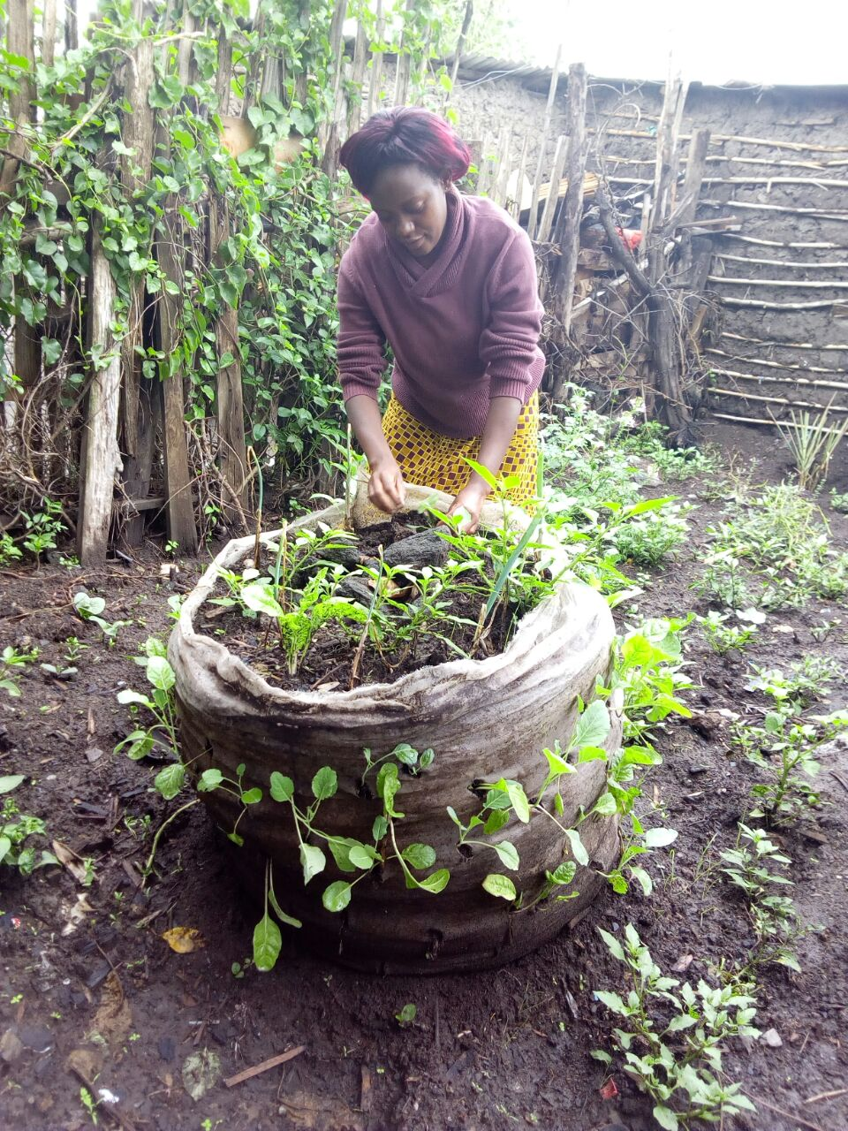

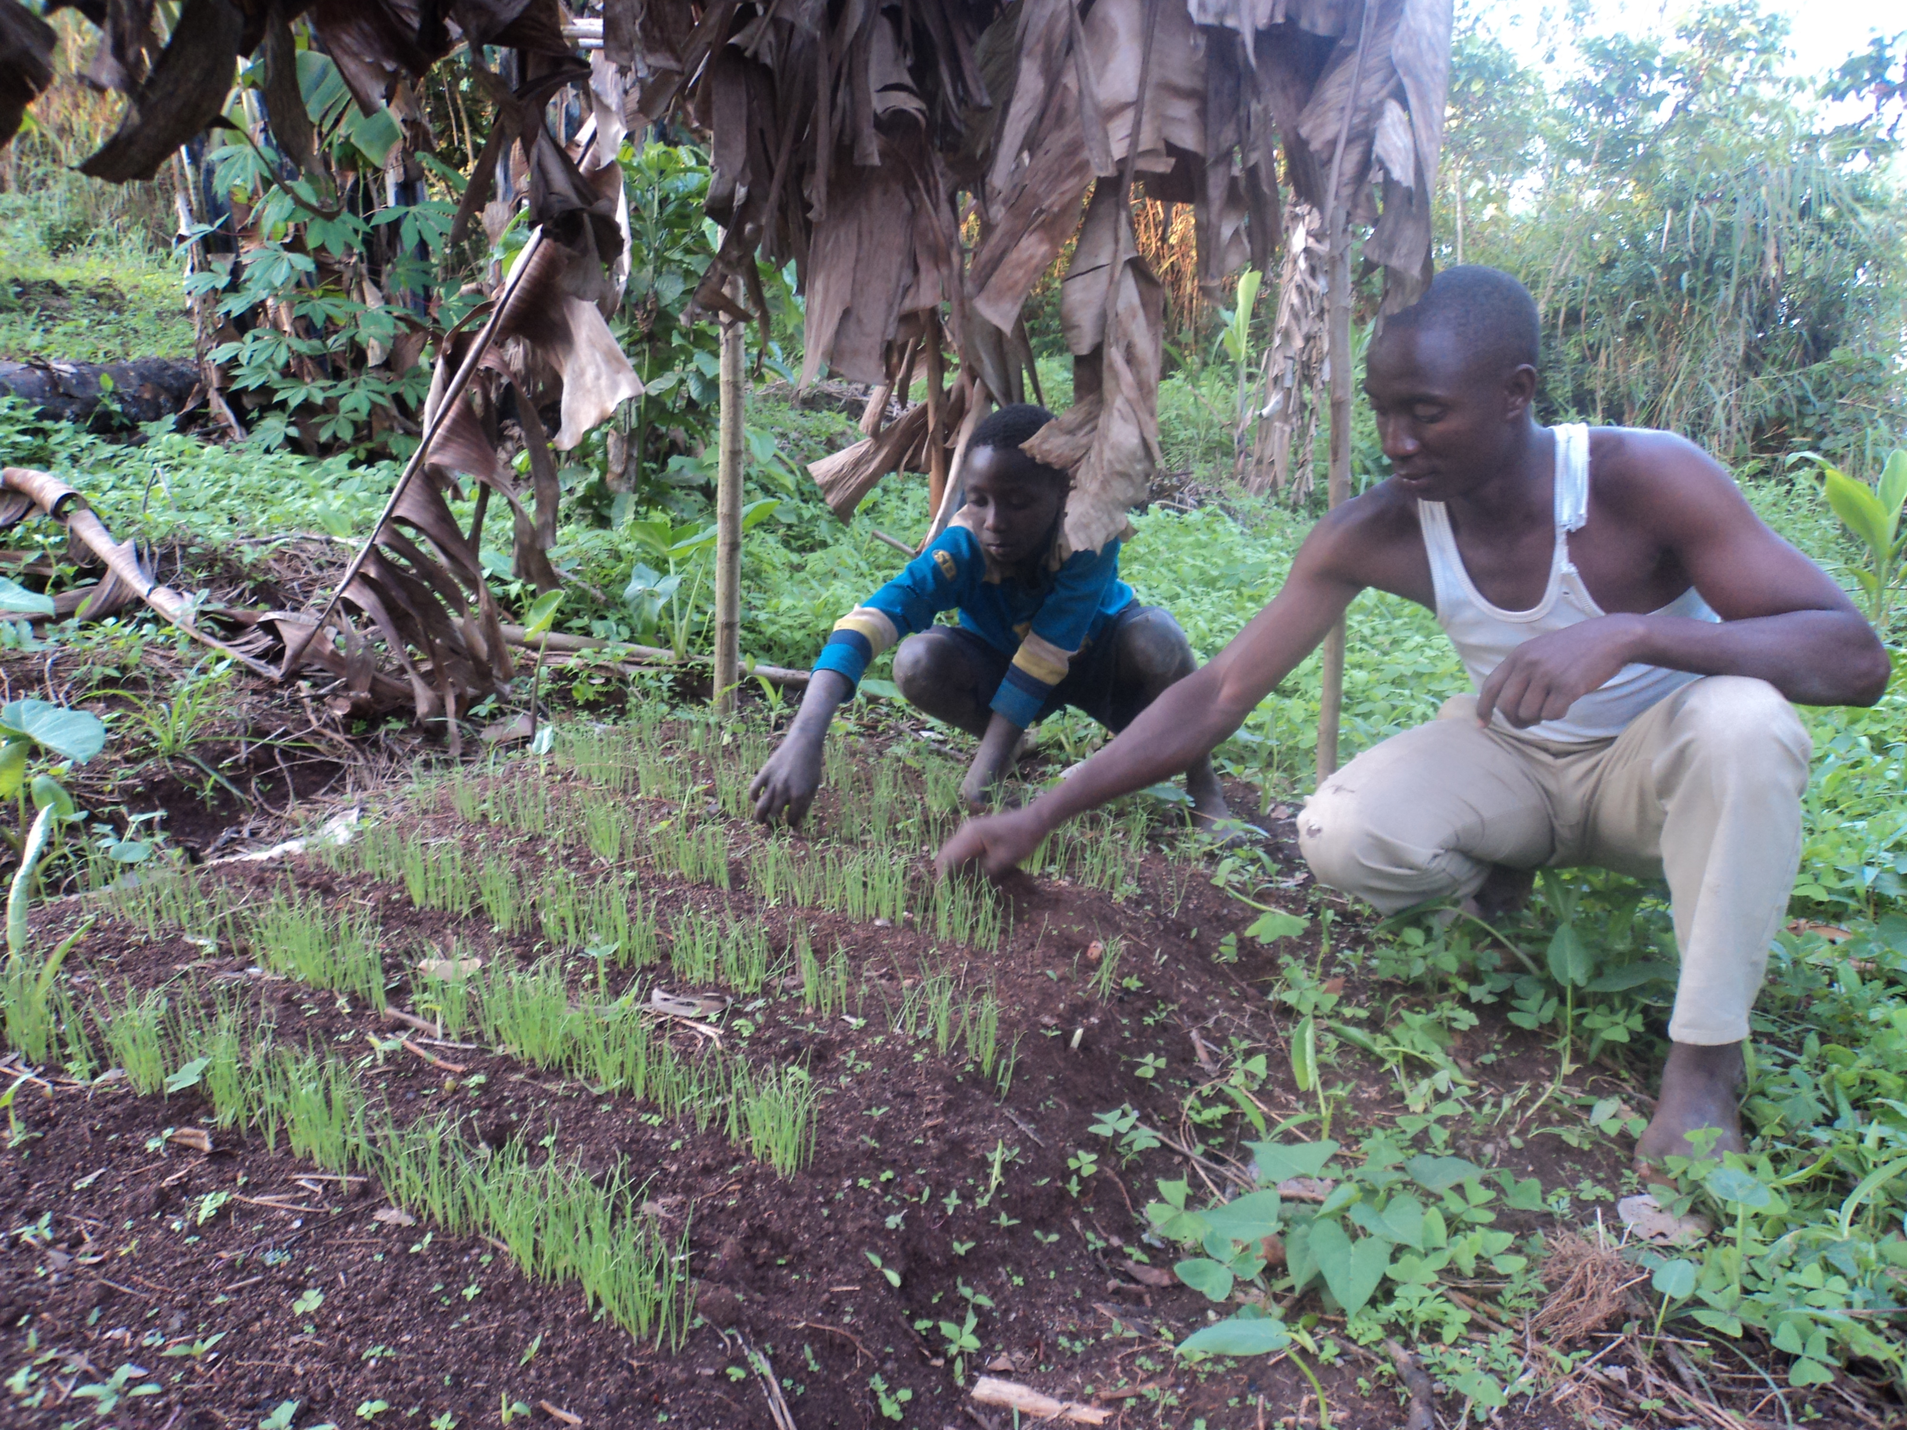

Peter Marks President/CEO  
Seed Programs International 828-707-1640

skype:petermarksspi

[www.seedprograms.org](http://www.seedprograms.org)  
[Subscribe to our quarterly e-news](http://eepurl.com/w9qrb)

[Follow us on Facebook](http://www.facebook.com/seedprograms)

***************************************

**LOCAL COMMUNITY NEED**

A significant number of Buncombe County school students do not have access to transportation options outside of the school bus. This means they cannot participate in activities that occur before or after school hours, like tutoring, attendance makeup, clubs, or sports.  My wife, a social worker At North Buncombe High, estimates 5 to 10% of that school's students are in this situation. I shared this story with participants of the recent Foundation & Grants Management Seminar hoping a local club may have an interest in building a program to address the need.

Benji Burrell

Business and Technology Engineer

(828) 283-0744 office, (804) 662-0964 mobile  
[benji@benjiburrell.com](mailto:benji@benjiburrell.com)

[Website](http://benjiburrell.com/) • [LinkedIn](https://www.linkedin.com/pub/benji-burrell/17/622/a02)