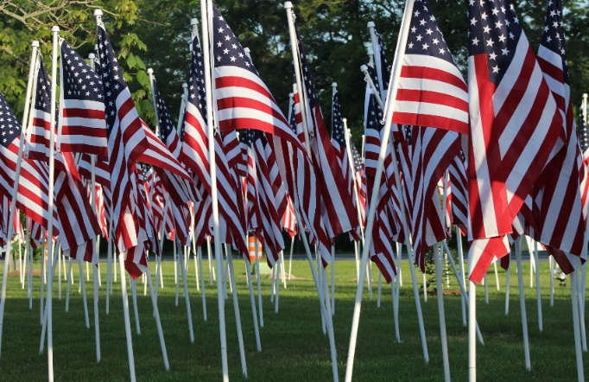
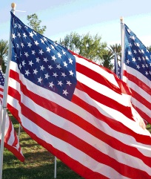
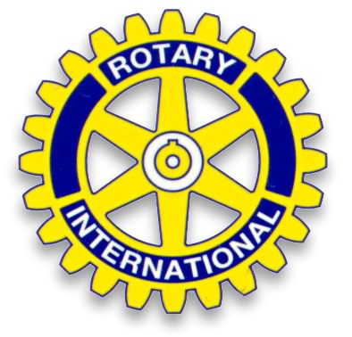
Georgetown-Millsboro Rotary Club Celebrating 96 Years - 1926-2022
Flags for Heroes 2022

Sponsor a Flag for $50.
Honor active duty military, veterans, police, firefighters, first responders, or other heroes, by sponsoring a flag. Over 500 flags will be proudly displayed in six locations in Georgetown and Millsboro the week before and the week after Memorial Day 2022. Proceeds support local youth programs, scholarships, and Rotary’s community projects.
To help assure accuracy, please list only One Hero per form. One check may be written for multiple flag sponsorships at $50 each.
Name of Hero __________________________________________________________
Sponsor Name _________________________________________________________
Address _______________________________________________________________
City/Town____________________________________________ State ___ Zip ______
Phone ______-______-_________ Email Address _____________________________
Sold by ____________________________________ Check # ___________
Make your $50 check payable to: Delaware Community Foundation. (Makes your donation tax deductible) Mail to: Delaware Community Foundation, 36 The Circle, Georgetown, DE 19947 Please write G-M Rotary Flags for Heroes on the memo line.
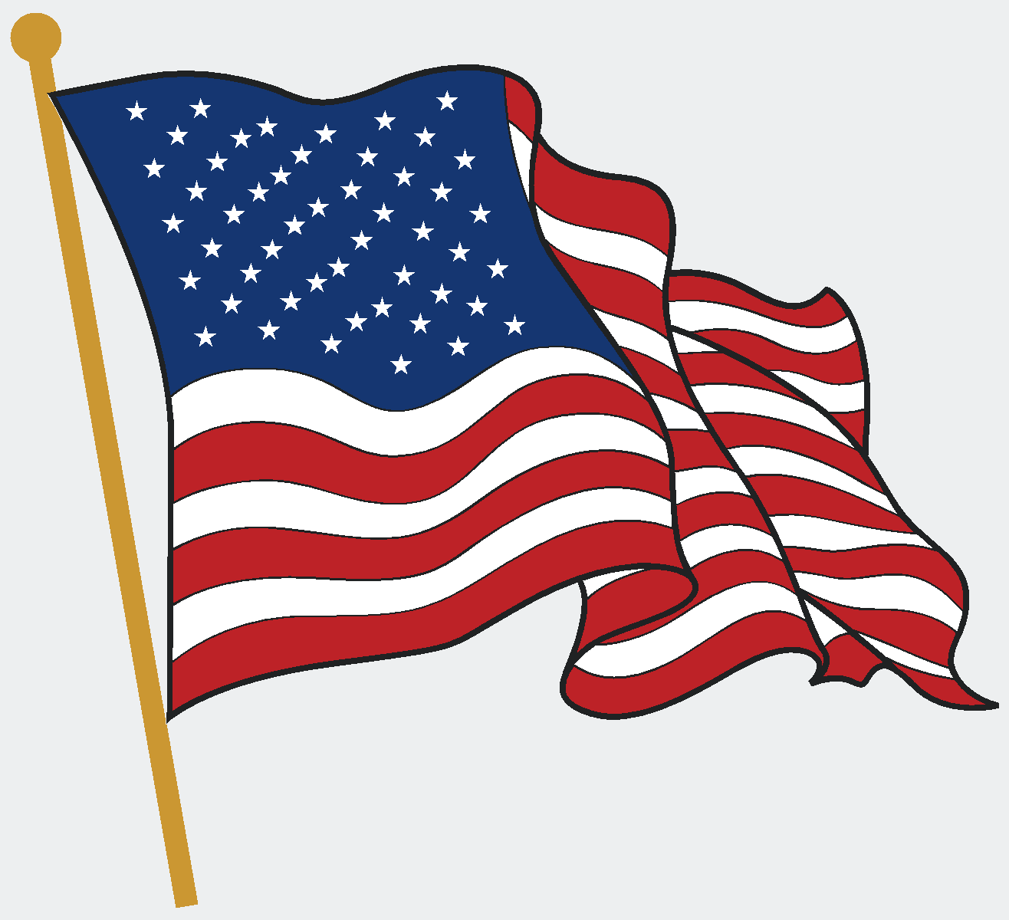
Receipt
The Georgetown-Millsboro Rotary Club Celebrating 96 Years - 1926-2022
Sponsor ____________________ ________________________
Thanks!
Amount $ _______ Check # _________
Sold by: __________________________ Date ____________

