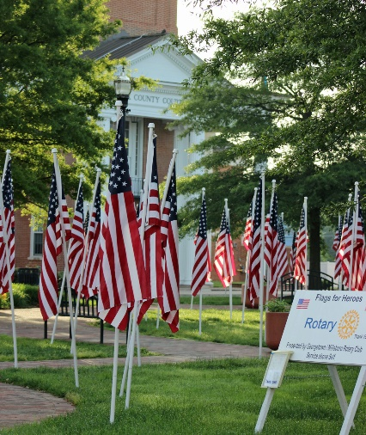
Flags for Heroes
Corporate Sponsors

Please help us honor our heroes including active duty military and veterans, police, firefighters, and first responders. Over 500 American flags will be proudly flown in six Georgetown and Millsboro locations the week before and the week after Memorial Day. All proceeds from Flags for Heroes, are returned to our communities as college scholarships, RYLA (youth leadership training) scholarships, grants to local organizations providing direct service to deserving youth and adults, assisting organizations that feed the hungry and shelter the homeless, supporting school and community youth groups and more.

Sponsor Name _______________________________ Contact Name __________________

Contact Email ____________________________________ Phone _____ ______-________

Address ____________________________Town _______________ State ____ Zip ______

Gold $1000 ___ Silver $500 ___ Bronze $250 ___

Sponsors will receive: An ad in the Flags for Heroes Sussex Post newspaper insert that will be mailed to thousands of homes, a Corporate Sponsor banner in Georgetown and Millsboro, recognition on the G-M Rotary website and Facebook page, and verbal recognition at Rotary events. In addition, Gold sponsors will receive 20 flag sponsorships, Silver sponsors 10 flag sponsorships and Bronze sponsors 5 flag sponsorships to honor your heroes.

Please list the first and last name of your heroes:

________________________ ________________________ ______________________

________________________ ________________________ ______________________

________________________ ________________________ ______________________

________________________ ________________________ ______________________

________________________ ________________________ ______________________

________________________ ________________________ ______________________

________________________ ________________________ ______________________

Please mail this form with your check payable to the Delaware Community Foundation to Delaware Community Foundation, 36 The Circle, Georgetown, DE 19947. Write G-M Rotary Flags on the memo line. Thank you. Sold by: ______________________________

