Thank you to everyone who sponsored a flag showing both patriotism and honoring veterans, first responders, and heroes who have made a difference.
ROLL OF HONOR
OLD GLORY ($2000+)
B&F Towing Co.
Carman Ford Lincoln

STARS AND STRIPES ($1000+)
MySherpa
Jamestown Painting Inc.
Womble Bond Dickinson
Bayshore
Burns & McBride
Specialty Finishes Inc.
Stonegates Retirement Community

GRAND OLD FLAG ($500+)
McCrery & Harra
New Castle County Government
Sherwin Williams
IFS Insurance
Bumpers & Company
WSFS Bank

RED, WHITE, AND BLUE ($250+)
The Handyman Service  Instant Imprints  Dr. Margaret Munley, DDS  Melting Pot  Stifel Financial (Jim Walls)  PNC Bank  Charles Allen  True Bearing Properties  Tony Baffone  Staples Concord Pike | IFS Benefits  Doc’s Meat Market  Kreston Wine & Spirits  Patrick Baronsky & Associates  Joe McDonough, B+ Foundation  EDiS Company  State Farm  Suken Jogani  Singer
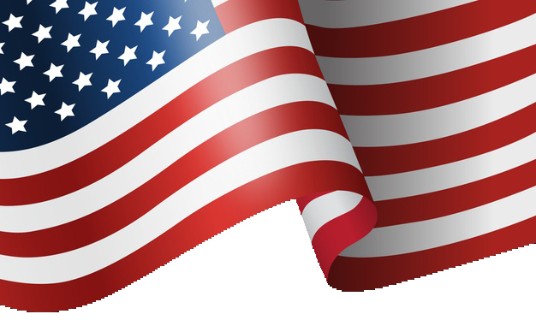
Honoring those
who serve.
FLAGS FOR HEROES
November 11, 2019

Liz Vaughn
Brandywine Hundred Rotary Club President

A Veterans Day Event to Benefit the
Brandywine Hundred Community

PRESENTED BY
Today we honor and remember those who have faithfully served family, community, and our country. This year’s display includes 500 American flags waving proudly in the wind—each flag with a memorial tag honoring a hero, including those who served our country so bravely and gave the ultimate sacrifice. All gave some. Some gave all.

Thanks to the generosity of the community and local businesses, this display has grown each year. The Flags for Heroes Project provides needed funds to worthy organizations in our area, all of them serving the heroes in our midst. This year proceeds raised money for America's VetDogs, an organization that raises, trains, and provides service dogs to veterans who are suffering war-related setbacks. In addition, the project supports The Heroes Self Defense Foundation, founded by U.S. Army veteran Sr. Cpl. Ryan Quackenbush, which helps police K9s and local police officers.
Flags for Heroes would not be successful without your generosity. Let us be reminded of the true meaning of Veterans Day—a time to remember, celebrate, and recognize the heroes that have served and sacrificed for our freedom. The Flags for Heroes display is open to the public from November 1 through November 14. Thank you for attending today’s ceremony and visiting our flags display. Any questions please email brandywinehundredrotary.de@gmail.com. Thank you.

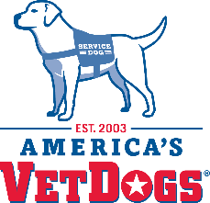
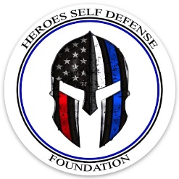
Sincerely,
Brandywine Hundred Rotary Club
www.brandywinehundredrotary.org

Flags for Heroes
Dedication Ceremony

November 11, 2019

Welcome – Todd Harra
Presentation of the Flag – Mt. Pleasant High ROTC
National Anthem – Jari Villanueva, USAF Ret.
Pledge of Allegiance
Prayer of Dedication – Rev. CDR John Gayton, USN Ret.
Guest Speaker – NCC Chief Paramedic, Larry Tan, Ret.
God Bless America
Presentation of Checks – Chris Vanderslice
Benediction
Taps
Dismissal
Special Guests:
All of our U.S. veterans and families present today
Ryan Quackenbush, Heroes Self Defense Foundation
Mary Cheyne, U.S. Army vet and her dog, Pepper - America’s VetDogs
New Castle County Mounted Police
New Castle County Paramedics

