ROTARY CLUB OF TAMALE DISTRICT 9102, GHANA.

MONITORING REPORT ON A PAST GLOBAL GRANT PROJECT:
WATER AND SANITATION PROJECT IMPLEMENTED IN NALERIGU, GHANA

November, 2020

INTRODUCTION
In the year 2015, the Rotary Club of Tamale, District 9102, Ghana, in partnership with the
Rotary Club of Brandywine Naamans, Wilmington, Delaware USA, and funding support from the Rotary Foundation Global grant undertook a water and sanitation project within the Nalerigu Township. The project comprises the drilling of two boreholes with hand pump and 180 micro flush toilets for households.
Five years after the implementation, the Rotary Club of Tamale, the host club to the project undertook a monitoring visit to ascertain the state of the facilities provided under the project and also assess the impact of the intervention to the community.
The Monitoring team comprised 3 members of the host club (Mary, the current club president, Nana-Asare, the immediate past president and Salifu, a host committee member to the project), and a representative of the Local Government authority.
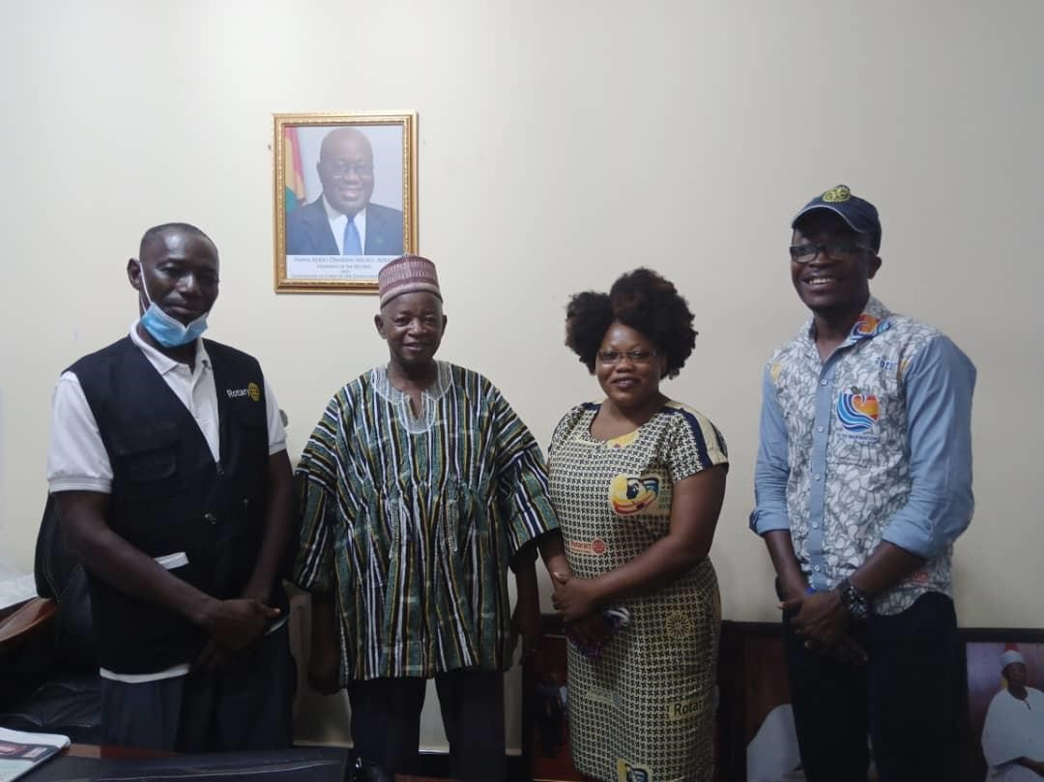
A courtesy call on the Deputy Regional Minister of the newly created North East Region of Ghana. Hon. Tahiru Tia Ahmmed

THE STATE OF THE FACILITIES.
The team visited the two boreholes and sixty-two of the micro flush toilets selected randomly. From what we saw, all the boreholes are in good condition with a very good yield and the surroundings well kept.
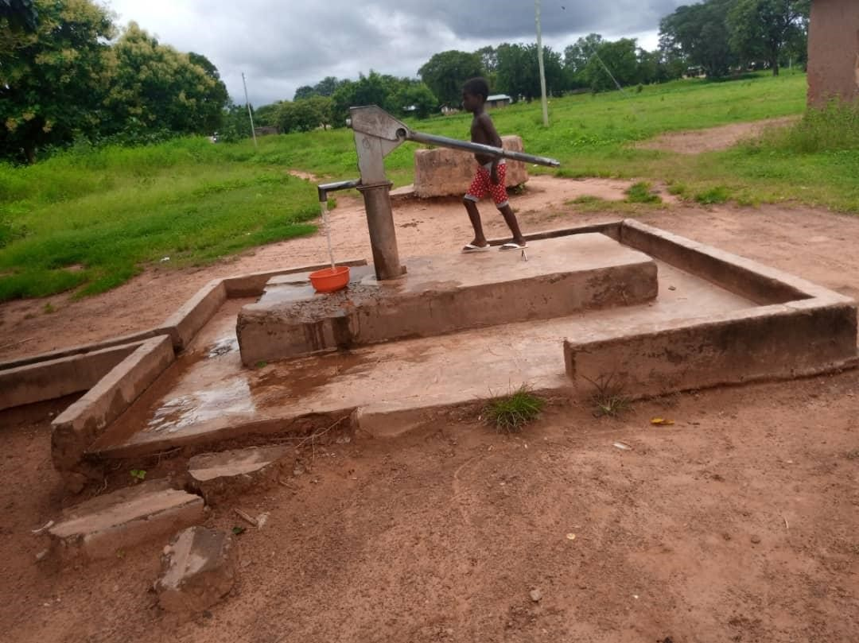
This is the bore hole around the Senior High School still functional.

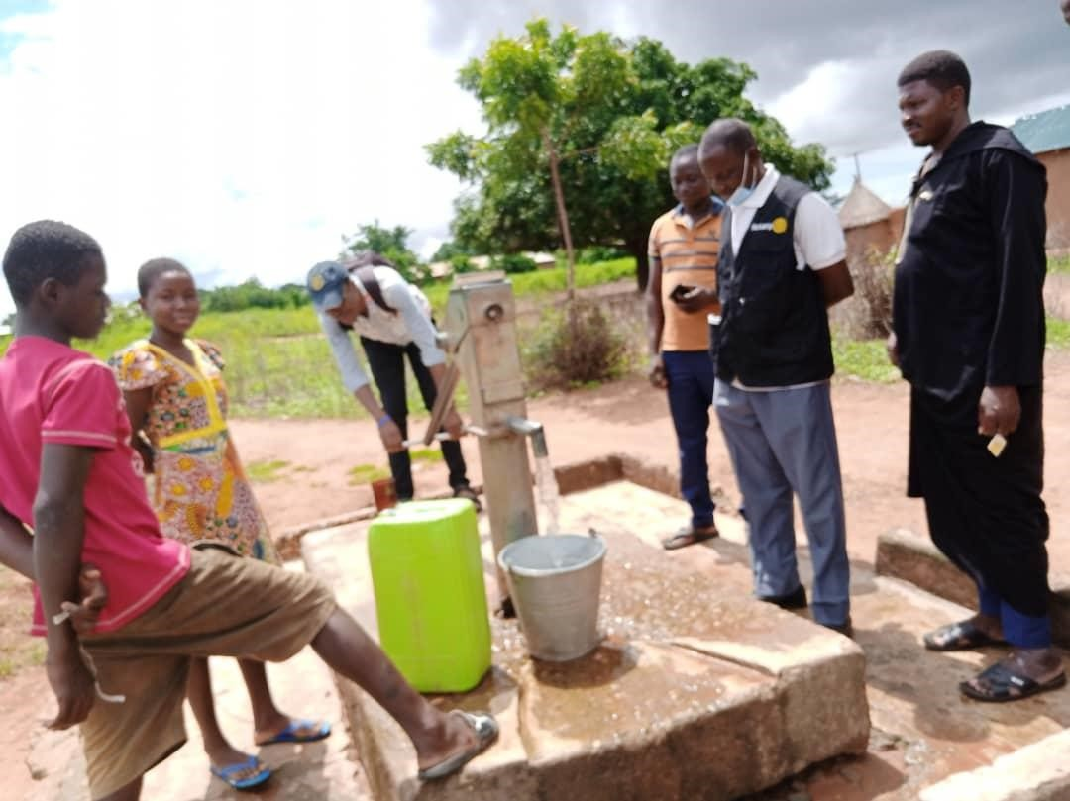
The second borehole in the community also working so well.

With regards to the household micro flush toilets, those visited were also in good shape and are being used by the various household beneficiaries. The following are some photos of the household toilets.

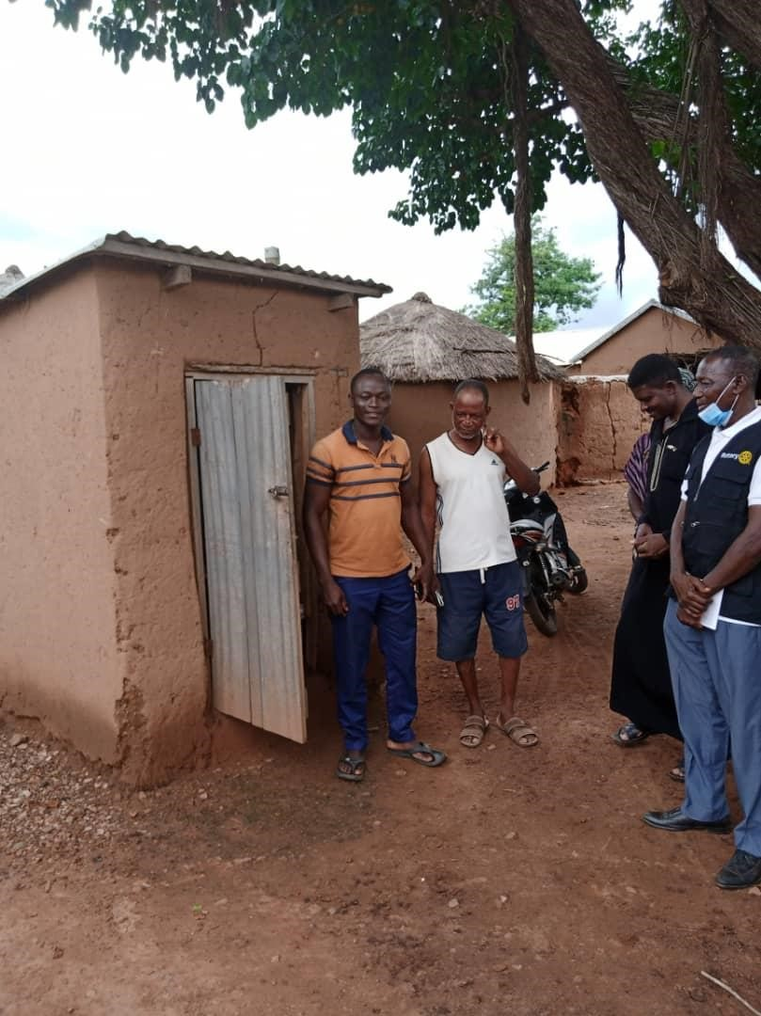
Some community leaders expressing their delight on the project. Especially, the household toilets.

FUNCTIONALITY / USEFULNESS
All the facilities are functioning well considering that these interventions were handed over to the community five years ago. When we asked one of the community leaders who is a sub-chief to the community on the functionality of the facility, he indicated that the facilities are still in good shape and thus serving its purpose. We also realized that apart from the facilities provided five years ago, there has never been any borehole or household toilet facility in the community and so they attested to the fact that the facilities are serving their needs though more is needed to augment what they currently have.

SUSTAINABILITY
The community leaders together with the WASAN committee has a maintenance plan for the two boreholes which has been very helpful to the sustainability of the facility. The district assembly representative ensures that the boreholes are serviced ones every three months and also fix any part of the pump that is not in a good condition.
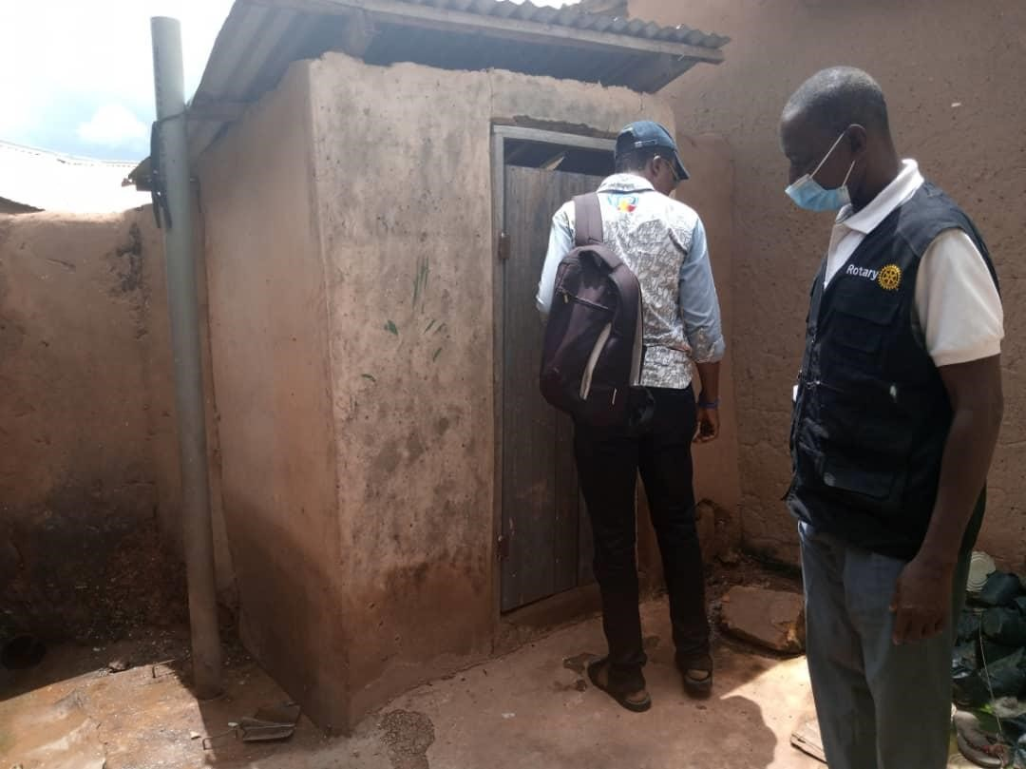
An inspection of a toilet in the house of the district assembly rep in the community.

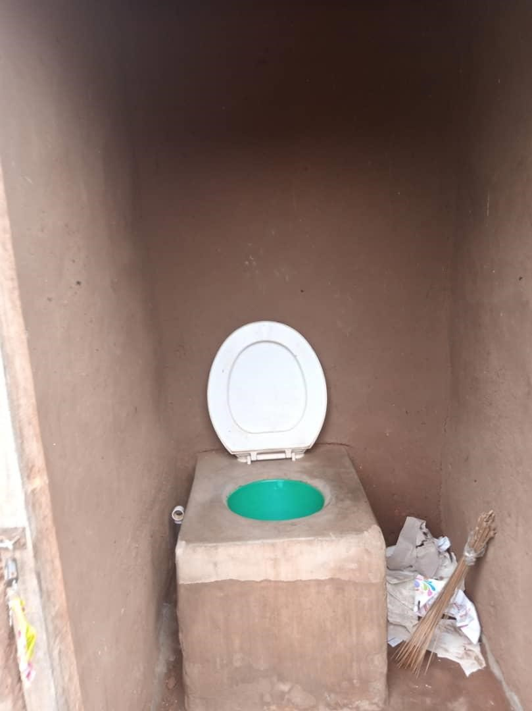
A micro flush toilet in one of the household.

OBSERVATION
The following are general observations made by the team on our visit to the community;
- Project sustainability has been superb. This is seen in the way the community has kept the facilities in good state after 5 years of handover.
- The population of the community has outgrown the facilities and so more of such facilities would be needed to cater for the growth in population.

RECOMMENDATION
Based on the observation made on how well the community and households have sustained the facilities and, the request from the community leaders, we recommend that, another grant be prepared to supply an additional micro flush toilets and boreholes. This would help to further achieve the overall goal of maintaining the success choked by the earlier intervention due to growth in population of the community.

