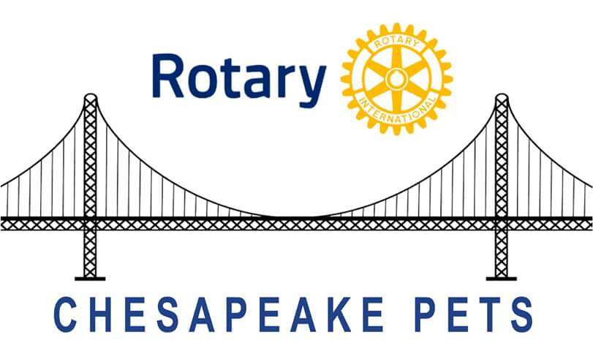
NEWS RELEASE
For immediate release (Date)

Rotary International President-Elect Training Seminar
_________________ was among 220 incoming presidents of Rotary clubs in Virginia, Maryland, Delaware and the District of Columbia who attended a two-day training for Rotary leaders at the Westfield Marriott in Chantilly, VA last week. The training is required for all incoming presidents of the 35,000 Rotary clubs in over 200 countries.
___________ will be installed at the end of June as President of the Rotary Club of ___________ in ______ (city, state) ____ for the 2016-2017 Rotary Year.
Keynote speaker at the President-Elect Training Seminar (PETS) was Rotary International President-Elect John Germ of Chattanooga, TN, who challenged the group to strengthen clubs and continue Rotary’s motto, Service Above Self. Among its other local, national and global efforts to make the world a better place, Rotary is on the forefront of the fight to eradicate Polio, partnering with the Gates Foundation and the World health Organization.
Other speakers included Joe Mulkerrin of Hampton Roads, VA, an incoming director of Rotary International, and John Smarge of Naples, FL, a former RI Director.
#

Further Information: (Name)_________________(Telephone))____________Email)______________

