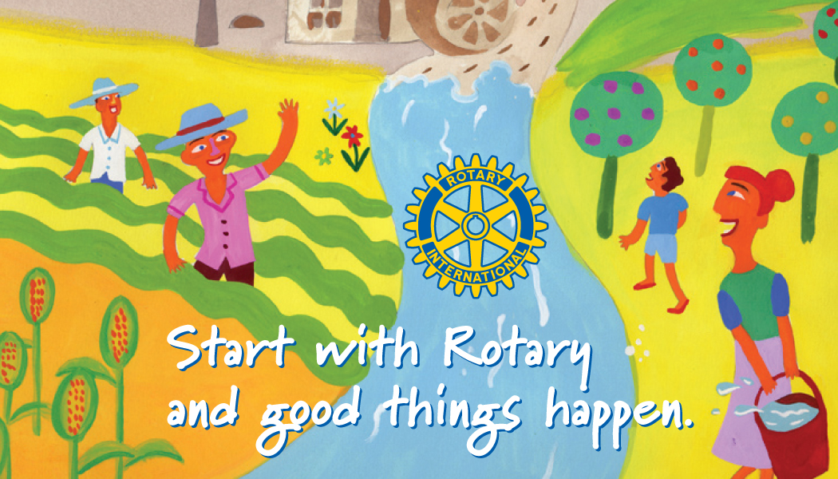

What is Rotary?
Rotary is a global network of community volunteers.
Rotary club members are business, professional, and community leaders in your locality who meet regularly to plan and implement community service activities and network with other professionals. For those interested, members can also choose to become involved in international humanitarian service efforts. More than 1.2 million men and women in over 200 countries and geographical areas belong to over 35,000 Rotary clubs.
Rotary builds international understanding through scholarships, exchange programs, and humanitarian grants. Throughout the world, Rotary clubs participate in a broad range of educational, intercultural, and humanitarian activities designed to improve the lives of others.

Benefits of Membership
Belonging to a Rotary club provides members with an opportunity to make a contribution to their own communities and to communities around the world.
Members may join Rotary for many reasons, including community involvement, personal development, professional networking, and camaraderie with fellow members. But perhaps the most important benefit is the satisfaction gained from making a real difference in the world.

Rotary Club of South Anne Arundel County supports:

Annual Events
Super Bowl Raffle – January
Quacks for Packs – May
St. Michaels Cruise Raffle – June
Dictionary Project – October
Lights of Kindness - December

Scholarships/Youth Programs
RYLA
Scholarship for Scholars
Southern High Interact
SHS Scholarship Foundation

Rotary Club of South Anne Arundel County Projects
Our club has always been focused on youth-related projects. From our first project after the club was chartered in 2005 (where built desks and provided donated computers to 8 girls living in the Marys Mount Manor Girls’ Group), to our most recent grant to STAIR, we remain committed to supporting youth-in-need in our community.
Other notable projects and initiatives:
Bountiful Backpacks – our signature local initiative where we provide weekend food for the neediest families in our local elementary schools; since the start of this project, we have spent over $100,000 on food, providing more than 35,000 bags with just shy of 200,000 pounds of food
Trade School in Haiti – one of our members, Bill Scrivens, has dedicated himself to jumpstarting the Haitian economy by helping to build a trade school that trains electricians, plumbers, nurses, and computer experts in Haiti
Local grants – each year we provide financial support to local non-profits that provide services to youth in a variety of ways; examples of grant recipients include STAIR, Rivers Edge Forest, South County Reading Camp, You Gave It We Give It, and more


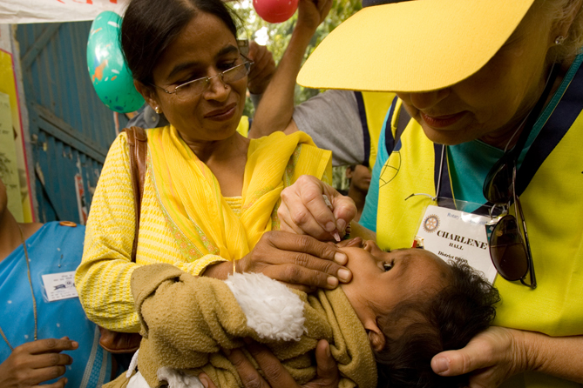

Come Join Us!
We meet on the 1st, 2nd, 3rd, and 5th Thursday mornings of each month from 7:30-8:30AM. Breakfast is provided, with unique speakers each week.
On the 4th Thursday of each month, we meet from 5-6PM for a happy hour at Pirates Cove in Galesville.

Leadership
President ’21-‘22
Blair Smith
Vice President ’21-‘22
Wendy Van Vliet


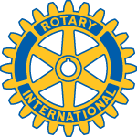
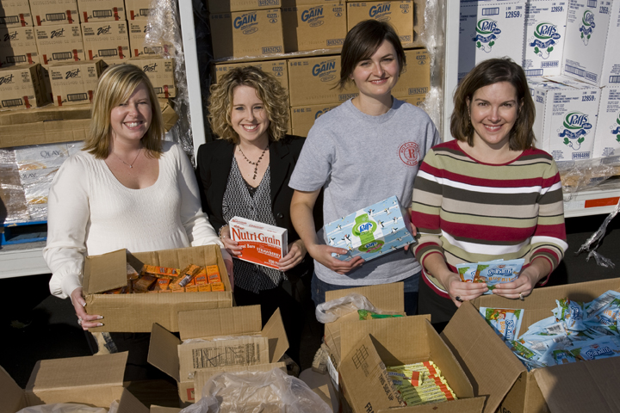
Service
IT’S
All
PolioPlus, Rotary’s most ambitious program to date, focuses on global immunization efforts and has played
a leadership role with the World Health Organization, CDC, and UNICEF in bringing the world to the brink of polio eradication. The Bill & Melinda Gates Foundation has contributed US$355 million to Rotary to support PolioPlus activities.

ROTARY CLUB OF SOUTH AA COUNTY
Lee Derrick, Membership Chair
lee.derrick@ffgadvisors.com
ROTARY CLUB
OF
SOUTH ANNE ARUNDEL COUNTY

