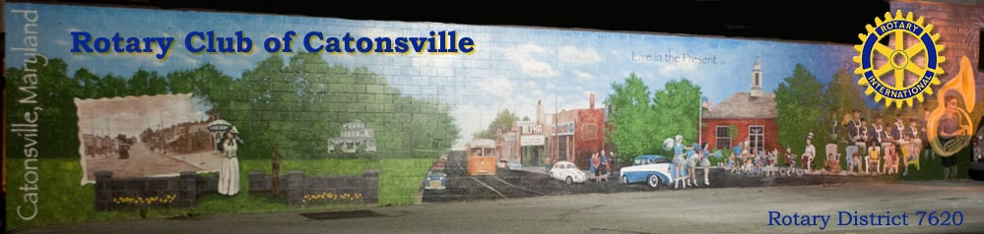
Thank you for submitting a funding request to the Rotary Club of Catonsville-Sunrise Charitable Foundation. Please complete the following information and submit to our Foundation email address: rccsunrisecharitable@gmail.com.
All awards will be determined on an individual basis.
Project Name:______________________________________________________________
Name (of person completing the application):____________________________________
Email:_____________________________________________________________________
Phone Number:_____________________________________________________________
Organization Website:________________________________________________________
Amount Requested:_________________
Total Project Budget:________________
Type of Project:_____________________
Population Served:__________________Geographic Area Served:____________________
Ages Served:_______________________
Dates the project will be underway:____________________________
Dates the project will be completed:____________________________
Organization Mission Statement: ____________________________________________________________________________
____________________________________________________________________________
____________________________________________________________________________
____________________________________________________________________________
Brief History of the Organization Project Narrative:
Project Overview: In one or two sentences describe the specific purpose of the project and how funds will be spent.
Project Details: What do you hope to achieve? Why is the project needed? Who will participate in your project? What specific activities will you do to achieve your goals?
Project Budget: If applying for a specific project, include a project budget (income and expenses) including all committed and anticipated funding for the project. The project budget should be aligned with the project details.
Project Promotion: How will you promote this project and how will that promotion feature the support of the Rotary Club of Catonsville?

Organizational Capacity: Who will staff your project? What are the qualifications of your staff? What experience does your organization have that will support the project’s success? How does the project help your organization meet its mission?
Project Evaluation: How will you measure the success of your project?
Project Sustainability: What are your plans for continuing this project after your grant cycle ends?
Partnerships: Do you plan to partner with another organization(s)? If yes, please describe the partnership arrangement(s).
For other Rotary Clubs only: Has a District Grant been applied for? Has a District Grant been approved?

