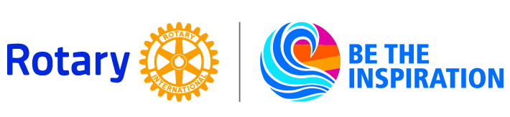
Rotary International District 7620
District Grant Application Form
2018-2019
Date:
Club Name:
Club Contact No. 1: (Name, address, phone, and email)

Club Contact No. 2: (Name, address, phone, and email)

Club Contact No. 3: (Name, address, phone, and email)

Project Title:
Project Mission: (One sentence)

Amount of Funding Provided by lead Rotary Club:

Amount of Funding Provided by partner Rotary Clubs: (List by Rotary club)

Funds provided by cooperating organizations: (List by organization)

Funding requested from District 7620:
Total Project Budget:

Preparing Project Narrative, Budget, Letters of Participation, and Letters of Endorsement (See this document for instructions.)
To complete the application, attach the following:
- project narrative
- budget with narrative
- letter(s) of participation
- and letter(s) of endorsement before
Complete application packages need to be submitted electronically to District Grants Committee Chair, Barry Thompson at bht1113@aol.com.

