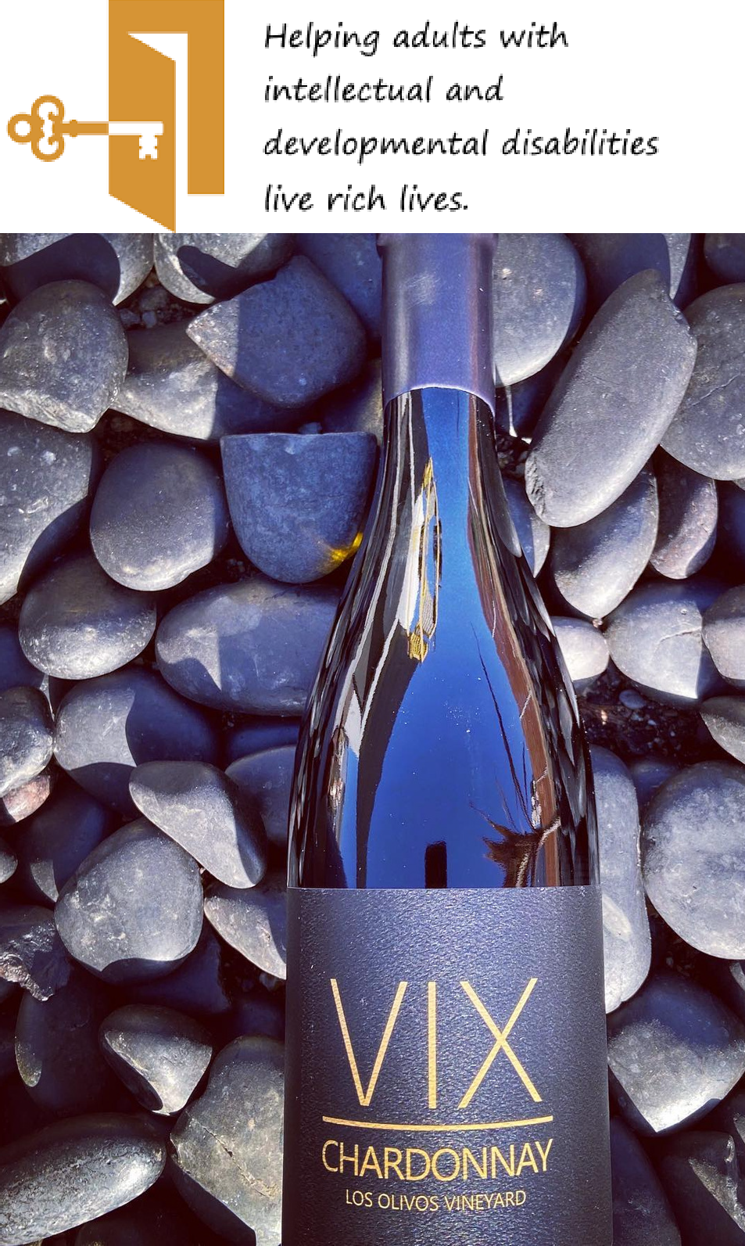SWIRL. SMELL. SIP. REPEAT!
All proceeds benefit
Hartwood Foundation

VIRTUAL WINE TASTING

Thursday December 10, 2020
6:00pm-7:00pm

$ 100 BUYS 3 BOTTLES
DELIVERED OR PICK UP AT VIENNA VINTNER
320 MAPLE AVE EAST, VIENNA, VA 22180

RSVP by calling AJ Oskuie at:
703-981-4911

