**Above Pictures of Display in Front of Highly Visible Area at**- **Medical Building 6858 Old Dominion Rd, McLean**

**Just Announced: Corona Virus Healthcare and   
Essential Worker Heroes  
Unique Opportunity to Recognize Your Special Company Heroes   
Medical Personal (Doctors, Nurses, Technicians, Health Care Workers), Support Staff, Food Workers, Grocery Clerks, Cashiers, Delivery Drivers, Warehouse Stockers, Teachers, etc.   
In addition to the Medallions with the Hero’s Name:   
“Healthcare and Essential Worker Hero”  
Will Be Recognized with A Waterproof Red-White-Blue Ribbon   
Tied Around the Flag Above the Medallion and Added Signage  
*Note – Memorial Day 2020 recognition may be limited to one or two locations and limited number of Flags Based Upon Governor/CDC Guidance on Social Distancing/Gatherings –Recognition Will be Extended for Displays for Independence Day and Veteran’s Day***

Honor Your Hero with a Flag   
 **Flags are Beautifully and Patriotically Flown in Three or More Locations in the McLean-Tysons Area  
Corporate Sponsorships Now Available–   
Honor Your Employees or Business Partners   
- Show Visual Appreciation of Your Team Members in Your Community- Your Logo Displayed On-Site Banner Recognizing Your Company Heroes and  
- Special Recognition by McLean and Tysons Rotary Clubs & More…**



***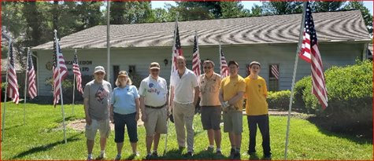*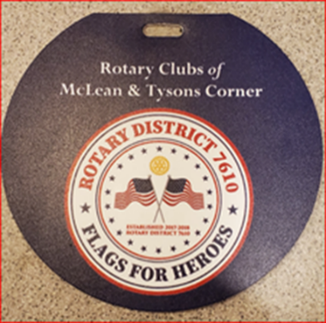**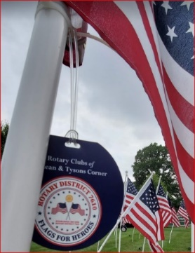

***American Legion Post 270 -* 1355 Balls Hill Rd**

**Rotary Clubs of McLean & Tysons Corner**

The Rotary Clubs of McLean and Tysons are working together to provide this opportunity for companies and organizations to Honor their Heroes with American Flags displayed in highly visible, high traffic areas in multiple locations throughout the McLean community. The two award winning organizations, among the 33,976 world-wide Rotary Clubs, are known throughout the world for their national, local and community projects and are prominent contributors to the Northern Virginia community.

**Who Are Your Heroes?** Employees, Veterans, Military, Healthcare Workers, First Responders, Family Members, Teachers, Essential Service Providers, Friends or Anyone You Wish to Honor with a Beautiful American Flag

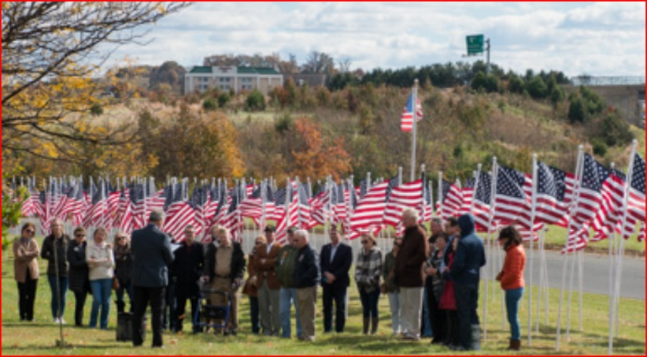

**Scheduled Locations for Display**

**Flags and Opening Ceremony with Local Politicians and Dignitaries in Front of Sharon Masonic Lodge - 999 Balls Hill Rd, McLean**

***Flags Visible from the Road on the Beautiful Grass Areas in Front of:*- American Legion Post 270 - 1355 Balls Hill Rd, McLean  
- Sharon Masonic Lodge - 999 Balls Hill Rd, McLean  
- Garfield Memorial Christian Church - 1731 Great Falls Street, McLean  
- Medical Building - 6858 Old Dominion Rd, McLean (Tentative)  *Corporate Sponsors May Select From One of the Active Locations or Can Discuss Having a Display Erected in Front of their Corporate Site***

**Currently Scheduled Dates  
(Dates Dependent on Status of Virginia Guidance and   
Safety of Volunteer Staff to Install Flags)**

**Independence Day Weekend - July 4th 2020   
Veterans Day Week – November 11th 2020  
Memorial Day Weekend – May 31, 2021**

|  |  |  |  |  |  |
| --- | --- | --- | --- | --- | --- |
| ***Flags for Heroes Sponsorship Opportunities and Benefits Rotary Clubs of McLean and Tysons Corner*** | | | | | |
|  | **Platinum**  ***Stars and***  ***Stripes Hero***  ***Sponsor*** | **Gold**  ***Red-White-Blue Hero Sponsor*** | **Silver**  ***Valor***  ***Hero Sponsor*** | **Bronze-**  **Small Business**  ***Patriot Hero***  ***Sponsor*** | **Community Sponsor**  ***Friends of***  ***Rotary*** |
|  |  |  |  |  |
| **Contributions to Rotary Clubs McLean & Tysons** | **$10,000** | **$5,000** | **$2,500** | **$500** | **Supports with promotion or donations (Printing, signs, lights, etc.)** |
| **Number of Flags to be Displayed at One Location (Each Flag with Personalized Medallion)** | **15 Flags** | **5 Flags** | **3 Flags** | **1 Flags** | **1 Flag with (Community Sponsors May Sell Additional Flags)** |
| **Company Officer/member Introduced at Ceremonies at Flag Sites (Ceremonies will vary by date and site – address importance of Recognizing Heroes within Community)** |  |  |  |  |  |
|  | **Platinum**  ***Stars and Stripes Hero***  ***Sponsor*** | **Gold**  ***Red-White-Blue Hero Sponsor*** | **Silver**  ***Valor***  ***Hero Sponsor*** | **Bronze-Small Business**  ***Patriot Hero***  ***Sponsor*** | **Community Sponsor**  ***Friends of***  ***Rotary*** |
| **Corporate Officer or Member invited to McLean or Tysons Rotary Club (for Tysons – annual Holiday Breakfast – for McClean – annual recognition program) Introduced for recognizing the heroes within Community** |  |  |  |  |  |
| **High Quality Recognition**  **Plaque to be Awarded at either t a FFH Ceremony or Company Function (by a Club Officer) for Recognizing Heroes within Community** |  |  |  |  |  |
| **A “Quote” from Corporate Officer with message of support for recognizing “Heroes” included in any press releases to local papers** |  |  |  |  |  |
|  | **Platinum**  ***Stars and Stripes Hero***  ***Sponsor*** | **Gold**  ***Red-White-Blue Hero Sponsor*** | **Silver**  ***Valor***  ***Hero Sponsor*** | **Bronze-Small**  **Business**  ***Patriot Hero***  ***Sponsor*** | **Community Sponsor**  ***Friends of***  ***Rotary*** |
| **-For McClean Club, signage at the McLean Rotary Club “McLean Day” table- with Thank You to the Sponsor for Recognizing the Heroes within Community**  **- For Tysons Club – invitation for two to Annual Wine Tasting event and thank you from podium and recognition from Podium** |  |  |  |  |  |
| **Recognition on Signage at each of the Flag Sites (logo or name size/location depends on level of sponsorship** |  |  |  |  |  |
| **Recognition (logo or name) on both McLean and Tysons Rotary Club Web Sites for recognizing heroes within community** |  |  |  |  |  |
|  | **Platinum**  ***Stars and Stripes Hero***  ***Sponsor*** | **Gold**  ***Red-White-Blue Hero Sponsor*** | **Silver**  ***Valor***  ***Hero Sponsor*** | **Bronze-Small**  **Business**  ***Patriot Hero***  ***Sponsor*** | **Community Sponsor**  ***Friends of***  ***Rotary*** |
| **Logo or Name on Flyers (as appropriate)** |  |  |  |  |  |
| **Thank You Letter signed by the Tysons/McLean Rotary Club Presidents** | Thumbs up sign | Thumbs up sign |  |  | Thumbs up sign |
| **American Flags Displayed at FFH locations - Banners will indicate:**  **“Organizations Recognizing Heroes Within Our Community”** | Thumbs up sign | Thumbs up sign |  | Thumbs up sign | Thumbs up sign |

|  |
| --- |
| ***Founding Grand Signature***  ***“Star Spangled Banner” Hero Sponsor***  ***Special Recognition of Sponsor’s Community Heroes***  ***(Only 1 Founding Grand Signature Awarded for 10 Years & Rights to  Renew for Next 10 Years)***  ***$25,000 – 10 Year Sponsorship***  ***25 Flags with Personalized Medallion***  ***Special Banner Designation and Recognition  All Benefits Listed Plus Additional Recognition as Special Rotary Club Events: Corporate Officer/Member Recognized at Club Installation or Awards Banquet for Recognizing Heroes within Community and More….*** |