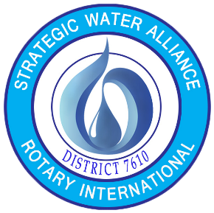
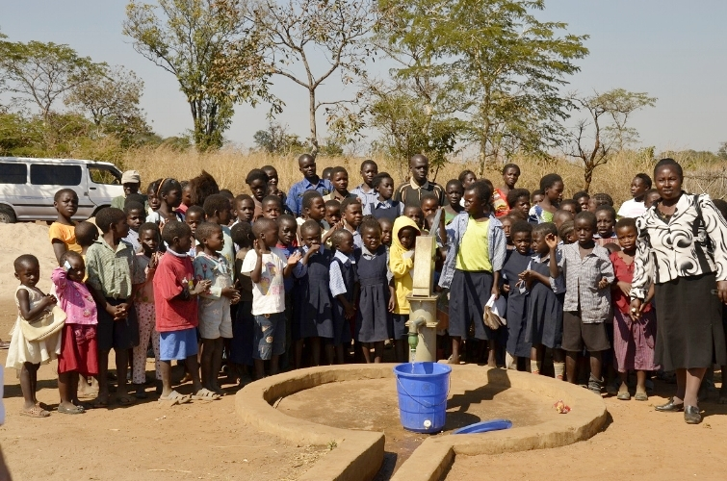

Join us in person or virtually
on October 28, 2023 9AM for the
Annual Walk for Water

Sponsored by
The Strategic Water Alliance (SWA) of
Rotary International District 7610

Please join us at Jones Point Park, Alexandria VA. or
participate virtually in the Annual Walk for Water, which supports water, sanitation, and hygiene programs for global communities.
Register and pay online at
https://www.eventbrite.com/e/12th-annual-walk-for-water-tickets-722767696637
$10 for teenagers, $35 for Adults, $50 for families
PAYMENT OPTIONS: Pay online OR Send a Check
Make Checks Payable to: Rotary Club of Alexandria (SWA), P.O. Box 320666,
Alexandria, VA 22320
SWA Participating Rotary Clubs
Alexandria, Bailey’s Crossroads, Dulles International Airport, Dunn Loring-Merrifield, Fairfax, Fredericksburg, Rappahannock- Fredericksburg, Sterling, Great Falls, Herndon, Leesburg Evening, Leesburg Daybreak, Manassas Bull Run, McLean, Tysons Corner, Vienna, West Springfield, Gainesville-Haymarket
Crystal City - Pentagon

