About Rotary  Rotary is a global network of community volunteers. It was founded in Chicago in 1905 and is the world’s first service organization.  Rotarians carry out a variety of service projects relating to humanitarian issues such as poverty, clean water, literacy, health, hunger, substance abuse, and pollution. Rotary sponsors service clubs offering career development and mentoring programs for youth and young adults. Membership is by invitation and is directed toward obtaining representatives from a wide cross-section of businesses and professions.  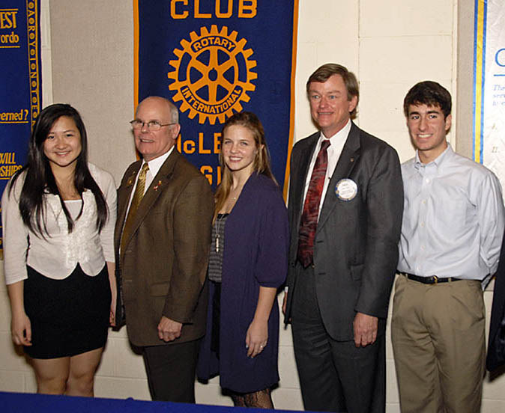  Rotarians present Youth Service Awards to area students who have made outstanding service contributions to the communities.  Five Avenues of Service  - Community Service  - Vocational Service  - International Service  - Club Service  - Youth |  | Membership  General Qualifications  Rotary welcomes all adults of good character and good business or professional reputation, who hold, or, if retired, have held a professional position in any worthy and recognized business or profession.  While membership in Rotary is open to all qualified persons, regardless of race, creed, gender, or nationality, Rotary is not for everyone: Rotary requires a commitment of time, energy, and financial resources. There is an attendance requirement.  If you think that Rotary is right for you, if you are interested in learning more about Rotary, or if you are interested in joining Rotary, please contact the club president, club membership director, or any club member, who will be pleased to extend an invitation to visit the club.  Annual Financial Expectations  (Subject to change)  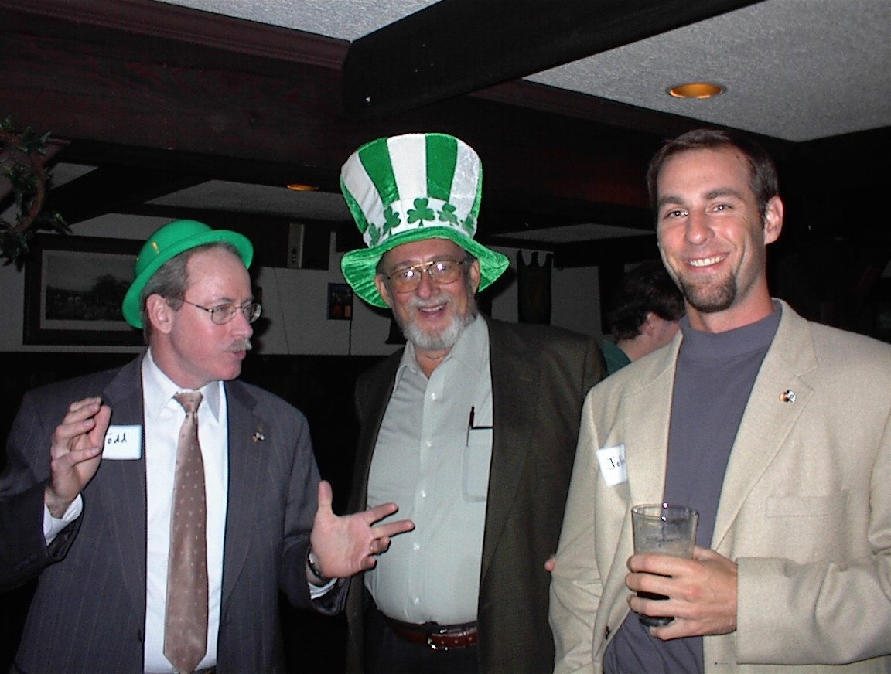  Todd Dempsey, Chet Gray, and John Rosenbaum enjoy a “wee bit o’fun” at a St. Patrick’s Day party. |  | The Rotary Club  of McLean, Virginia  P.O. Box 561  McLean, VA 22101  “Service Above Self”    Meets Tuesdays, 12:00 Noon  Lutheran Church of the Redeemer  1545 Chain Bridge Road  McLean, VA 22101  Come and visit us!  www.McLeanRotary.org
  Induction (one time charge) | $150
  McLean Club Dues | 176
  Rotary International Dues | 70
  Rotary District 7610 Dues | 43
  Weekly Meals | 900
  Foundation contributions (recom.) | 200
  Social Events (est.) | 200
  Total Annual Estimate | $1,739

About Our Club  The Rotary Club of McLean was chartered on November 10, 1965. Club members are business and professional men and women, or retirees, who either work or live in the greater McLean area. The club supports educational, vocational, and humanitarian projects that promote peace and understanding throughout the world. Rotary is particularly known for its efforts to end polio throughout the world. Our approximately 60 members work to improve the lives of the less fortunate in the local, national, and international communities. Each week at our club luncheon meetings, we enjoy fellowship and programs featuring speakers on topics of local or global importance.  Through our club, we build lifelong friendships, and we experience the personal fulfillment of volunteering to help others.  Our Purpose  The object of Rotary is to encourage and foster the ideal of service as a basis of worthy enterprise and, in particular, to encourage and foster:  FIRST. The development of acquaintance as an opportunity for service;  SECOND. High ethical standards in business and professions; the recognition of the worthiness of all useful occupations; and the dignifying of each Rotarian’s occupation as an opportunity to serve society;  THIRD. The application of the ideal of service in each Rotarian’s personal, business, and community life; and  FOURTH. The advancement of international understanding, goodwill, and peace through a world fellowship of business and professional persons united in the ideal of service.  Our Foundations  The McLean Rotary Club Foundation, Inc. is an independent IRC 501(c)(3) organization through which we accept tax-deductible donations and support worthwhile projects, primarily in the local community.  The Rotary Foundation of Rotary International also is an IRC 501(c) (3) organization that annually raises and distributes more than $250 million for humanitarian and educational projects. |  | Our Club Projects and Activities  Adopt-a-Family The club supplies holiday gifts, clothing, and other necessities to families in need of support.  McLean Day Each May, the club operates a food and beverage stand at McLean Day to raise funds for the club’s service activities.  Literacy Projects Club members serve as mentors and reading coaches at Timber Lane Elementary School. The club purchases books for Timber Lane students to take home. The club also provides financial support to the Literacy Council of Northern Virginia to teach English to adults.  International Projects The club sponsors Stop Hunger Now which provides nutritious lunches to children around the world. It purchases Shelter Boxes for victims of earthquakes, tsunamis, and hurricanes. It established a library at a school in Swaziland and in Meerut, India; established water purification plants to help eradicate Guinea worm in northern Ghana; installed kitchen, laundry and playground equipment for an orphanage in Ukraine; and, in partnership with Partners for Surgery, has provided surgical equipment for a medical project in Guatemala.  Salvation Army During the holidays, our club members collect funds by ringing bells for the Salvation Army at Giant.  Fellowship The club enjoys a variety of social activities, including happy hours, baseball games, holiday parties, and Interclub activities.  Youth Scholarships The club awards students to local high school seniors to help them continue their education.  Youth Service Awards The club honors deserving high school students who make outstanding service contributions to the community.  Support to local organizations. The club provides support to organizations such Homestretch, a local group providing transitional housing and support to homeless families; Alternative House, a home for troubled teens; Lewinsville Senior Center; Langley Residential Support Services, which provides housing for special needs adults; and the Falls Church-McLean Children’s Center. |  | 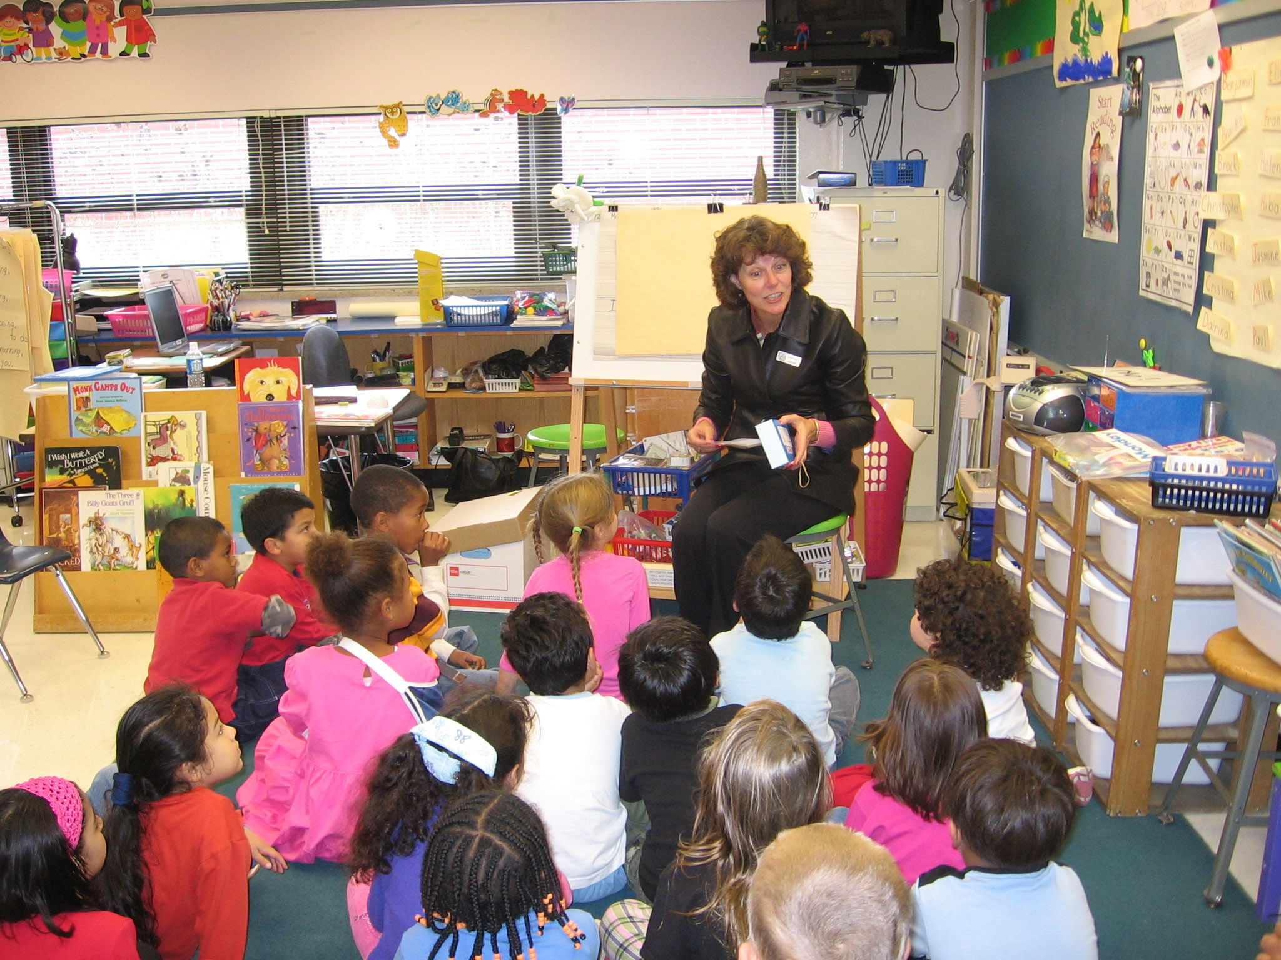  McLean Rotarian Kathy Martin reads to children at Timber Lane Elementary School.  Four-Way Test  Of the things we think, say, or do:  - Is it the TRUTH?  - Is it FAIR to all concerned?  - Will it build GOODWILL and BETTER FRIENDSHIPS?  - Will it be BENEFICIAL to all concerned?  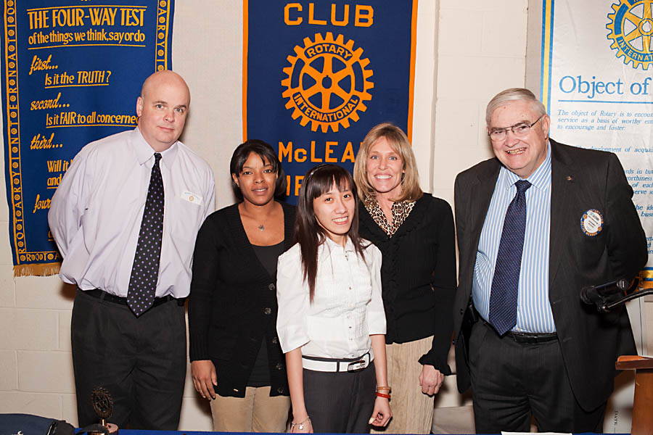  Rotary Club of McLean Foundation, Inc. trustees present scholarships to a Pimmit Hills High School student.  Ask Us  For more information please visit our  website at www.McLeanRotary.org  Revised May 2015

