Lake Ridge Fellowship House
Cookout Procedures

Background: Lake Ridge Fellowship House is a government-assisted apartment community designed for individuals with limited income who are independent, over 62, or who are disabled. The Fellowship House opened in 1983 and has 99 one-bedroom apartments, a social hall and other common areas. The Rotary Club of Lake Ridge sponsors semi-annual cookouts. These cookouts take place in April/May and September/October, and are made possible through the generous support of Lake Ridge Rotarians.

Fellowship House POC: Susan Hoffler, 703-494-4455, shuffler@fellowshipsquare.org

Lake Ridge Fellowship House: 12800 Harbor Drive (Tackett’s Mill), Woodbridge, VA 22192
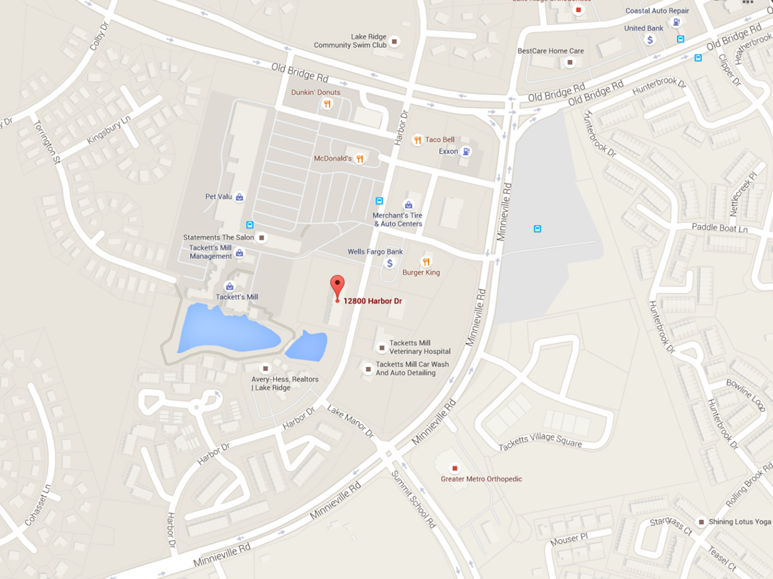

Schedule
11:00 | Set-up
11:15 | Light charcoal
11:30 | Begin grilling
12:00 | Picnic begins
1:30 | Clean-up

Personnel Requirements
Set-up
Grill Masters
Entertainment
Clean-up

Required Supplies
Item | POCs
Large coolers for ice (4)
Grill tongs, spatulas, and forks
Extension cords (as needed for crock pots)
Insulated aprons (grill master discretion)

Shopping List
Item | Quantity | Est Cost
Hamburgers | 80 (1 per person) | $47.54
Hot dogs | 80 (1 per person) | $19.98
Hamburger buns | 80 (1 per person) | $12.90
Hot dog buns | 80 (1 per person) | $11.90
Aluminum pans | 4
Iceberg lettuce | 2 heads (separated)
Tomatoes | 6 large (sliced)
Onions | 2 large (sliced)
Cheese (American slices) | 72 slices | $7.49
Pickles | 1 jar | $4.78
Potato salad | 15 lbs | $16.44
Cole slaw | 4 lbs
Baked beans | 12 lbs
Chips | 60-70 individual bags | $17.96
Watermelon | 1 (cubed/balls)
Cantaloupes | 2 (cubed/balls)
Honey dew | 1 (cubed/balls)
Strawberries | 1 large container (halved)
Soda | 8 bottles | $15.84
Sweet tea | 3 bottles
Water | 1 pack (fall)/2 packs (spring) | $2.98
Ice | 2 bags (fall)/3 bags (spring)
Cookies | 1 large tray (70 min) | $21.70
Marshmallows | 1 large bag
Paper plates | 80
Napkins | 80
Utensils | 80
Cups | 80
Trash bags (large) | 1 small box
Charcoal | 1 large bag (check FH first)
Lighter fluid | 1 small container (check FH first)
Condiment containers | 150-175
Leftover containers | 20-30
Foil | 1 roll

Notes:

- Put utensils in napkins on the tables - keeps line moving.
- Buy additional “soda type” cups for serving fruit. Portion control and keeping the line moving
- Tried condiments/containers in clusters on the tables. Either we do that 100% or the serving line 100%. I believe we wasted some ketchup/mustard/mayo
- Reserve spaces at tables for Scooters and Wheel Chairs? Might be socially unacceptable, but there is always a bit of a struggle with them moving around and getting a place at a table.
- Consider a different table arrangement that might be more efficient for adequate spacing and traffic flow.
- There is typically left over Ketchup/Mustard/Mayo from each BBQ that isn’t used by the residents. Check with them prior to event to see what remains before buying new. Likewise for charcoal and charcoal lighter fluid.

