Directions to logging in to our Club’s database and adding/editing your data.

Go to your browser and type in

<https://www.directory-online.com/Rotary>

See below:

* Your user name is the email address that you get Pmail from.
* Use your last name for Password

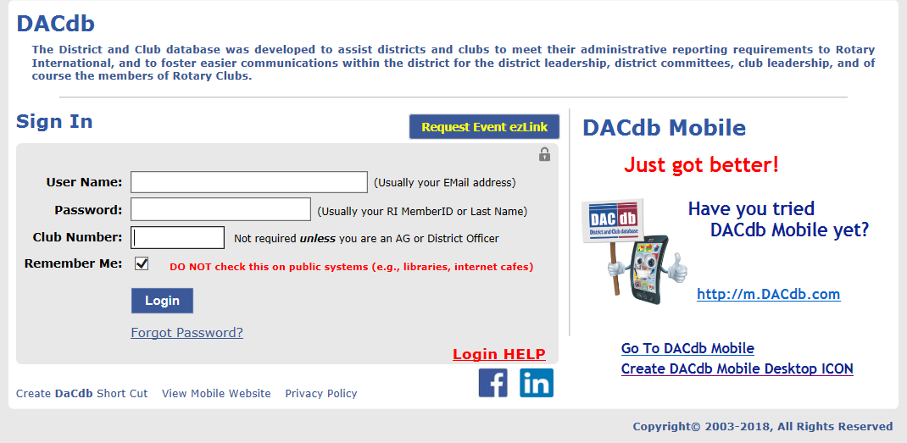

Add to your smartphone or tablet for more convenience

