Hanover County Rotary Club
Updated 03/07/2024
Active members

Holly Austin (Steve)
Address: 10271 Stratford Hall Court, Mechanicville VA 23116
Cell: 804-337-8622
Office: 804 918-7331
Business web: www.atleestationymca.org
Email: austinh@ymcarichmond.org
Classification: Executive Director – Atlee YMCA
Membership: 4/13/16
Birthday: 8/3

Arnie Cohen
Address: 6365 Broad Sky Circle; Mechanicsville, VA 23111
Cell: 214-924-2116
Email: arnoldsidney1@gmail.com
Classification: Private school administrator
Membership: 9/14/11
Birthday: 3/19

Celeste Cohen
Address: 6365 Broad Sky Circle; Mechanicsville, VA 23111
Cell: 972-998-9595
Email: celestecohen@sbcglobal.net
Classification: Retired
Membership: 3/12
Birthday: 12/30

Maria Diana (Penny) Guiles
Address: 9286 Hanover Crossing Dr., Apt A, Mechanicsville, VA 23116
Office: 804 727-2105
Cell: 804 921-7132
Email: pennyguiles43@gmail.com
Classification: Convention Services Manager
Birthday: 5/31
Transfer from Church Hill Rotary Club (past president)
Janice G Henicheck
Address: 7473 Seven Springs Road, Mechanicsville VA 23111
Cell: 570 574-1481
Email: jhenicheck2@gmail.com
Classification: Non-profit
Membership: 1/1/95
Birthday: 1/22

Glenn R. Moore
Address: 8 Ellensview Circle, Richmond, VA 23226
Home: 804 285-0533
Cell: 804 356-5479
Office: 804 285-3888
Business web: www.mthblaw.com
Email: gmoore@mthblaw.com
Classification: Attorney
Membership: 4/92
Birthday: 11/21

Judson Taylor Musick III
Address: 10 Waterfall Rd., Henrico VA 23228
Home: 804 740-0886
Office: 804 225-4668
Email: musickjt3@yahoo.com
Classification: Accountant Sr., VA Dept of General Services
Membership: 2/15/06
Birthday: 7/8

Michelle Nelms
Address: 9337 Guenevere Place; Mechanicsville, VA 23116
Cell: 804-248-6310
Email: mjnelms@comcast.net
Classification: Software Engineer
Membership: 8/28/19
Birthday: 04/05

Aimee Peterson (Nathan Harris)
Address: 13191 Overhill Drive, Glen Allen VA 23059
Cell: 814-440-2593
Email: aimeespeterson@yahoo.com
Classification: Healthcare Consultant
Membership: 6/2021
Birthday: 12/19

Sanjeev Saxena
Address:
Cell: 913-202-8535
Email: saxena.sanjeevk@gmail.com
Classification: Healthcare
Membership: 12/01/21
Birthday: 6/02
Ken Scaplehorn (Wendy)
Address: PO Box 6661, Ashland, VA 23005-6661
Home: 804 550-3227
Cell: 804 337-7265
Office: 804 550-5191
Email: scaplehorn@aol.com
Classification: Waste Management
Membership: 1987
Birthday: 6/17

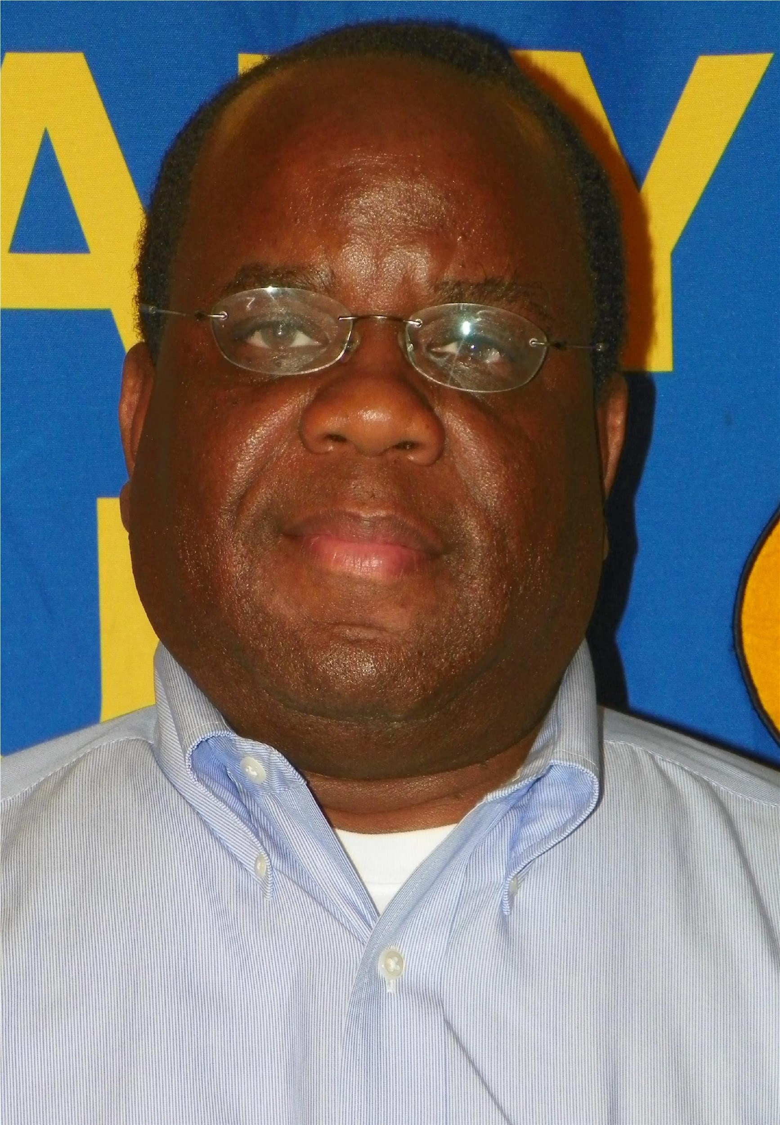 | Ted Warlick (Julie)  Address: 9026 Hopkins Branch Way, Mechanicsville VA 23116  Cell: 804 347-7386  Email: theowarlick@gmail.com  Classification: Retired  Membership: 4/23/14  Birthday: 9/20

R-85
Robert Nelson Barnette Jr. (Janice)
Address: 7071 River Pine Court Mechanicsville, VA 23111
Home: 804 559-2310
Cell: 804 647-7087
Office: 804 541-5451
Business web: www.cbi.com
Email: r.barnette@comcast.net or rbarnette55@gmail.com
Classification: Consultant
Membership: 6/30/09
Birthday: 3/18

Michael S. Smith (Joanna)
Address: 9509 Hartford Oaks Drive, Mechanicsville, VA 23116
Cell: (804) 814-8005
Home: (804) 746-8650
Email: mssmithusa@comcast.net
Classification: Retired
Membership: 9/1/1992
Birthday: 1/11

W Canova Peterson (Pat)
Address: 7338 Hill View Drive, Mechanicsville, VA 23111
Cell: (804) 338-1448
Business Web: www.canova.net
Email: cpeterson@canova.net
Membership: 1975

Brenda Rosalez (Jim)
Address: 6402 Harbour Mist Lane, Mechanicsville VA 23111
Home: 804 514-2347
Cell: 804 514-2347
Office: 804 291-8728
Email: bwrosalez@fastmail.fm
Classification: Retired
Membership: 1997(7/1/11 with our club)
Birthday: 7/26
Clinton J. Norris (Rebecca)
Address: 10318 Grendel Ct. Mechanicsville, VA 23116-583
Cell: 804 221-7727
Office: 804 747-0044
Email: cjnorris3@comcast.net
Classification: Clinton J. Norris, DDS, PC
Membership: 10/1/90
Birthday: 3/26

Alumni / Honorary Members

Jerry P Owen (Honorary)
Address: 1500 Westbrook Ct. Apr 2145, Richmond VA 23237
Home: 804 200-1330:
Cell 804 357-4279
Email: jowen666@gmailcom
Membership: 1974
Birthday: 11/20
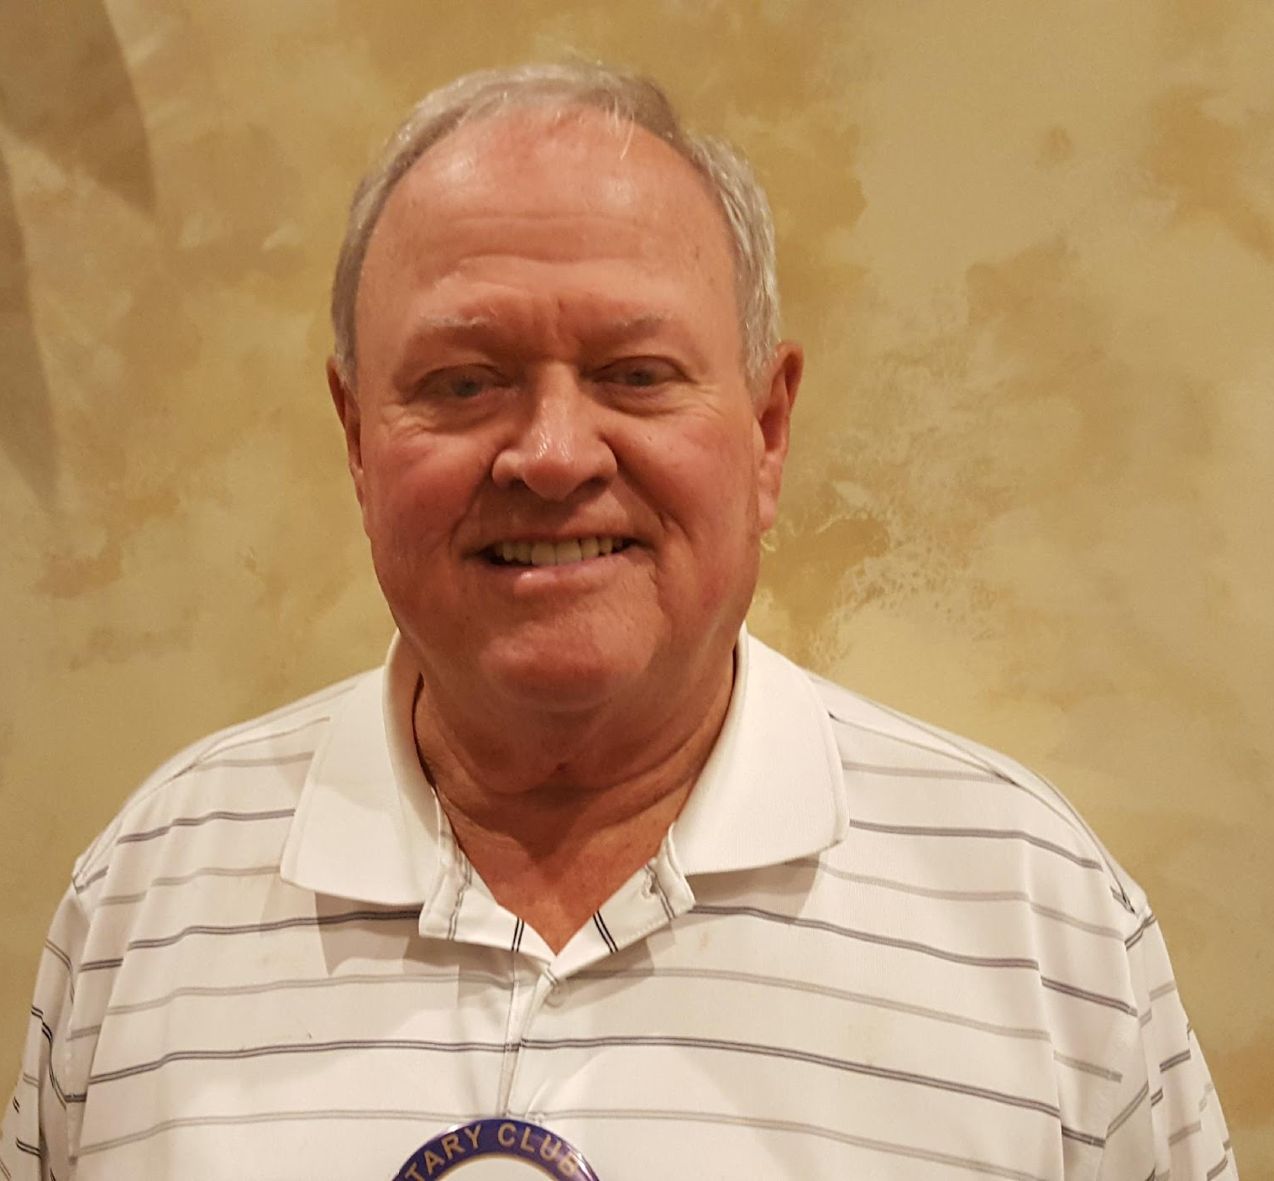 | Harvey F. Selden (Honorary)  Address: 7328 Princess Anne Dr., Mechanicsville, VA 23111  Home: 804 347-7923  Email: hfselden@comcast.net  Birthday: 8/24
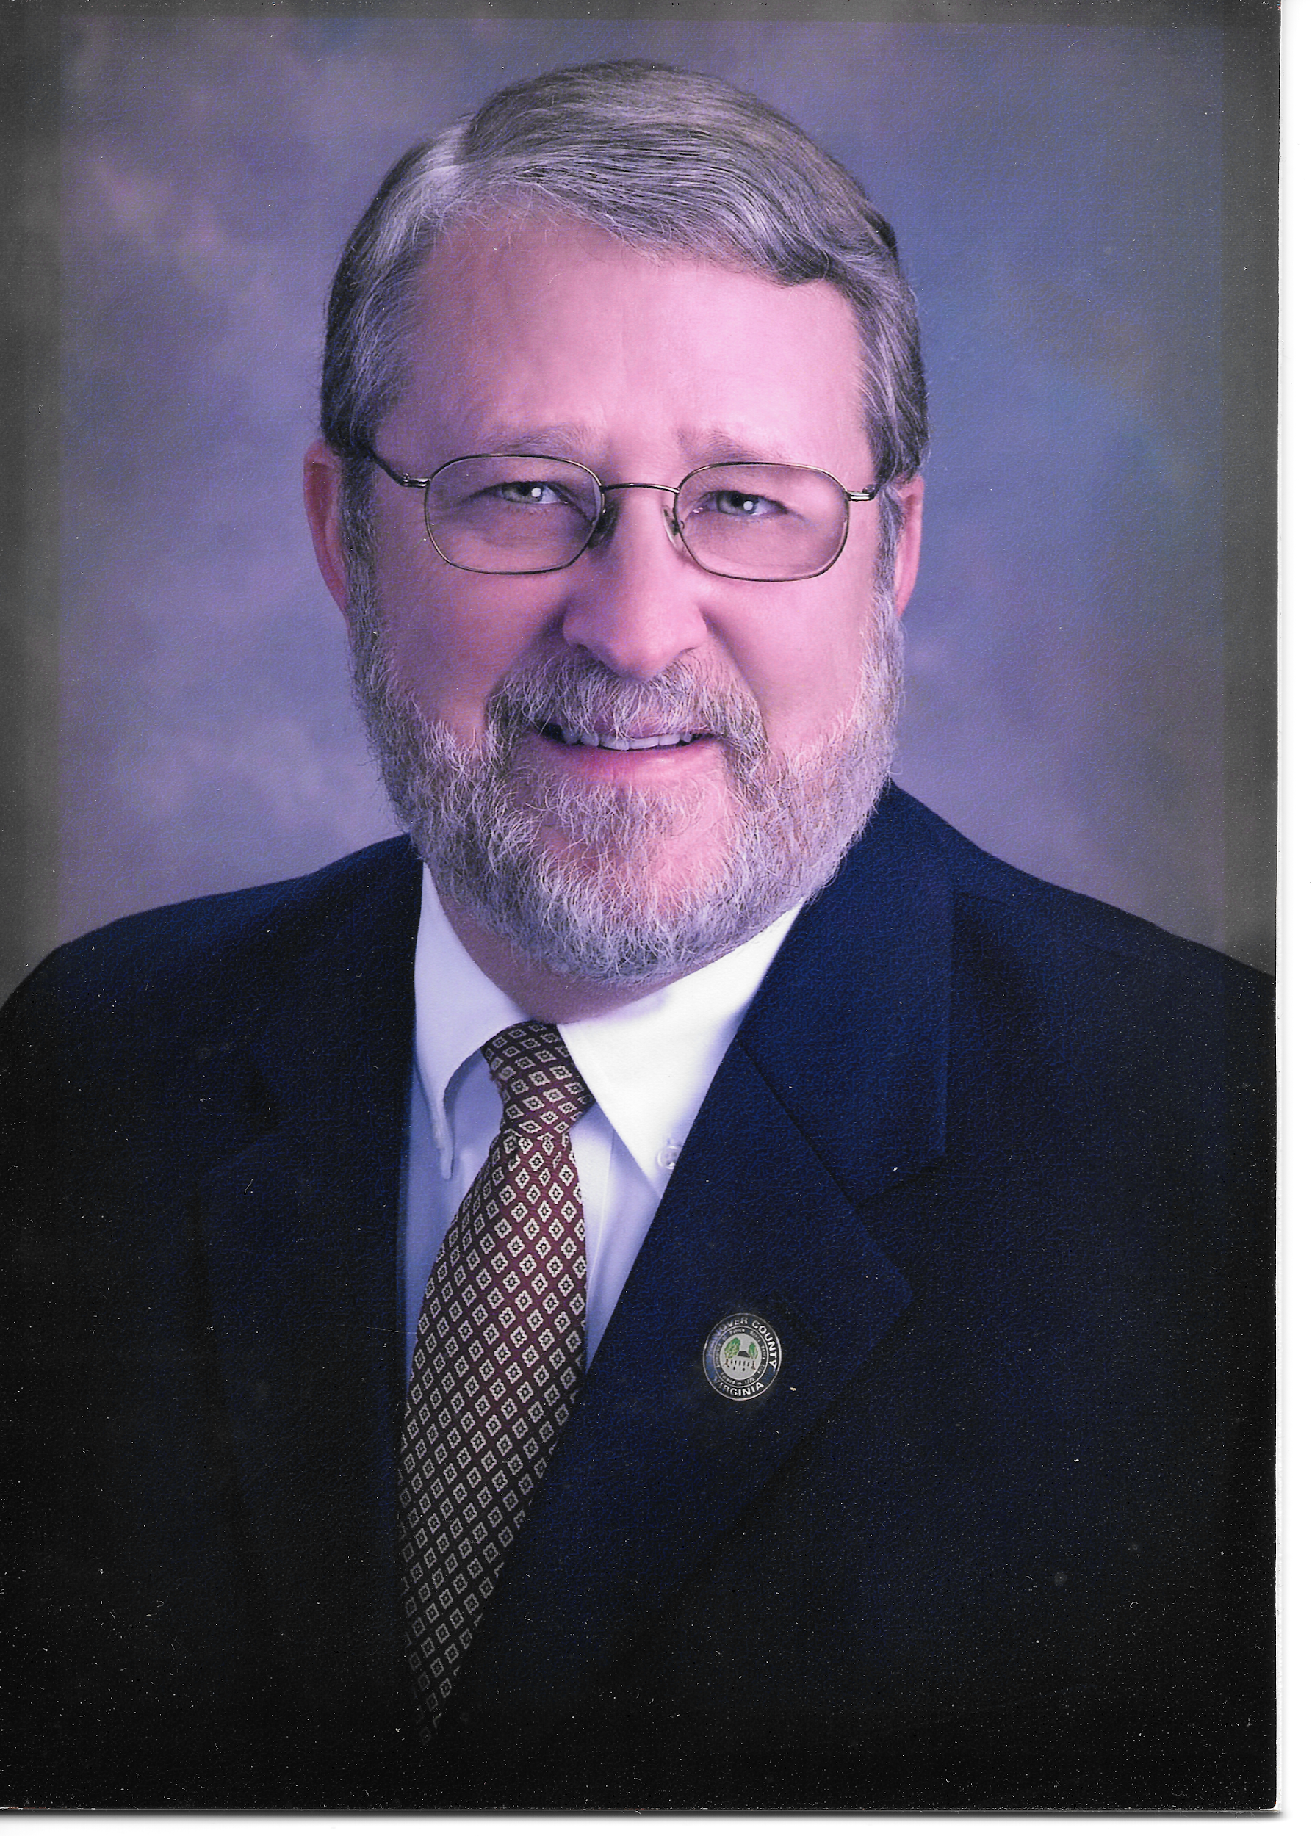 | Ed Via (Honorary)  Address: 10354 Wanchesa Way, Ashland, VA 23005  Home: 804-550-2600  Office: 804 572-1811  Cell: 804 572-1811  Email: edbasic@yahoo.com
Inactive Members

David H Creasy (Nancy)
Address: 10250 Malabar, Mechanicsville, VA 23116-4716
Home: 804 730-2131
Cell: 804 334-9523
Office: 804 308-8717
Business: http://tinyurl.com/creasyoffice
Email: david@creasycparichmond.com

Classification: CPA
Membership: 1/1/87 (82 or 83)
Birthday: 9/20

Dan Baldecchi (Merv)
Address: 2820 Ackley Ave., Richmond VA 23228
Cell: 804-399-8689
Office: 804-916-1378
Business web: www.colonialwebb.com
E-mail: Dan.Baldecchi@colonialwebb.com
Classification: Senior Account Executive
Membership: 3/1/06
Birthday: 11/10

Rickey Dandridge
Address:
Cell:
Email: rrdandridge@hanovercounty.gov
Classification:
Membership:
Birthday:

