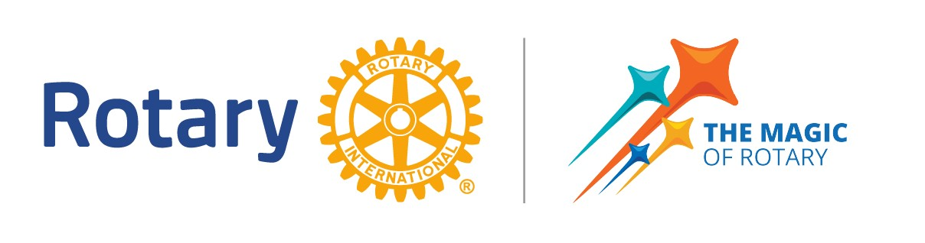

**Hanover Rotary Club Notes**

2/5/25 Weekly Meeting

Clint called the meeting to order at 6:31 PM.

Thought for the day: Michelle

Pledge: Ken

Attending Members: Janice, Michelle, Judson, Ted, Catherine, Glenn, Ken, Aimee, Holly, Animesh, Arnie, Clint, Sanjeev

Visiting Rotarians:

Guests:

Sergeant-at-Arms Report: Glenn told us there were 12 Rotarians. (Sanjeev came in after, making it a total of 13 Rotarians)

**Good bars for good jobs** – none tonight

**Announcements:**

Holly recognized Judson for obtaining Paul Harris Fellow with 3 sapphires.

**Happy/Sad Bucks:**

Arnie is happy to be back

Holly is happy, but extremely anxious that her daughter got her learner’s permit this week

**Rotary Minute:**

Ken gave a Rotary Minute about Rotary Firsts. First Rotary Club meeting was in Chicago Feb 23 1905. He shared other first Rotary Clubs.

**Shrimp & Suds Update**

Michelle gave a Shrimp & Suds update – read the e-mail she sent!

**Program:**

Holly has worked at the YMCA for 22 years. The Atlee Station Family YMCA is one of two in Hanover County. They partner with the Patrick Henry YMCA. The Y has been in Richmond since 1854. They were founded in London and is 120 countries around the world. Their cause is to strengthen the foundation of our community. The Greater Richmond YMCA has a new CEO since June 2023. Holly shared a diagram of their Mission in Motion which will feed into their 2030 goal of 3 impact areas, 3 engagement opportunities giving more than 30% of families thriving.

The Atlee YMCA has many programs and a strong membership. 1 in 5 receive assistance from the YMCA which is funded by donations to the YMCA. The Atlee Station YMCA given away $1.3 million in the last 10 years in financial assistance. 100% of donated dollars can go to assistance, because membership supports operations.

She told us about the many, many programs they have for kids, teens and active adult programs.

They’ve raised $1.1 million to complete phase 1, which will include a pavilion, fields and an adaptive playground. Building is in progress!

After Judson led the Club in the 4-Way Test, Arnie adjourned the meeting at 7:36 p.m.

Michelle Nelms

**Upcoming Dates**

**February 2025**

February 12, 2025 NO MEETNG

February 15, 2025 RYLA

District Grant Management Seminar

February 19, 2025 Club and Board Meeting - Ryan Hudson - Hanover County Supervisor

February 26, 2025 NO MEETNG

**March 2025**

March 5, 2025 Club Meeting – Jaime Stoops, Acting Director Pamunkey Regional Library

March 12, 2025 NO MEETNG

March 19, 2025 Club meeting and Board Meeting – Sandy from Sandy’s Plants

March 24, 2025 District Grant Management Seminar

March 26, 2025 NO MEETNG

**April 2025**

April 2, 2025 Club Meeting – Speaker TBD

April 9, 2025 NO MEETNG

April 12, 2025 District Training Assembly – Open to all, contact Penny

April 16, 2025 Club and Board Meeting – Essay Contest Celebration

April 23, 2025 NO MEETNG

April 30, 2025 Hanover County Social Event

**May 2025**

May 1, 2025 District 7600 End Polio Now Baseball Game

May 7, 2025 Shrimp & Suds pre meeting

May 8. 2025 40th Annual Shrimp & Suds

May 14, 2025 NO MEETING

May 21, 2025 Club & Board Meeting - Professor James Doering

May 28, 2025 NO MEETING

**June 2025**

June 4, 2025 Club Meeting - Debbie Preston, Director of Human Resources, Hanover County

June 11, 2025 NO MEETING

June 18, 2025 Club & Board Meeting

June 25, 2025 NO MEETING