Hanover Rotary Club Notes
10/18/23 Weekly Meeting

Janice called the meeting to order at 6:45 PM.

Blessing: Ted
Pledge: Arnie

Attending Members: Judson, Michelle, Ken, Janice, Glenn, Holly, Arnie, Celeste, Vera, Ted, Sanjeev

Visiting Rotarians:

Guests: Gabby Troutman, VA Grassroots Manager, Chesapeake Bay Foundation

Sergeant-at-Arms Report: Vera gave a Sergeant-at-Arms report. 11 Hanover Rotarians, 1 guests. Judson gave a joke about a wolf that could see in the dark – and Celeste gave a Landonesque joke

Happy/Sad Bucks:
Vera is happy to be here

Rotary Minute:
Ken gave a Rotary Minute about Rotary Firsts during it’s 120 year history

Announcements:
Janice gave a review of the District Conference

Glenn e-mailed the peanut sales forms to everyone. He tries to sell them to people he works with. The orders are due November 15. (A meeting night) Contact him if you need a hard copy or it sent again.

There will be outing to Top Golf. Arnie sent an e-mail. He needs to know by October 20 if you are going. $20 to play, $10 to watch.

There are shirts available for volunteers – please contact Janice if you need one.

Upcoming Dates

October 2023
October 24th WORLD POLIO DAY
October 25th Top Golf visit – contact Arnie for more detail

November 2023
November 1st Regular Meeting – Jim Doring, Randolph Macon College
November 8th Shrimp & Suds Kick Off Committee Meeting
November 9th DISTRICT EVENT - Foundation Banquet @ Colonial Heritage
November 15th *** PEANUT ORDERS DUE ***
November 15th Regular Meeting - Major Samuel Kim, Salvation Army Commander
November 22nd No Meeting
November 23rd Thanksgiving Holiday
November 29th TBD

December 2023
December 2nd Community Service : Red Kettle - Ring the Bell at Ashland Wal-Mart 9am – 6pm
December 6th Christmas Party - AshCreek Clubhouse – collecting new underwear for Liberia
December 9th Community Service : Books & Bears for Childrens Hospital
December 13th No Meeting
December 20th Regular Meeting
December 25th Christmas Holiday
December 27th No Meeting

Program:
Gabby Troutman, Virginia Grassroots Manager with the Chesapeake Bay Foundation (CBF) was the speaker. They work to Save the Bay through education, restoration, advocacy and litigation. The watershed is the largest estuary in North America and is the 3rd largest in the world. It is fed by 50 major tributaries – the largest ones being in Virginia. It has the largest land-to-water ration of any estuary in the world.
The biggest sources of pollution are sediment and sand (erosion) that block sunlight to below the land, as well as fertilizer and toxins that affect water quality.
Climate change has a big impact on the temperature of the water in the bay, the frequency and intensity of storms which leads to increased flooding, increased loads of pollutants and changes to salinity regimes.
The region is particularly vulnerable to sea level rise.
The State of the Bay is measured every two years – it is 32/D+ in 2022 – unchanged from 2020. The ultimate goal is 70.
The way to get involved is to advocate for Clean Water – connecting with local leaders.
Go to www.cbf.org/action to sign up to get alerts, volunteer or donate

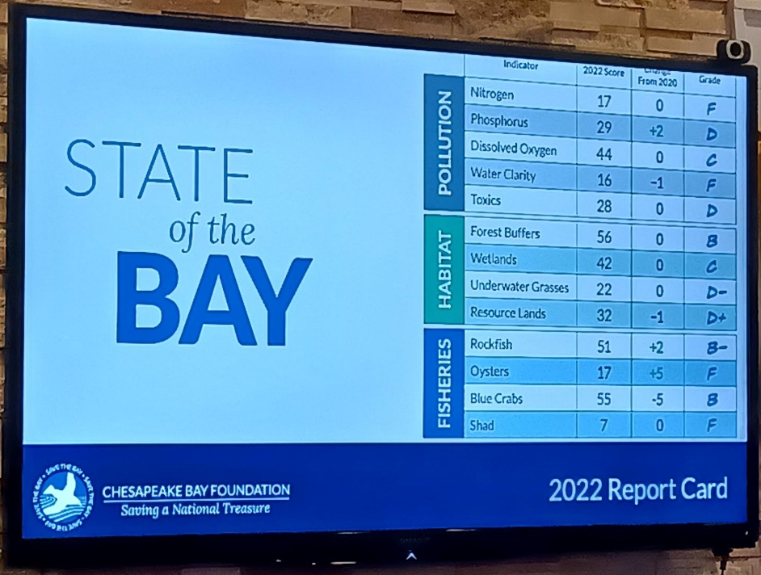

Clean the Bay Day is a long-standing volunteer program that is held annually on the first Saturday in June. (www.cbf.org/clean)

After Judson led the Club in the 4-Way Test, Janice adjourned the meeting at 7:45 p.m.

Michelle Nelms

