Hanover Rotary Club Minutes

7/28/21 Weekly Meeting

Brenda called the meeting to order at 6:52 PM.

Blessing: Brenda

Pledge: Mike Swinford

Attending Members: Brenda, Janice, David Creasy, Glenn, Aimee, Ken, Mike, Dan, Ted, Judson, Mike & Rachel Swinford, Michelle

Honorary Rotarian:

Visiting Rotarians: Stephen Beer, Innsbrook Rotary

Guests:

Sergeant-at-Arms Report: Mike gave the sergeant-at-arms report but no joke today. 13 Hanover Rotarians present and one visiting

Happy Bucks:
Mike is just happy – so is Ted
Stephen is happy to be here and wake up this morning

Rotary Minute:
Ken gave a Rotary Minute on the Rotarian Code of Conduct adopted by Rotary International. It appears monthly in The Rotarian.
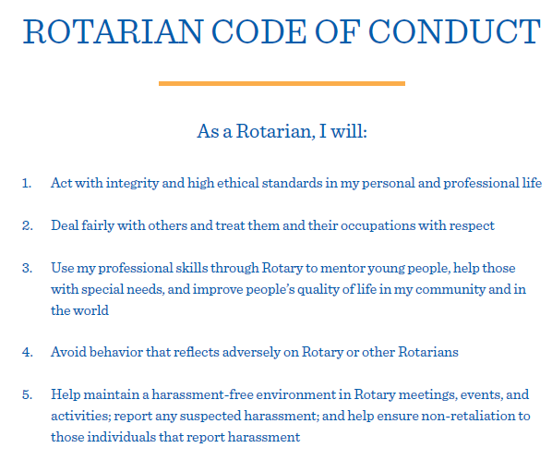

Announcements:
Next week - 8/4 - Judy Cocherell, PDG – Speaking about Rotary Leadership Institute
8/11 - Lynn Pulley-Paine from Hanover Humane Society
8/18 – Jim Doering Ph D, Prof of Music, Chair of Dept of the Arts, Randolph Macon
8/25 – Jenelle Janabajal, FBI SSA (Supervisor Special Agent)

District Conference – Oct 15-17 at Marriott Downtown Richmond
District Baseball Game – August 1st – Tickets have been purchased already. Buy tickets on the night if you want to go. We are in Section 204.
Rotary Training on Aug 7 – Public Image and Foundation, $32. Sign up on DACdb.

Program:
Brenda introduced Stephen Beer of the Rotary Club of Innsbrook and is the District Rotary Foundation Committee Chair.
Stephen presented David Creasy with a Major Donor Level 1 pin as well as a crystal award for his contributions to the Rotary Foundation

Stephen spoke on why he gives to the Rotary Foundation. At first he didn’t know what the Foundation was about but after his Club received a grant, he found out more about what they do. After a visit to Honduras where they built a well, he became more motivated and wanted to support the Foundation and its activities more. The international service motivates him the most and he has visited several countries for service projects.
There are 3 reasons he gives to the foundation:
- Rotary’s impact to communities around the world
- The Foundation is an efficient way of giving because of the way Rotary uses the money. Rotary has a 4-star rating on Charity Navigator – the highest rating given. They have a 100% score the last 3 years, one of only 4 last year. 92% of contributions go to the causes, with 8% only going to administration
- Rotary’s Seven Areas of Focus. Stephen showed several examples of projects the Foundation supports within the seven Areas of Focus.

After Judson led the Club in the 4-Way test, Brenda adjourned the meeting at XX:XX p.m.
Michelle Nelms

