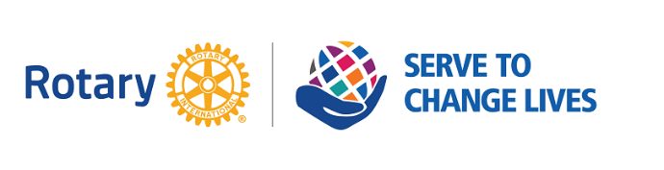
Hanover Rotary Club Minutes

6/15/22 Weekly Meeting

Penny called the meeting to order at 6:45 PM.

Blessing: Penny

Pledge: Ted

Attending Members: Ted, Penny, Ken, Michelle, Holly, Sanjeev, Judson, Robert, Rickey, Janice

Honorary Rotarian:

Visiting Rotarians: Vera Jones, Alexandria Central Rotary Club

Guests: Renee Robinson from Hanover and King William Habitat for Humanity, John Suddarth from Solar

Sergeant-at-Arms Report: Penny gave a sergeant at arms report. 10 Hanover Rotarians, 1 visiting Rotarian, 2 guests.

Happy/Sad Bucks:
Penny is happy because she will out of town at a wedding next week
Janice is happy to have received the get-well card from the club
John is happy to be invited to be with us tonight

Rotary Minute: Ken gave a Rotary Minute. RI Foundation is wrapping up the year, and contributions can still be given online or through Mike on the statement. Cut off for this year is June 30. The Permanent fund was set up to fund Rotary projects in perpetuity. The fund only distributes proceeds. Donations are added to the principal making the fund very large.

Announcements:
The Installation Banquet will be on Thursday, June 30 at Roma’s. If you haven’t already, please let know if you will be there. It will be a plated dinner starting at 6 with drinks and appetizers.

August 24 – Joint Social with Mechanicsville and Ashland at COTU

Foundation giving deadline is June 30 due to fiscal year end. Give donations early.

Next week - June 22 - No meeting
Thursday, June 30 – Installation Banquet
July 7 – Kenny James, District Governor
July 13 – No meeting
July 20 – need speaker idea – contact Penny if you have one!
July 27 – Service Project, Doorways visit (tentative)

Program:
Habitat for Humanity envisions a world where everyone has a decent place to live. Their signature project is building homes for people through the homeownership program where people must spend 200 hours on their home with each additional adult contributing another 100 hours. They structure mortgages to be affordable and they put them through training to prepare them for home ownership.
They recently introduced solar on to homes to reduce electric cost and makes them more efficient.

They also have a critical repair program where they will help people to repair their home. They help mostly on health and safety issues like plumbing and mold remediation. It’s a little-known program that needs publicity!

The new Habitat Restore is in the old Wynn-Dixie and is like Goodwill for Home Improvement materials that are sold to the public.

They also have a recycling program of things that don’t work or won’t sell, so they get aluminum out of the them. It’s all volunteer. They raised $25K from that program

To support them, volunteer on construction or the ReStore. Donate to ReStore or their programs. Help scout affordable and viable land.

They expanded to serving King William last year.

Habitat is partnering with Rotary International to provide solar and new houses in a new program: Environmental Sustainability Rotary Action Group.

There are many financial Benefits, saving a homeowner over $30K over 25 years.

After Judson led the Club in the 4-Way Test, Penny adjourned the meeting at 7:35 p.m.

Michelle Nelms

