Hanover Rotary Club Minutes

2/9/22 Weekly Meeting

Brenda called the meeting to order at 6:50 PM.

Blessing: Brenda

Pledge: Ted

Attending Members: In person: Brenda, Penny, Ken, Michelle, Glenn, Arnie, Holly, Janice, Ted, Judson, Rickey

On Zoom: Aimee, David Creasey, Sanjeev

Honorary Rotarian:

Visiting Rotarians: Celeste Cohen, Anchorage International Club

Guests: Diana Villarreal, guest speaker, Ronald McDonald House

Sergeant-at-Arms Report: Glenn gave a sergeant-at-Arms report. 11 Rotarians in person, 2 Rotarians in Zoom, 1 visiting Rotarian, and 1 guest (on Zoom). True to his word, Glenn enforced his fine rule for people not wearing their name tag and asked for $1 in the basket

Happy/Sad Bucks:
Arnie is happy because Lauren (his daughter) will be an endowed chair at Randolph Macon and Celeste is happy because their other daughter will visit for the celebration

Rotary Minute:
Ken gave a Rotary Minute, about the Area Representative for the district as assistant director to the District Governors to help DG’s better support their club. They help incoming club presidents to achieve their goals and they visit their clubs at least 4 times a year.

Announcements:
1. Rotary Night at the Diamond, May 1; Gates open at 12:30P with game time at 1:35P. $2 goes back to End Polio Now Foundation
2. Arnie volunteered to attend the grant writing seminar on March 24th
3. Steve Dunham from Ashland Rotary will be the new Area Governor in July
4. We will be getting money back from the grant for the Washington Henry Sunshade Project
a. Mechanicsville Rotary is in process of closing out the grant now. All grants must be closed before you can start another. There are grant partnering opportunities on the RI website we may want to explore
5. Brenda thanked Glenn and Judson for taking on new roles in the club
6. Mechanicsville Rotary is looking at having their fundraiser in April (to be confirmed)
7. The District Conference mentioned new types of Rotary Clubs - e-Satellite, Pub Club, and "Cause based"
8. Brenda passed around a card from the YMCA thanking us for our support
9. Arnie volunteered to attend the grant writing seminar

Program:
Diana Villarreal from Ronald McDonald House joined the call via Zoom

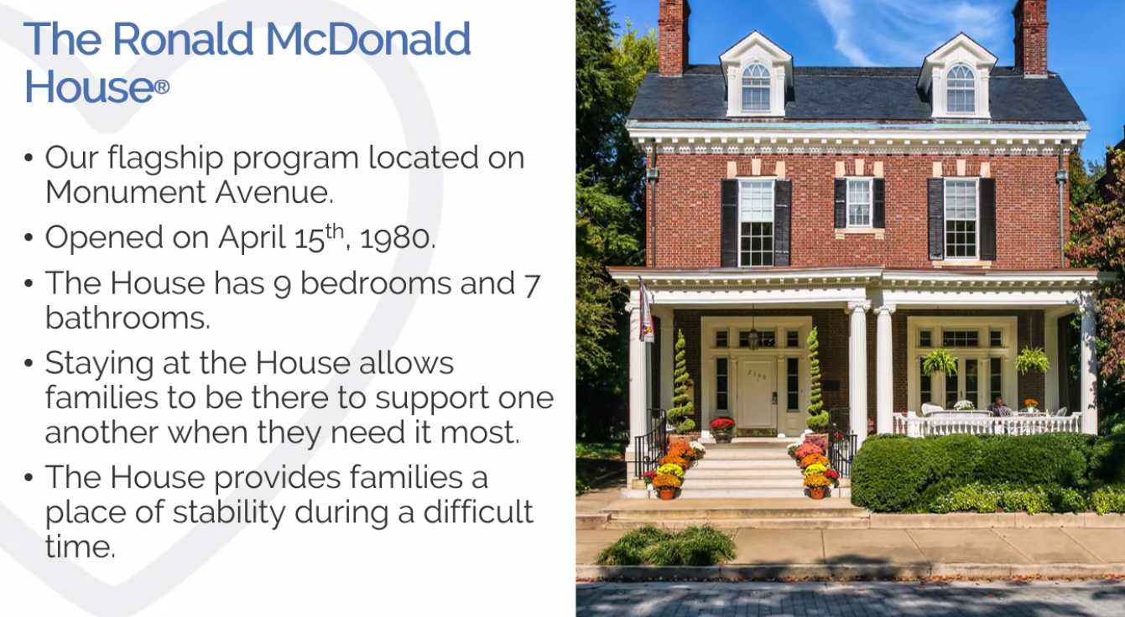
Anyone can stay at the Ronald McDonald House and when they are full, they put up families in a hotel so that they can accommodate everyone.
Families come from 86 Virginia counties, 22 states and 5 foreign countries. It is free and they can stay as long as need to. They are asked to make a donation of $15 night but don’t turn people away if they don’t.

They work will many hospital and referral partners for patients with a variety of treatments.

She told us about a family who stayed with them for over a year and a half. They lived 90 minutes away.

They also have sleep rooms and Family rooms at the CHoR and VCU that are actually at the hospital where families can stay for 3 nights for the most critical patients.
At Bon Secours St Mary’s they also have the rooms, but also have a kitchen which allows family a respite place. They have Happy Wheels carts that offer snacks, activities, toiletries and small comforts – donated and staffed by volunteers.

There is a Sibling Center that siblings can stay at all day like a day care to free up their parents to participate in the care giving

Lunches with Love delivers 160 lunches to families in pediatric units.

They are reliant on the Richmond Community to donate kits, money and time to the Ronald McDonald House. McDonalds’s restaurant owners/operators support more than 10% of RMHC Richmond’s annual operating budget.

There are many volunteer opportunities for people wishing to volunteer time and participate in special events.

The past year has been challenging during the past two years when they have had to get creative in some cases to provide services and pick up/drop off.

Aimee introduced our project for this quarter. We will be collecting for activity packs for Ronald McDonald House, either items or monetary. Flyer will be forthcoming.

After Judson led the Club in the 4-Way Test, Brenda adjourned the meeting at 7:32 p.m.

Michelle Nelms

