Hanover Rotary Club Minutes

2/2/22 Weekly Meeting

Holly called the meeting to order at 6:50 PM.

Blessing: Holly

Pledge: Ken

Attending Members: In person: Holly, Rachel, Mike Swinford, Glenn, Aimee, Ted, Judson, Rickey, Robert, Ken

On Zoom: Michelle

Honorary Rotarian:

Visiting Rotarians:

Guests: Becky Tres, Potential Member

Sergeant-at-Arms Report: Glenn gave a sergeant-at-Arms report. 10 Rotarians in person, 1 Rotarians in Zoo, 1 visiting Rotarian, and 1 guest. Glenn gave everyone a warning about starting to assess fines No joke tonight

Happy/Sad Bucks:
Holly is happy because she has a new nephew! Her brother’s first child.
Judson was happy to see Becky

Rotary Minute:
February is Rotary’s birthday month. Ken spoke about the responsibilities of the Rotarian across the world.

Announcements:
Ted is attending the Presidential Retreat this weekend.
Rickey’s organization is holding a golf tournament May 23.

Program:
Aimee was born and raised in Titusville, PA. She moved to Richmond because her husband Nathan lived here. She has a 5 year old Golden Doodle. She works at Optum, who acquired Advisory Board Company in 2017. She is in the research arm of the company. She likes to attend concerts at Maymont, and Lewis Ginter. She is involved in Worthdays which supports children in foster care and Lasagna Love which partners people with families to provide a lasagna for families in need.

Aimee discussed challenges of the health care industry and ways the industry is evolving.
She works in sales for the “Full” End-to-end Partnerships bundling services for a partner. Her team goes through Discovery, Design and Contract phases. A partnership with John Muir is one of her recent deals.
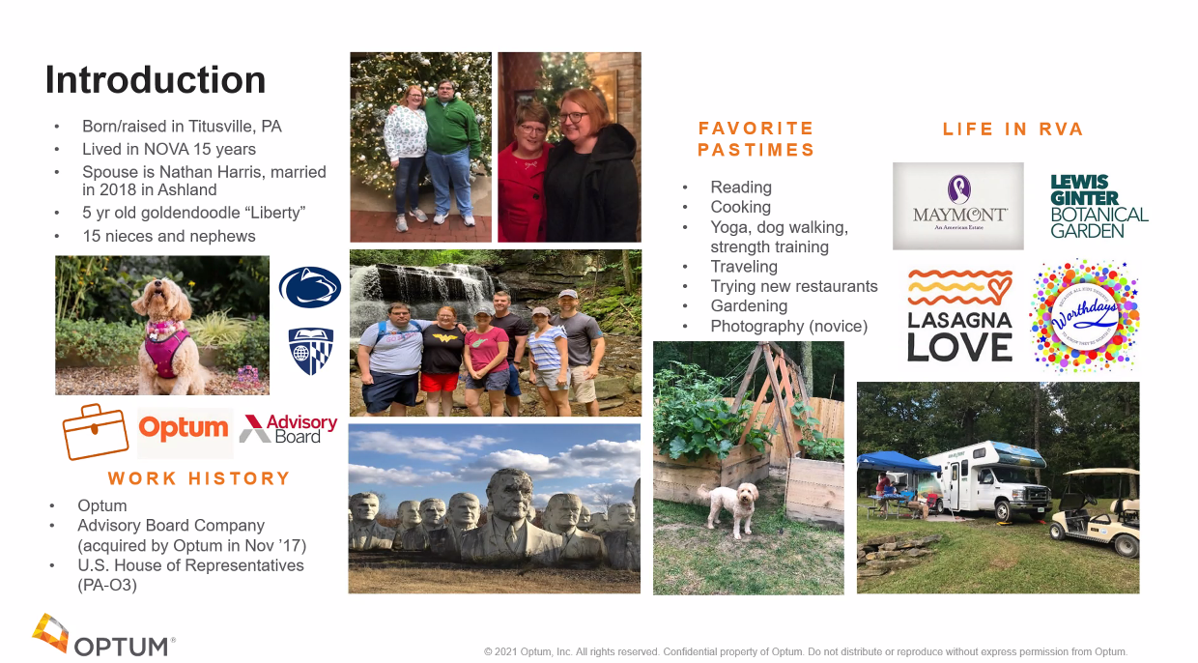

After her speech was finished, Holly presented Aimee with her badge.

After Ted led the Club in the 4-Way Test, Holly adjourned the meeting at 7:32 p.m.

Michelle Nelms

