Hanover Rotary Club Minutes

2/16/22 Weekly Meeting

Brenda called the meeting to order at 6:50 PM.

Blessing: Brenda

Pledge: Rickey

Attending Members: In person: Brenda, Penny, Michelle, Arnie, Holly, Janice, Judson, Rickey, Mike & Rachel Swinford

On Zoom: Aimee, David Creasey, Sanjeev

Honorary Rotarian:

Visiting Rotarians: Celeste Cohen, Anchorage International Club

Guests: Trisha Green, Executive Director of Patrick Henry YMCA

Sergeant-at-Arms Report: Penny gave a sergeant-at-Arms report. 11 Rotarians in person, 2 Rotarians in Zoom, 1 visiting Rotarian, and 1 guest. Penny told a joke: Why are sports stadiums so cool? They are filled with fans!

Happy/Sad Bucks:
Janice is happy because Janice found a rare Squish Mellow Pillow for her granddaughter, Lily – at Costco!
Celeste is sad because she never heard of Squish Mellows!
Rachel is happy because her grandson is coming back to visit soon
Rickey is happy because he presented his budget today
Aimee is happy because her colleague will be inducted into the Football Hall of Fame for Jacksonville Jaguars
Sanjeev is sad because his family members had COVID but is happy because they finish quarantine tomorrow and he will back next week.

Rotary Minute: None tonight

Announcements:
Rotary Night at the Diamond, May 1; Gates open at 12:30P with game time at 1:35P. $2 goes back to End Polio Now Foundation

Penny would like referrals of speakers, please contact her with your leads.

Program:

The mission of the YMCA is to put Christian principles into practice through programs that build a healthy spirits, mind and body for ALL. They work every day to strengthen the foundation of our community through youth development, healthy living and social responsibility.

They were closed for 88 days at the beginning of COVID and they quickly pivoted, so they started Camp Hope for child care, as well as started Summer Camp early. They also hosted blood drives, food drives and checked in on their senior members.

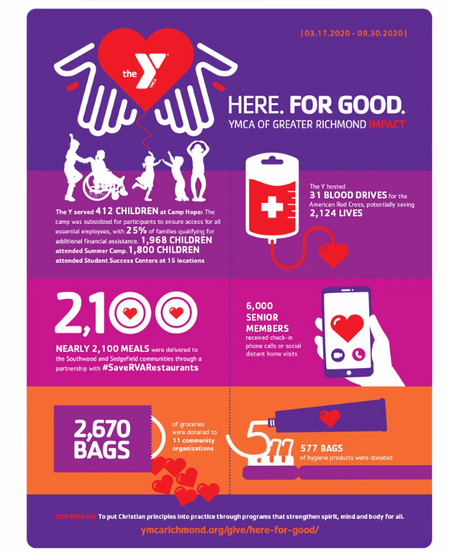

Membership fees are responsible for 88% of the operating budget, so it was a scary time when their membership declined by about 40% to its lowest point in January 2021. It has since increased but is still 22% behind pre-COVID levels. The YMCA is still in a strong position because of an emergency fund set aside for an event like COVID. They also benefited from CARES act funding.
In 2021, the Hanover Ys served 8,285 members, with 174 employees and 198 volunteers as well as 770 youth sports participants. Daily they are hearing that people are glad to be back and hearing about the positive impact the Y has on their lives.

They had 86 youth attend summer camp on a full scholarship and serviced 196 youth through YMCA Bright Beginnings. Our club contributed significantly as well as helped pack the kids. They raised over $414K and given back to the community. They have helped over 378 community members connect to more resources and assist with social navigation in the community.

The Atlee Station Y has two individuals with diverse abilities that are working there under a skills expansion program.

The Atlee Station Capital Expansion is in the works. They are fundraising right now.
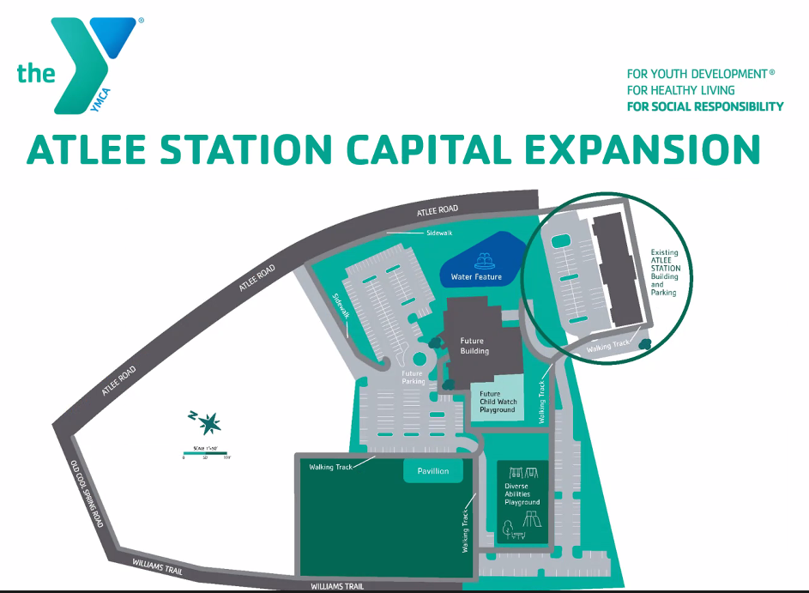

A mobile health care unit comes to the Patrick Henry Y weekly for those who need accessible heath care. It started as a result of COVID. They have also partnered with FeedMore to do a monthly food bank on the first Tuesday of the month.

Lifetime giving of the Hanover Rotary to the YMCA is $117,000! This resulted in a lot of lives touched. Holly is very grateful for our support.

After Judson led the Club in the 4-Way Test, Brenda adjourned the meeting at 7:32 p.m.

Michelle Nelms

